Eastern MA USAFA Families Club, Inc.

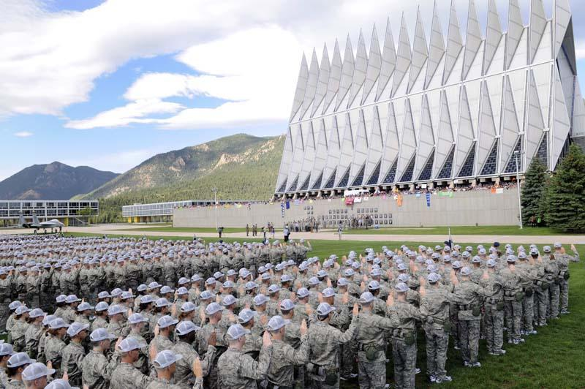
Swearing-In Ceremony – Day 2 of Basic Cadet Training

To: Eastern Massachusetts Class of 2025 Appointees and their Families

From: Eastern MA USAFA Families Club, Inc.

Date: May 1, 2021

Re: Information for the Class of 2025 Appointee and Family

An important reminder for all appointees and their families about the information presented here: all of the materials in this binder are to be considered “unofficial” and are presented for informational purposes only based on what has occurred in past years. Your appointee will receive “official” instructions and “official” documents directly from the United States Air Force Academy. Because the Air Force Academy is continually reviewing and updating its policies and procedures, some of the information in this packet may be somewhat different from other information you will receive. You should always treat anything you receive directly from the Academy as the most current information and follow those instructions.

For your quick reference:
WebGuy Password: ____________ Cadet P.O. Box #: __________Email: ___________________
(This entire handbook can be found online at http://www.usafaema.org/parents-handbook.html )
Eastern MA USAFA Families Club, Inc.

Important Dates 2021-2022

EMA Club Appointee Send-Off at Hanscom AFB 12 June 2021
In-Processing Day ~ 1st BCT begins 24 June 2021
Swearing-In Ceremony TBD
Basics’ Phone Call Home TBD
March out to Jacks Valley ~ 2nd BCT begins TBD
EMA Annual Club Cookout TBD July 2021
March back from Jacks Valley TBD
BCT Makeup/Onboarding 02-06 August 2021
BCT Graduation* TBD
Doolie Day Out* TBD
Cadet Wing returns ~ BCT ends TBD
Acceptance Day Parade TBD
Classes Begin 09 Aug 2021
Parents’ Weekend 04-06 Sept 2021
EMA Club Cookie Wrap and Meeting TBD October 2021
Thanksgiving Break 24-29 Nov 2021*
(*if Academic Calendar Option 1 approved)
First Semester Finals 10-15 Dec 2021 (Option 1)
08-13 Dec 2021 (Option 2)
Winter Break 15 Dec 2021-02 Jan 2022
(Generally, cadets may depart following last final)
EMA Club Winter Meeting TBD January 2022
Recognition Training 10-12 Mar 2022
Spring Break 19-27 Mar 2022
EMA Club Spring Meeting TBD April 2022
Second Semester Finals 09-13 May 2022
Graduation Day for 2022 Class 25 May 2022

*BCT events that parents do not attend

ALL DATES are subject to change

Eastern MA USAFA Families Club, Inc.
Dear USAFA Class of 2025 Appointee Parents,

On behalf of the Eastern MA USAFA Families Club, Inc., we first want to congratulate you on your cadet’s appointment to the United States Air Force Academy.
We are an active organization of parents from the area who have a son or daughter attending the Academy, or who has graduated from the Academy. Our purpose is to support each other on this four-year journey that is the Air Force Academy, which is most often described as a roller coaster ride.
Both appointees and family members will be experiencing a whirlwind of preparations and different emotions in the coming months as the appointee prepares to leave for In-Processing and Basic Cadet Training (BCT) that will begin on June 24, 2021. Attending a military academy places very different demands and pressures on a cadet and on a cadet’s family. Being a cadet is not at all similar to the experience of being a student at a civilian college. Cadets have unique requirements including curfews, mandatory formations, marching drills, physical training sessions, mandatory intramural sports, daily uniform requirements, and room and personal inspections, all while carrying a 6- or 7-course academic load each semester. Handling all of this can be stressful for both cadets and their families. The USAF Academy is a wonderful and life-changing opportunity, and our members can help you to fully understand these demands, the impact on cadets and families, and provide suggestions to help manage it all.
Over the next few months, our association has organized a number of terrific events to both recognize your cadet’s accomplishment and to help prepare for what lies ahead (see attached schedule of Upcoming Events or our website www.usafaema.org). We hope you will consider joining our group of dedicated parents and friends in supporting our cadets and our Air Force Academy. Dues for a lifetime membership in the Club are $100 and payable by September 1. We have enclosed a dues form with mailing instructions. We have members across the Commonwealth who are ready to assist you in any way we can. If you would like more information, we encourage you to contact any of our officers listed below by telephone or email.
Once again, congratulations, and we wish you and your cadet four incredible years at USAFA!
Go Air Force!

Sincerely,

Eastern MA USAFA Families Club, Inc.

Kim & Dave Margolis, Co-Presidents Vice President ~ TBD
kimmargolis72@gmail.com / david.i.margolis@gmail.com
(781) 346-2757 / (781) 298-1957
Wakefield, MA (Carter ’23)

Chris Matuszczak, Treasurer Carla Stafford, Secretary
chriskevfamily0725@gmail.com carla@sdiver.com
(413) 485-1965 978-429-9696
Westfield, MA (Kealyn ’24) Wayland, MA (Henry ‘23)

Eastern MA USAFA Families Club, Inc.

Upcoming Events 2021

Appointee Send-Off
Date: June 12th
Hanscom AFB
Time: 10am – 12pm
Spend some time with your fellow appointees and parents as your cadet prepares to leave for basic cadet training. Appointees will hear from and be able to speak with cadets who are presently at the Academy. Additionally, there is an information session for parents to help you navigate what you need to know in the upcoming months.

Summer Cookout
Date: mid-July
Location: TBD
A great day with good people! This is a fun day when the EMA Club comes together in an informal picnic atmosphere. Parents of the new Doolies are able to share their stories, sign “Beat The Beast” postcards for the Class of 2025, and our Club will spend time discussing Acceptance Day and Parents’ Weekend.

Parents’ Weekend
Date: September 4th - 6th
Location: USAFA

Our Club will help you plan for your first Parents’ Weekend and let you in on the ‘do’s and don'ts’. Make your travel and lodging plans early and plan to arrive in Colorado Springs in time for Friday’s early morning parade and all-day festivities! Saturday involves the squadron tailgates, and the Club will have a block of tickets for Saturday’s football game.

Eastern MA USAFA Families Club Meetings
Over the course of the academic year, we will have three meetings (October, January, April). We meet for a couple of hours, catch up on how our families and cadets are doing, and provide speakers who will talk about subjects related to USAFA and the Air Force.

INFORMATION for CLASS OF 2025 APPOINTEES & PARENTS

CONTENTS

- Introduction……………………………………………………………………………………………. 11

- Components of BCT………………………………………………………………………………… 12

- Preparing for In-Processing and Basic Cadet Training (BCT)……………. 13

- Keeping in Touch with Your Cadet During BCT.......................................... 25
- Address Format for Mail and Packages
- Telephone Calls During BCT

- WEBGUY & Keeping Track of What is Happening During BCT………….. 31

- What’s Happening During Your Cadet’s First Year.................................... 33

- Travel To and From USAFA After BCT………………………………………………… 35

- The Cadet Sponsor Program………………………………………………………………….. 37

- Parents’ Weekend (PW)..................................................................................... 39

- Care Package Information…………………………………………………………………….. . 41

- Medical Coverage Information………………………………………………………………. 43

- APPENDIX I- Cadet Knowledge…………………………………………………………….. 47

- APPENDIX II- MISC……………………………………………………………………………….. 57
- Cadet Milestones
- BCT Letter to Send to Basics
- Map of Stillman Field for Parades
- Honor’s List Criteria / Honor Code Handbook / USAFA Endowment Fund
- Useful Websites

- APPENDIX III- Eastern MA USAFA Families Club, Inc…………………….... 67

In-Processing
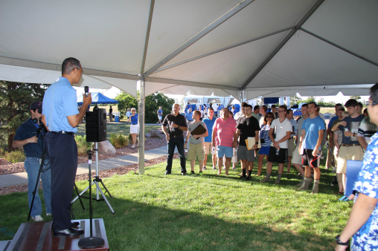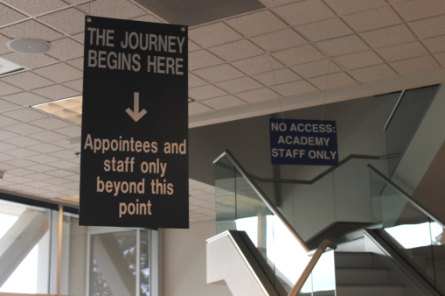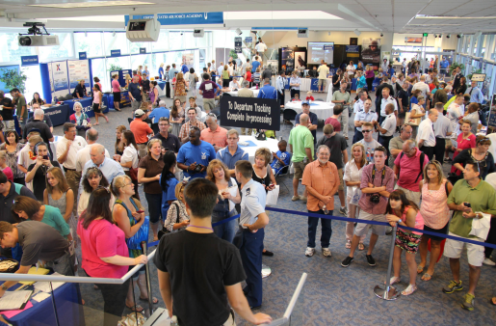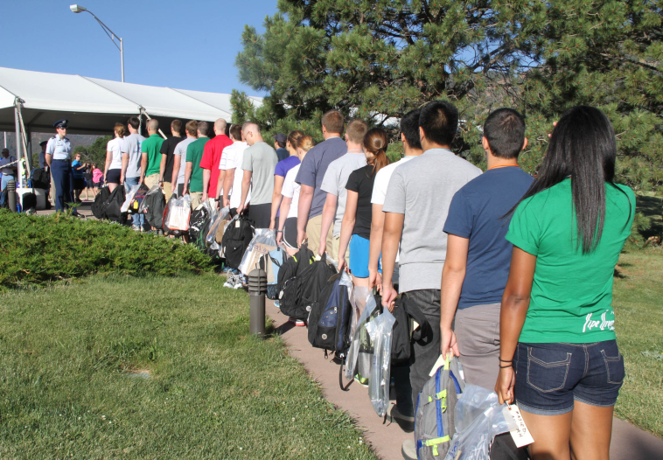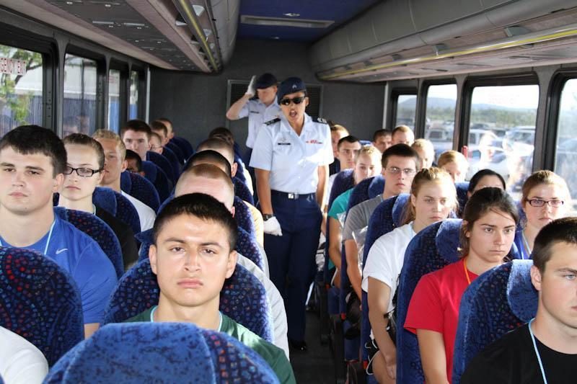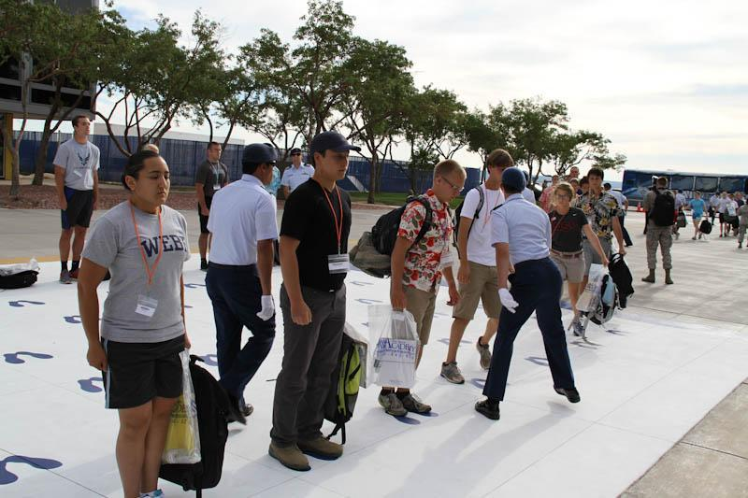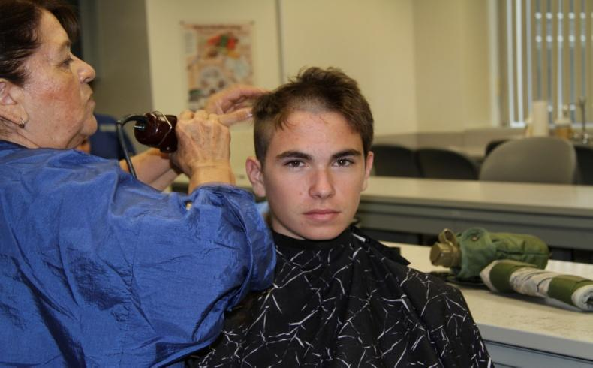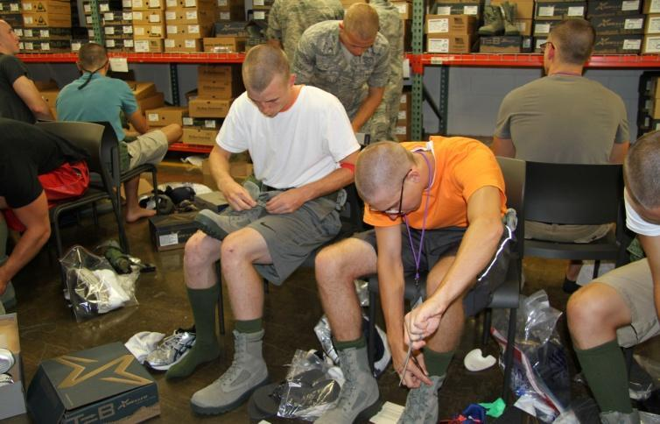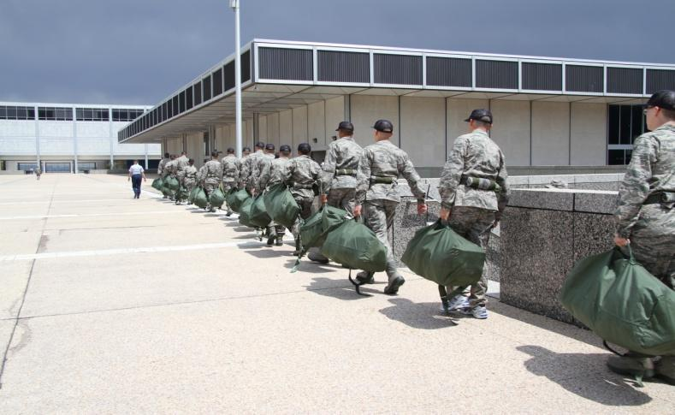
First BCT
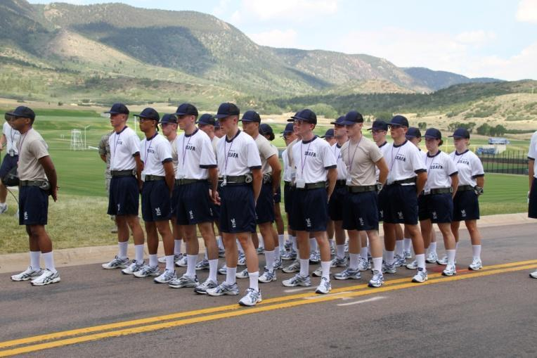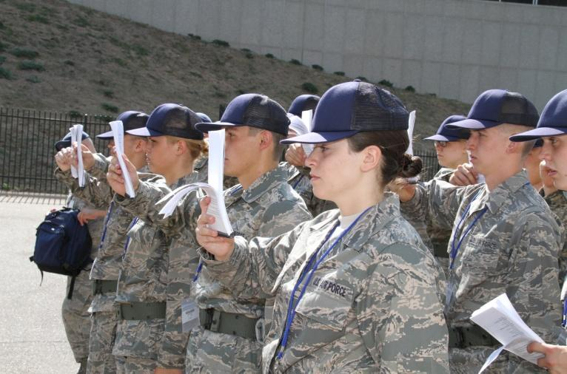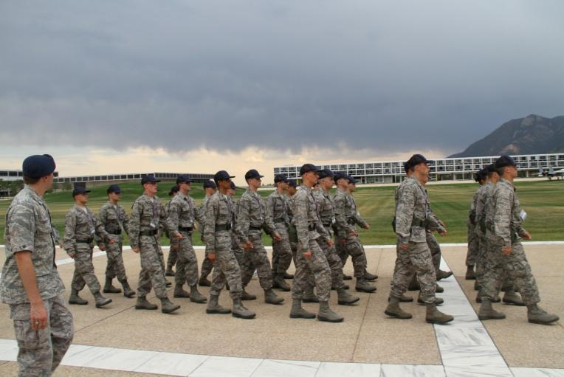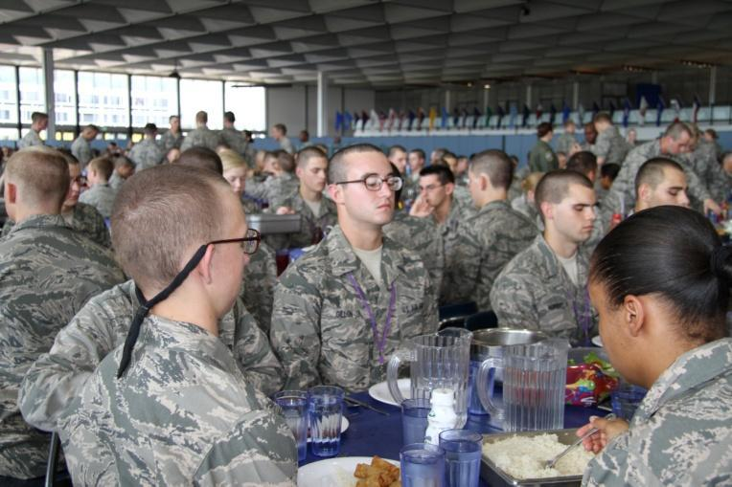

Field Day Doolie Day Out
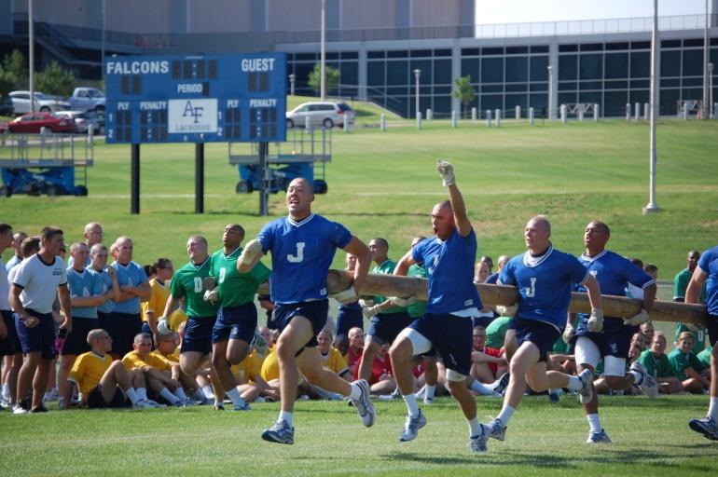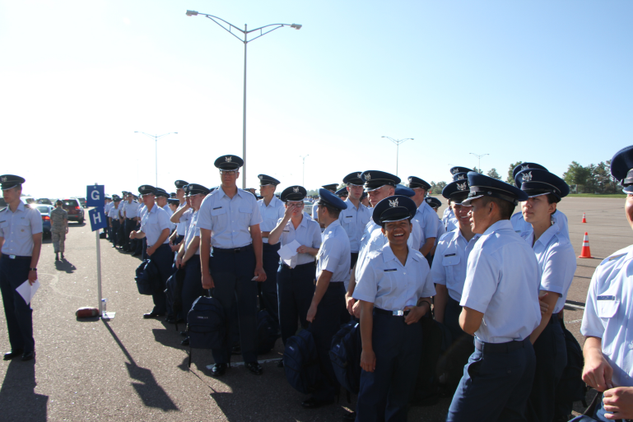

Second BCT
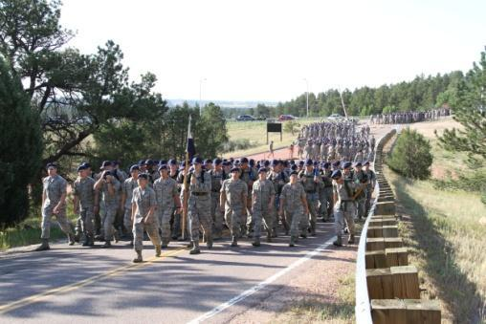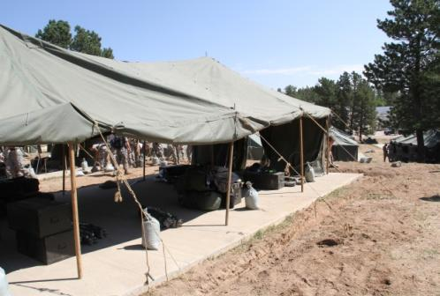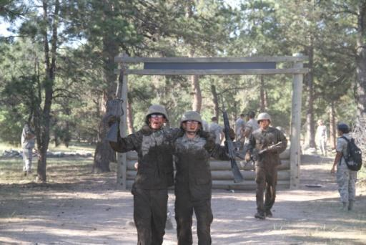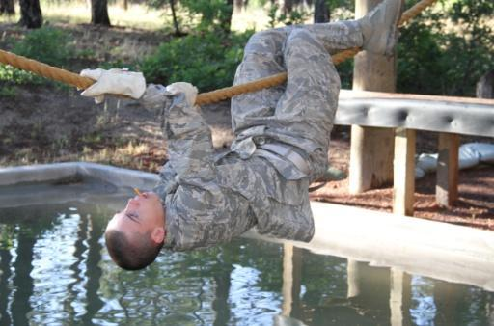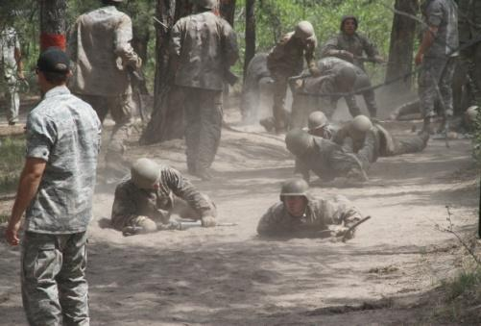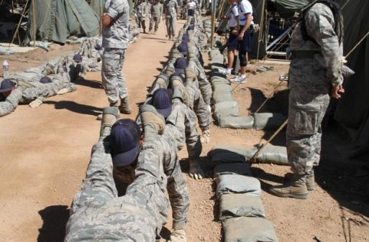Acceptance Day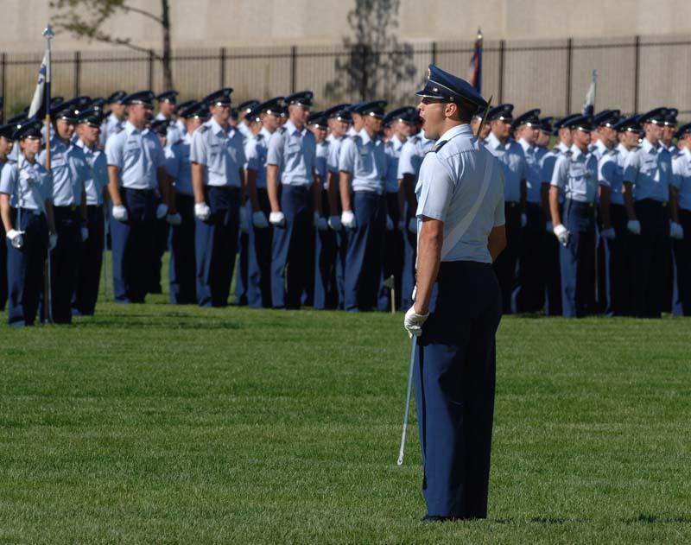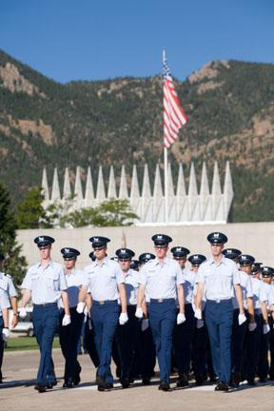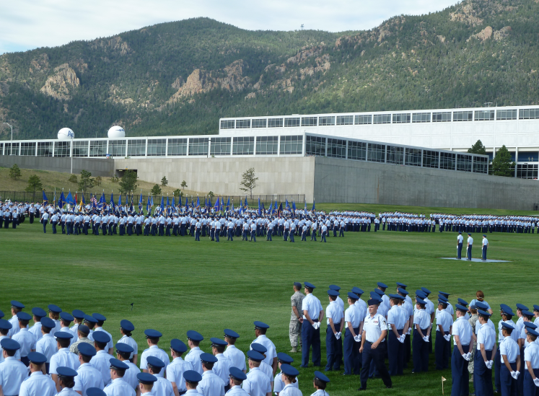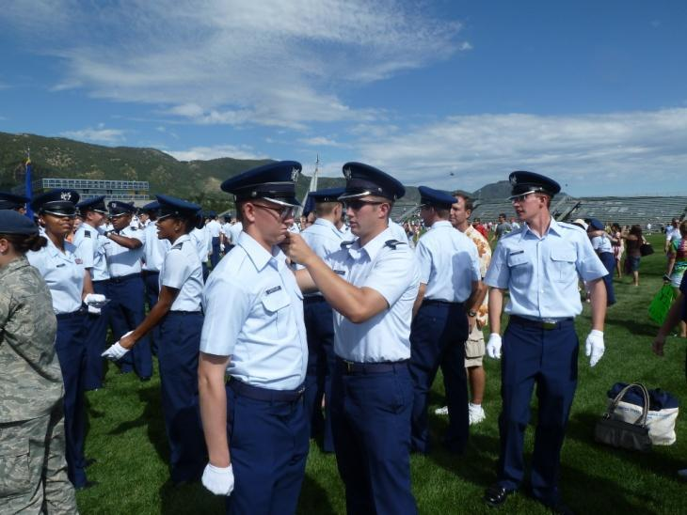

INTRODUCTION

The information contained in this notebook is intended to give you some insight into planning for this first year at the United States Air Force Academy (USAFA) based on the experiences of parents and cadets who have been there before you. The contents of this document are unofficial and meant for general informational purposes only, based on experiences from previous years.

We hope that this information supports you and your cadet as you begin a four-year adventure that is most often described as a “roller-coaster ride.” When talking to friends whose children attend civilian colleges and universities, you may find that you can no longer relate to their experiences. The things your son or daughter will do and go through will, in many ways, be so very different from theirs. Your separation from them may seem more permanent. The issues they bring can be unlike anything students in other college situations experience. With this in mind, we hope that you find that the Eastern MA USAFA Families Club, Inc is here for you and your cadet not only during this first year, but also for each of the next three years and beyond. Please take advantage of our collective years of experience. It can really make a difference!

This information was primarily derived from past materials issued by the USAFA, information posted on the various resources for parents and various USAFA websites for parents, and the combined experiences of our own club members.

Current members of the Eastern MA USAFA Families Club, Inc can be a resource for you as you begin this experience. Having someone to call or email with questions can help new parents weather the ups and downs of their cadet’s first year. This is especially important during Basic Cadet Training (BCT) when you can’t just pick up the phone and call your son or daughter. It is also very helpful in planning for Acceptance Day (A-Day) in August and also Parents’ Weekend (PW), an event that takes place at the Academy over Labor Day weekend when you’ll have an opportunity to see and visit your son or daughter for possibly the first time since they left for In-Processing. Having a contact to speak with and who can explain those little things no one thought to mention before your son or daughter left, can be very helpful.

General Information: Your first year cadet will be defined by a number of terms. Instead of what would traditionally be called a freshman, several terms are used to describe the incoming students. Not all are flattering. From the time that they received their appointment letter from the USAFA, until they take their “Oath of Office'' during Basic Cadet Training (BCT, also known as Beast) at what is called the “Swearing In” ceremony, they are referred to as an “Appointee.” Following the Swearing In, their rank becomes “Basic Cadet” (BC) for the duration of BCT. Following BCT, there is an event called “Acceptance Day.” It signifies the successful completion of BCT by the Class of 2025 and their acceptance into the Cadet Wing by the upperclassmen. On Acceptance Day (or “A-Day”), the Basic Cadets will receive shoulder boards from the upperclassmen. The shoulder boards, worn on the uniform epaulets, now indicate the academic year/rank of Cadet Fourth Class (C4C) or “Four Degree.” In succeeding years, they will become a Cadet Third Class (C3C) or Three Degree, then Cadet Second Class (C2C) or Two Degree, and finally, a Cadet First Class (C1C) or “Firstie.” The Appointees/Basic Cadets/C4Cs are also referred to as “Doolies.” This is a term adopted by the Academy’s first Class in 1959, when they were in BCT. Doolie is a derivative of the Greek word “doulos,” which means “subject/slave.” Many graduates and outsiders use this colloquial term, although the cadets themselves do not typically use it. Upper class cadets refer to C4Cs as 4 degrees, 4th classmen, or “SMACK” (Soldier Minus Ability, Coordination and Knowledge).

Components of BCT (Basic Cadet Training)

- In-Processing - Day one. This is when the appointee arrives at USAFA and checks in with all his/her paperwork, gets processed into the Academy, and becomes a Basic Cadet.

- Swearing-In - Day two. The Cadets take the “Oath of Allegiance to the United States” on the parade field.

- First BCT- Begins at In-Processing and encompasses the first 3 weeks of basic training. Takes place in the cadet area on campus and consists of marching, drills, knowledge memorization, and learning the ropes of becoming a cadet.

- Field Day - Fun day where all cadets engage in competitions with other squadrons- tug of war, running, log races, etc.
- Jacks Valley/Second BCT - Jacks Valley is where cadets are sent during Second BCT on “Deployment” to a tent city where they learn combat skills, train on the obstacle course, confidence course, and assault course, and participate in team building exercises.

- Doolie Day Out - The sponsor families pick the cadets up around 9:30AM or so and take them back to their house for the afternoon. Only registered sponsor families with assignment letters will be permitted to enter the pick-up area. They must have their assignment letter and dash pass, to be exact. If for some reason someone makes it all the way in without these documents, the cadet will be reported and there will be serious consequences for the cadet upon return. The cadets will be briefed about being released only to the family they are assigned to for the day. Parents from out-of-state should NOT come to town in hopes of spending Doolie Day Out with their son/daughter on this day. Doolie Day Out is for sponsor families to get to know their sponsored cadets.

- Acceptance Day (A-Day) - You may want to consider attending A-Day and the cadet wing parade. On Acceptance Day, Basic Cadets who have successfully completed BCT will be awarded “boards.” Boards are worn on every cadet’s uniform and indicate their rank. Once awarded their boards, basic cadets become C4Cs, or Cadet 4th Classmen. Shoulder boards are awarded immediately following the parade and are put on by upper class cadets. Parents are allowed on the field to observe this. Since cadets must stay in the Academic area, we suggest you bring a picnic lunch because you don’t want to spend all your time in line getting fast food in Arnold Hall. Appointees will not be allowed cell phones beforehand so plan on meeting up on the parade field afterward.
Note: If parents are allowed to attend this year’s event, for planning purposes, the Acceptance Day Parade begins at 9:00 am. Your cadet is free to spend approximately 11:00 am- 1:00pm on-campus with you after the parade. Please see Appendix II Stillman Field map so you will know where to locate your cadet by his/her squadron.

PREPARING FOR IN-PROCESSING & BASIC CADET TRAINING (BCT)

Read carefully everything you receive from USAFA, and keep that information in a secure and safe place.

- As you read through the USAFA Handbook for Appointees, Highlight any item that requires an action, and place an open checkbox ☐ that you can check off as you complete the task or acquire the information that you need to complete the action item. Note that some information needs to be mailed to USAFA prior to your arrival, while other information should be hand-carried with you to In-Processing. Also note that the materials from the Academy will contain your USAFA mailing P.O. Box Number that you will use for all four years. Make copies of everything you send to USAFA, as well as the information that you hand carry. If for any reason it gets lost, it can quickly be duplicated. We suggest sending the information via “Delivery Confirmation.” That way you will know that it was received at USAFA and on what date. It is also helpful to send duplicates of all mailed paperwork with your cadet to In-Processing.

Be sure to pay very close attention to the sections in the handbook relating to physically preparing for BCT. Some will read this sentence and decide that they don’t need to worry about that, so let’s say it again with emphasis:

Be sure to pay very close attention to the sections in the handbook relating to physically preparing for BCT.

Preparation for the Academy is as much a mental task as it is a physical one. A significant part of BCT is dedicated to getting you into the physical shape necessary to meet the demands the Academy will place on you. It is NOT a place to begin to get in shape! Many Basic Cadets make the mistake of thinking, “I just finished lacrosse or track in May, so I’ll be ok when I get there at the end of June.” This is not a good assumption to make. One of the most effective ways to draw the Cadre’s (BCT Training Staff made up of upper class cadets) attention to you, is to be last in any of the elements of the physical requirements for BCT.

THE MOST IMPORTANT FACT TO REMEMBER ~ Colorado Springs is more than a mile above sea level. That means that there will be an adjustment period to the “thin” air, especially when exercising or doing physical tasks. Physical training will be light during the first few days of BCT as theCadre allow Basics to adjust to the 7000’ altitude, but keep in mind that everything is done at a hustle, under stress, and often up stairs/hills. The best way to manage this adjustment is to arrive in excellent physical shape.

If possible, it is exceptionally helpful to speak with a current cadet or recent graduate about the Academy experience and especially BCT. They have done it and can tell you what to expect. At our “Appointee Send-Off” on the morning of June 12, 2021 at Hanscom AFB in Bedford, MA, there will be cadets in attendance for you to speak with about this experience who will be home on summer break. We will send you more information on this event in the very near future.

Packing for In-Processing Day. It is wise to only take:

Clothes you wear Paper, envelopes, stamps
Required underwear Some cash / credit card
Toiletries Cell phone & charger
Necessary documents

The less you pack the better – take only what is indicated on USAFA’s packing list and remember most everything is provided once you arrive. Carry only a small duffel bag or backpack (not a suitcase). If bringing your own boots, wear (don’t carry) them.

Follow USAFA’s instructions regarding purchasing and marking underwear. Whereas debate rages about the usefulness (or not) of compression shorts, the one underwear mandate to absolutely follow is for male cadets to bring only V-neck (not crew neck) white t-shirts.

Note to Parents:
We would encourage you to do just about everything we have encouraged your cadet to do (the physical conditioning part aside). Watch the videos, read everything your cadet receives, or that you can find. Talk to current cadets and most especially, talk to the parents of current cadets or graduates. Our Parents’ Association is here to support both you and your cadet. Other informative resources we’d suggest can be found at: www.academyadmissions.com/. Also take a look at our club’s website http://www.usafaema.org . On our website, you will find other parent groups designated specifically for your cadet’s class. These can be found on our website under the Membership/Parent Support. Ask any questions you may have; all of us have been where you are, and we may be able to alleviate your concerns.

Websites that are recognized by USAFA are on this page: https://www.usafa.edu/parents
Here you will find the monthly Falcon Family newsletters in addition to the Parents’ Club websites and also the Spirit Committee websites. The Spirit Committee website is where you will learn details about “Spirit Missions” the parents organize for the cadets of your particular class. The first of which is at the end of BCT and is a postcard campaign called “Beat the Beast.”

Class Web Sites:
Additionally, some parents will start a Class site for parents of a particular Class, i.e. Facebook – USAFA Class of 2025 Parents. It’s important to note that most of these sites are not officially recognized nor are they “blessed” by USAFA. However, they do provide a resource for parents to “chat” with other parents and share information. For security purposes, your request to join such a site will be vetted by the page administrator. One that is particularly useful because it includes parents of all classes is the USAFA Parent Resource Facebook page: https://www.facebook.com/groups/229767567187985/

Some advice from upper class parents about preparing for In-Processing:

Should parents go to In-Processing with the appointee?
Many parents accompany their appointee to In-Processing. Other appointees will want to say their good-byes here at home and head west on their own. Whatever works for you and your appointee is the “right” thing to do. Do NOT feel compelled to go just because you heard that another family is accompanying their appointee. No one will think less of parents that don’t make the trip for In-Processing. So, have that conversation with your son or daughter, and make that decision together. Keep in mind that you may be making that trip for Acceptance Day and again over the Labor Day weekend for “Parents’ Weekend” because it may be your first opportunity to see your son or daughter since In-Processing and BCT. Parents’ Weekend will also provide you an opportunity to go to the Academy Open House with your son or daughter, spend a couple of days with them, and meet other cadet families. We’ll provide you with more information on this event at a later date. If it is a choice between attending In-Processing or Parents’ Weekend, we would highly recommend that Parents’ Weekend be your selection.

For parents and appointees traveling together to Colorado Springs for In-Processing.
Arrange to arrive no later than the day before appointees are to report. This will give them a chance to have a good night's rest, eat breakfast and begin to adjust to the higher altitude in Colorado Springs. Drink lots of water, and keep in mind that complete adjustment to altitude will take several weeks. On In-Processing Day, you will show up, at the specified time for your cadet, at the Cadet Field House, on the USAFA campus and get a quick briefing. Your cadet will be separated from family and friends and begin official In-Processing with their squadron. There is a small parents’ information fair right where you drop off your cadet. After that you can check out the cadet chapel, visitor’s center, or other available Academy sites – such as the Heritage Trail at Doolittle Hall. Also bring binoculars, camera, sunscreen, water and dress in layers. Cool mornings at USAFA usually give way to warm afternoons. On Friday morning (June 24) there is the Class of 2025 swearing in ceremony where you can watch the class taking their oath. Some people make signs of encouragement etc., for their cadet. We advise that you arrive early to get a good spot and for parking. The Northgate typically opens early at 7:00am.

Encourage your appointee to leave their valuables at home during BCT, or their valuables could be confiscated by the Cadre until some future date. Remember that first year cadets are almost always in uniform while in the cadet area as well as traveling to and from a sponsor’s home or when traveling home on break. This policy generally continues until an event called “Recognition” which occurs in March.

The less you have, the less you have to keep clean! Encourage your appointee to leave as much as possible at home. For the appointee: Don’t over pack for BCT because you will be issued nearly everything you need during In-Processing. Things that you may eventually want can be shipped to you when you complete BCT. Bring toiletry items and very few items of civilian clothing (you will not be wearing them for a while). In addition to what you’re wearing to travel to Colorado Springs, bring something to sleep in that first night and something to wear to In-Processing. We suggest that no matter what you bring, you should use a light-weight backpack instead of luggage. The Cadre will require you to carry your backpack in your hand (not on your back), and this will become heavy very quickly. REMEMBER – What you bring to In-Processing Day you will have with you the entire day. Day 1 will seem like a very long day with lots of lines.

- Parent’s comment: Keep in mind that there is no air conditioning in the dorms, and fans will not be allowed in some Squadrons. Also, do not be shocked to learn that your cadet chooses to sleep on top of his covers, in a chair, or on the floor in order to save time in the morning by not having to make a bed. You’ll be amazed by the ingenuity and cleverness cadets will be able to conjure up to save time.

- Parent’s comment: To travel, my cadet wore a baseball hat, shirt, long cargo pants with zippers that turned them into cargo shorts, socks and sneakers on the plane. In his backpack, he carried his toiletries, a light nylon jacket, a change of underwear and socks, shorts, another shirt, pajama bottoms and a heavy knit long sleeve T shirt. It can get cool at night and in the morning at 7,000 feet above sea level even in June. What looked like fog when we arrived, we soon learned was actually a cloud! Later when I asked if he brought enough clothes with him, he said he “over packed.”

- Parent’s comment: When you initially arrive at In-Processing, your luggage/backpack is tagged and left at a designated area for a few hours allowing the appointees to go through the first several lines. They will be told to remove the documents which USAFA designated as requirements for the cadet to bring to In-Processing from the tagged luggage/backpack and keep the documents with them (Refer to your official communications from USAFA for a complete list, but it will likely include their ID such as birth certificate, dental records, prescription meds, immunization records, etc).

On–Campus Bank: Cadets are usually required to open an account at the Armed Forces Bank upon acceptance. This is where their first paychecks will be deposited. Following BCT and once settled into an academic squadron, your cadet will determine their own needs and perhaps open a checking account (with ATM/Debit card) and savings account at other financial institutions which can easily arrange for direct deposit of their USAFA paycheck. Following BCT and before academic classes begin; cadets will have an opportunity to do these sorts of things. You may also take care of banking issues during Parents’ Weekend.

Cash: Your cadet will need very little cash when traveling to the Academy for BCT; Enough money to get something to eat at the airport while they are traveling. Once they arrive at USAFA for In-Processing, they’ll not have use for cash for some time.

Textbook purchases, Cadet Store purchases, credit cards, ATM/check card: It is advisable to make sure that your appointee has an ATM debit card & a credit card and remember to bring both to In-Processing. If your cadet is 18 or older, they will be able to apply and obtain a credit card in their own name and begin to build their own credit history. If the cadet is under 18 years of age or prefers not to have a credit card at this time, a parent can provide a credit card (from their own credit card account) in the cadet’s name to use for emergencies when they are traveling, or later when he made his own travel arrangements for holidays and breaks. You can acquire one of these by simply calling your credit card company. Your cadet will also need an ATM/Check Card in their name. The card can be used like a credit card or debit card. You may wish to have one parent as a co-owner on the checking account in case the parent wishes to easily transfer additional funds from other parent accounts into the account jointly held with their cadet. The cadet will only be able to access money in that specific jointly held account. Having a debit card allows the cadet to quickly access their funds from the on-campus ATM machines. They will need a debit or credit card to purchase their textbooks (textbooks are very expensive at USAFA – depending on the major, could be several hundred dollars). During BCT and after, cadets will also need to purchase items like room cleaning supplies, shoe polish, an iron, ironing board, deodorant, soap, etc. from the AAFES Shoppette (referred to as the C-store)which accepts these cards. Uniforms and equipment come directly out of the cadet’s payroll.

Haircuts for BCT: For men, having your hair cut before you leave will get you used to the look and may save you some time during In-Processing. For female appointees, once at USAFA, your hair will be cut to several inches above your shoulders if you cannot put it into a low bun in about 1½ minutes. You’ll need to decide if you wish to have your hair cut before leaving home or have the AF do it for you if you cannot accomplish the bun.

Combat Boots: USAFA recommends purchasing one pair of ABU boots prior to arrival. According to Cadet Issue, the ONLY requirements for the boots are listed below, and ANY model/brand of boots that meet these requirements is acceptable. The requirements are:
- Coyote in color
- 8 inches high
- a rubber sole
- a waterproof upper bootie (Gore-Tex or similar)
The boots MUST NOT HAVE STEEL OR SAFETY TOES or ZIPPERS.
Belleville models 650 (men's) and F650 (women's) and 690 (unisex); NIKE SFB Field 8"; Danner Rivot TFX 8" all meet these requirements.

If the boots don’t meet the standards or are not uniform with the other cadets, they will not be allowed to wear them. To ensure a perfect fit and to lower the risk of blisters, it is HIGHLY RECOMMENDED that you purchase 1 pair of ABU boots and wear them for 2-4 weeks prior to arrival at USAFA. Prior to arrival for BCT, USAFA suggests that your Basic run in the boots if you purchase a pair. This will make it easier for him/her when they get to Basic Training. All incoming cadets will be issued sufficient boots to ensure that they have two (2) pairs of serviceable boots for wear during BCT. Cadets should be sure during issue that they fit perfectly!

Athletic Shoes: Cadet Issue may not have an appointee’s athletic shoe size (if they have bigger size feet) immediately on hand, so therefore it would be a good idea for the appointee to wear them to In-Processing so that s/he doesn’t need to pack them in their backpack.

What NOT to wear on In-Processing Day: If you wear a T-shirt, plain T-shirts only are suggested! Do not wear an Old Navy T-shirt to In-Processing. Don’t wear an Army or Marine T-shirt either. Don’t even wear one that says Air Force Academy or Air Force. The Cadre will quickly want to know, “Are you in the Army? The Navy? The Marine Corps?” Or, “How is it that someone who has not yet even started BCT thinks they’ve earned the right to wear an Air Force Academy shirt?” Bottom line ~ these shirts tend to get noticed. Once again, Day 1 is not the day to have the Cadre notice you and remember your name. The word of the day, every day during BCT is “inconspicuous.” Basic Cadets who get the job done, and remain inconspicuous, are referred to by the Cadre as “stealth cadets.” Being a Stealth Cadet is a good thing!!

Words of Advice From Cadets Who Have Been There

Responses of upper class cadets when asked, “What would you tell an appointee to either do or bring with them to the Academy when they arrive for In-Processing and BCT?”

- Bring confidence in your abilities and a willingness to test your limits
- Please bring a sense of humor and some humility. Cynicism and “big heads” aren't graduation requirements here.
- Come in physically fit – this goes for everyone (men and women) as you will be held to the same standards
- TUCK IN YOUR SHIRT before getting off the bus at Footprints
- Bring a good attitude ~ you'll need it to get through this place
- A sense of humor and be able to laugh at yourself after making a mistake
- Bring your courage and strength - you will be challenged to the MAX
- Tell your parents to join the Parent's Club; it will really help them
- Give everything you have and then some
- Take it one day at a time and concentrate on the things that are really important
- Everyone struggles the first week; persist and it will get better
- Just do the best you can do; that's all anyone will ever expect or ask of you
- Believe in yourself, because if you don't, who will?
- Understand that it will be hard, but that in the end, it is all worth it
- Bring a lot of faith, hope, and a burning motivation to kick BCT in the $%$!
- NEVER, EVER Quit! Don’t let anyone tell you that you can't do something
- Come to the Academy with intensity and conviction
- Don’t let anyone tell you, you can’t do it
- Be prepared to come to the Academy with the intention of learning to serve in the Air Force as an officer, leader and to defend our country. If that is not why you’re here, you are in the WRONG place.
- For most of you, this will be the first time that you will be surrounded by fellow classmates and three classes of upperclassmen who are just like you – everyone here is a good student, a good athlete, a leader, competitive by nature and driven to succeed. Most of you come from high schools where you were one of only a few folks like that. This can sometimes be an issue here. What was superior performance at your high school is average here. You’ll have to learn to accept that fact.

The following is a copy of a web posting of an open letter from a cadet to incoming appointees. This is an “unofficial” document, but contains some good advice.

The opinions expressed on this page in no way reflect the views of the Department of Defense, the United States Air Force, or the Air Force Academy. (The world would be much cooler if they were! Rather, they are my own twisted, cynical beliefs.)

So you went and got yourself accepted to the Academy? Congratulations! Muhuhahaha! Welcome to the dark side. You will soon be one of us. Resistance is futile - you shall be assimilated. My advice to you at this point is living it up. You have at most three or four months of freedom left—if you were lucky enough to have gotten an early appointment. Go quit your job, spend a lot of money, and have fun because this is your last chance for about a year. I know that they tell you to get into really good physical shape before you come, but don’t go nuts. We’re sitting at 7,200 feet up here and they give you about two weeks to get acclimated to the altitude so your little hearts don’t explode. I’d say be able to do a strong 50-60 push-ups, 90 sit-ups, and be able to run a mile without keeling over—speed’s not too important. Otherwise, be a fatty and spend some quality time in front of the TV eating Twinkies. When you in-process, don’t bring anything valuable. It will all be taken away the first day and I’ve heard horror stories about bags getting lost in the shuffle. Just bring lots of undies—trust me you’ll never want to wear the issue stuff after spending Beast in them. I consider myself a master of getting away with stuff here and I promise, you aren’t going to smuggle much in here. But if you’re like me, not knowing what time it is, is torture. So when they come around the first day and confiscate your watch, slip it in a pocket and don’t hand it over. Just keep it stashed through Beast. Another thing, DON’T SHOW UP EARLY! Every year there’s one or two of these people and they just end up looking dumb and spending extra hours receiving special attention. If they say to be there no later than noon, show up at 11:59. And lastly, ladies, don’t bother cutting your hair off. No matter how short you get it, they will go over you again—it’s a psychological game. Enjoy your long hair as long as you can. See you this summer! Heh, heh…

Basic Cadet Training (The Beast)
Basic Cadet Training is a six-week program broken into two three-week periods: 1st and 2nd Beast. Mentally, 1st Beast is by far the harder of the two; everyone is going through culture shock and you haven’t yet formed the friendships that will carry you through this place. The best advice to get you through 1st Beast is perseverance—it gets better. On the first day, there is going to be one kid who gets themselves stuck all alone in the hall with three or four Cadre flaming them. You will sit in your room and think, "Thank God that’s not me!" If you want to gain some huge cool points in the eyes of the Cadre and your classmates, go out there and help that poor sucker! Go out there, stand next to that kid and do not leave him. Eventually, you will do this every time someone gets yelled at without thinking. Be brave enough to be the first one to help. Then there are a whole slew of placement tests you will take during 1st Beast. Do your best on all of them. Now we get to 2nd Beast. By now you and your classmates will almost be a team and you’ll be getting into the flow. So we ship you to Jacks Valley and change the flow. But 2nd Beast is far more exciting, and far more physically challenging. This is the stuff you see on TV: obstacle courses, firearms training, and living in tents. You won’t need my advice by this point. You’ll have a lot of USAFA figured out for yourself. Completing BCT will forge a bond between you and every other military person in the world. We all talk about Basic Training "back in my day" and argue about who had it worse. Suffering becomes a badge of honor and you’ll earn yours.

The following is a copy of a letter that a USAFA Prep school cadet anonymously posted on his web site for his soon to be AF Academy classmates prior to In-Processing and BCT. The comments are unofficial but do contain some thoughts of value for appointees.

Welcome Future Classmates!!

Please pardon the typos and spelling. (I'm not an idiot, I just hate typing) I'm currently a Preppie at USAFA’s Prep school. I have written this in order to help you, my soon to be classmates.

First of all for those of you who don't know what preppies are, we're the ones who had to spend an extra year in the military to get into USAFA, but by doing so we have learned a lot of the ins and outs of the academy. When BCT starts make sure you get to know some of us because we can all help. There should be approximately 150-200 preppies In-Processing with the rest of you. USE US!!! Every bit will help.

- There are a few things you should know so you can understand what you are getting yourselves into next year. When you show up to basic your heads will be whirling around as you're getting yelled at, and moved around like cattle. Do your best to understand that this is all for a reason.... Keep your composure and press on. Better yet, help your classmates keep their composure as well... we all need to stick together. Even on day 1, if you see another basic cadet being surrounded and hounded by the upper class Cadre, go stand at attention next to him. Support each other – never let a few people gang up on any one of us. The Cadre will respect us for that.
- Understand that you're going to make A LOT mistakes. You're going to get embarrassed and you're going to feel like an idiot at times. Just remember that everyone feels the same way. And most importantly, don't take things too PERSONAL. If you do, plan on going INSANE VERY QUICKLY. They’ll try to break you physically, and rattle you emotionally, but they can't break your will. Remember why you came, why you want to be here and NEVER GIVE UP.
- Don't pimp your classmates!!! That means don't make yourself look good at another person's expense! Don't smart off, show off, or degrade someone else! Not only will you be giving those in charge of us a reason to make you PERSONALLY more miserable than everyone else, but you will also end up INDIRECTLY punishing your element, flight, and even your squadron. Believe me; you don't want to make any more enemies than necessary. WHAT COMES AROUND WILL ALWAYS GO AROUND AT THE USAFA.
- The military is notorious for acronyms. That can be mind-boggling at first. Here’s a taste of what I call, cadet speak:
- 4 Degree or 4° ~ freshman
- 4 Smoke ~ freshman
- AOC-(Air Officer Commanding) an officer (usually a major) in the “real” AF assigned to each cadet squadron
- Ac Pro ~ Academic Probation
- Ac Pro Ranger ~ Person consistently on AC Pro
- BCG's ~ (Basic Cadet Glasses) horrible, ugly, plastic, square-rimmed glasses issued during BCT (also called Birth Control Glasses because no one is going to procreate while wearing them)
- BCT ~ Basic Cadet Training – when spoken, it’s pronounced “BEAST”
- BOHICA ~ saying that expresses displeasure at getting screwed over (Bend Over, Here It Comes Again)
- Cadet Borrow ~ term for stealing since stealing has bad connotations
- Cadre ~ upperclassmen in leadership positions
- Checkpoints ~ daily list of knowledge freshmen memorize (menus, days until graduation, etc.)
- Contrails ~ a book issued to freshmen that contains all the knowledge they memorize
- Cover ~ stupid name for a hat in the military
- CQ ~ 3° cadet in charge of quarters - sits at the squadron desk answers the phone
- CST--Combat Survival Training
- Dead Week ~ the week after finals and before graduation
- Falcon Love ~ nickname for a romantic relationship between a male and a female cadet
- Falcon Goggles ~ phenomenon in which a male cadet loses the ability to distinguish an attractive female from an unattractive one
- Firstie ~ senior
- Flame Session ~ intense training session involving lots of physical activity and yelling
- Form 10 ~ report of deficient conduct, usually assigned tours or confinements
- Form 18 ~ medical excusal form, usually excusing a cadet from duty--the USAFA Holy Grail
- Fundatory ~ having mandatory “fun”
- Gank ~ term for stealing
- GR ~ Graded Review - USAFA's version of an exam, unnecessarily early in the morning
- Hell Master ~ 3° who gives a particular 4° special attention during Recognition
- Hit ~ punishment, usually comes with a Form 10
- Honor Guard ~ USAFA rifle drill team
- Jack's Hack ~ cough cadets get after 2nd BCT in Jack's Valley from dust silting in the bottom of their lungs
- Jodie~ songs sung while marching in formation to keep step
- K-Bowl ~ Knowledge Bowl - events in which 4' (freshmen) compete in grasp of military knowledge
- Minutes ~ duty in which freshmen call how many minutes are left until an event acting as alarm clocks for upperclassmen
- Mitch's ~ nickname for the dining hall, Mitchell Hall
- Nuking ~ event where the freshmen in a squad take an upperclassman outside and douse them in chocolate syrup, rotten milk, ketchup, or whatever other condiments they can gank from Mitch's
- Pimping ~ making yourself look good at a classmate's expense
- Prop & Wings ~ uniform emblem upperclassmen wear that freshmen are awarded at the completion of Recognition
- Rack Time ~ sleep/nap time
- Ram Jam ~ getting "volunteered" for unpleasant tasks
- SMACK ~ nickname for a freshman an acronym that stands for Soldier Minus Aptitude Character and Knowledge
- Spirit Cheese ~ sliced cheese thrown like a frisbee during football games
- Spirit Mission ~ outrageous pranks to boost morale
- Stellar ~ outstanding
- Stract ~ an adjective to describe a very military person
- Terrazzo ~ large flat concrete and marble area in the cadet area
- Tool ~ a very strict person, a derogatory name
- Voluntold ~ “Volunteering” to do something for an upperclassman

Useful tips about In-Processing and BCT:

- Don't lock your knees when standing at attention or you'll pass out.
- Ladies, don't bother getting a haircut before you come because they'll massacre it anyway (unless you put it into a bun in 1 ½ minutes).
- Bring as few valuables as possible. Mom and dad can send them to you later. However, if you just have to bring that one picture of Suzy or Johnny, wrap it up with something soft so you don't break it when they throw your stuff around.
- Bring 100% real cotton balls instead of synthetic ones. They're used to polish your boots...synthetic cotton balls scratch the leather.
- Learn how to starch, iron and make creases in your clothes before you get here. It's pretty pathetic for those who don't know how.
- When they tell you to hydrate, HYDRATE!! Don't make yourself sick by drinking too much too fast. Take advantage of every bathroom break.
- 2 in 1 shampoo/conditioner is great for those 30 second showers in the cold.
- Portable, electric razors are great especially out at Jack’s Valley. Be sure to get a good one with a long charge like a Norelco.
- Plan on showering with lots of other people. You'll get used to it and it won't matter after a while.
- Learn how to break in and your shine boots BEFORE you get here.
- I suggest you pray a lot if you're religious. Go to chapel whenever it’s allowed (even if you’re not religious). It’s a safe place to get away from everything for a little while – the Cadre can’t tell you, you can’t go and they can’t harass you there. All of the chaplains are great people.
- Go with the flow, do what you're told, don't try to stick out
- Get in kick a_ _ shape BEFORE you arrive. You don’t want to arrive here out of shape. 50 pushups 90 sit-ups, 10 chin-ups, and a lot of leg lifts are a start.
- The less stuff you bring with you the better.
- Keep the faith and be prepared to be pushed beyond every comfort level there could possibly be
- Get close with your classmates. It does MIRACLES. We’re going to depend on each other this whole first year.
- The first week of basic will not be as physical as most people think. It’s because they are trying to get you acclimated to the 7,000 ft. altitude. Don’t be fooled though, the rest of BCT will be very different
- Preppies and prior enlistees - when you first arrive, please don't act like a know-it-all! It’s safer to play dumb until they figure out who you are so they don't harass you as much.
- Preppies, it might behoove you to start learning some Jodies since you'll probably be an element leader.

Some dos and some don’ts:

- Do not be an idiot and show up early to In-Processing!!! Arrive at your appointed time. If you're early-- your day will feel extra long!!! If you're late--the Cadre will hate you for having to make them wait and plan on getting some EXTRA SPECIAL ATTENTION FROM THEM--trust me you won't want special attention.
- For In-Processing - do NOT wear a T-shirt that says, “Train This!!” One year, an appointee showed up with a t-shirt that had the Superman symbol on the chest! Doing this ensures that you will personally meet the entire Cadre on your very first day at USAFA. From that point on, every Cadre member will know your name – that is not a good thing! Trust me on this.
- On the ride over to the Cadet Area from the AOG building where In-Processing began, there will be at least one or more sharply dressed Cadre members on the bus just waiting to start making your life miserable. As soon as the bus is out of view of the crying parents waving good- bye, BCT BEGINS!! These Cadre members will yell at you to: “Stop Talking!” “Stop Smiling!” “Look Straight Ahead!” “Sit Up Straight!” “Sit on the Front Third of the Seat!” “Palms on your thighs,” “Don’t Move!” “Mommy and Daddy aren’t here anymore to help you!” “You’re girlfriends and you’re boyfriends have already moved on and found new boyfriends and new girlfriends!” You get the picture. DON’T BE ALARMED!!!! You absolutely will be, but you shouldn’t be. Even though you know it’s coming, it will still be a shock! This is just a heads up – be ready for it. You need to be serious on the bus.
- When they issue you all of your clothing and it’s time for you all to start standardizing your rooms, leave one of each item out for show, and put the rest of your clothes in your laundry bags – it’s a hell of a lot easier, and you'll do better on your inspections.
- Don't leave water in your iron when you're not using it or it will rust the bottom.
- Stash candy in your bags somewhere where the upperclassmen won't find it so you can have it later! You'll be glad you did. Hint: Ceiling tiles are removable.
- I’d recommend that you not bring a lot of cash with you. You just won’t need it. $50 or $60 bucks is more than enough.
- Purchase and bring your own boots! Start breaking them in now!! You can count on having blisters during basic. You won't have as many if you start breaking in your boots now.
- Choose what you're going to wear to In-Processing day very carefully. Be sure it’s something comfortable since you'll be running around in those clothes and on your feet all day - 8 hours of standing and hustling around according to the yellow handbook. Bringing your stuff in a decent sized backpack. It will allow you to have both hands free and one less bag to carry that first day as you In-Process and collect everything you’ll need for the first year at USAFA.
- For those of you who have not managed to look in their instructions in the Appointees booklet, it was advised that you bring cleats with you for the outdoor intramural sports you will play during the school year. They also recommended that you have someone time you to see if you can swim 500 feet in five minutes so you know which swimming class you belong in.
- Join a club if you’re not on an intercollegiate team, or play on a club sport team. Something that will keep you away from the upperclassmen!!!!! (SOMETHING WHERE YOU GET TO TRAVEL IS ESPECIALLY NICE)!! Also, during your free periods hang out in the library, or in an empty classroom!! You can't be “trained” in the library!!! Same goes for religious services.
- If your Cadre has a hard time remembering your name by the end of basic, give yourself a pat on the back for a job well done. They can't harass you as much if they forget who you are all the time.
- Please bag the bad attitude and the “I’m so cool” or, “I’m cooler than you attitude” before you come. Once your head is shaved and you’re wearing the same thing as everyone else, no one really cares or knows who was, is, or will be cool and who won’t be. We all have to get past the Beast. Beast isn't meant to be a hoot. It’s going to suck at times. You can reduce the suck-factor a lot if you come with a positive attitude...it's your ATTITUDE that will make or break you at USAFA. People with attitudes end up being lonely cadets and you can’t survive this place alone – you will really need your friends. WHENEVER you get the chance, help out your classmates with whatever you can!! Somewhere along the way I can guarantee the favor will be returned!!
- One last thing, please don't be afraid to ask to use the bathroom because you're afraid your Cadre will yell at you when you really need to go. You will be drinking a lot of water and will need to pee a lot. They're going to yell at you anyway so you might as well get used to it AND be comfortable.

- The End. See you at In-Processing. Good luck to all of us!!!!!

KEEPING IN TOUCH WITH YOUR CADET DURING BCT
One of the more difficult things about sending a son or daughter off to USAFA for BCT is the lack of communication. During BCT, basic cadets do not have access to a telephone, cell phone, or email. You will most likely receive your first call at the completion of first BCT and a second call after BCT is completed. BCT has two components: the first takes place in the cadet area and the second out at Jacks Valley. This lack of access to phones and emails is purposeful. USAFA is looking to sever that “cord” to home, and have the basic cadets relying on their classmates for support and encouragement. Team building is a very big part of BCT, life at USAFA, and life in the AF. Mail is the only way to communicate with your cadet. Depending on your son or daughter’s propensity for writing and determination to find time to write, you may receive some letters during BCT. In other words, you will probably experience a case of communication withdrawal. FYI: There is not a whole lot of time for cadets to sit and write a long letter during BCT, so should you receive one and it’s brief, it’s not because s/he didn’t want to write, is not doing well, or doesn’t love you anymore. They just don’t have that kind of time. However, that doesn’t mean that you should stop writing!! Cards and letters give a basic cadet something to look forward to during mail call. Notes from home are always welcome.
Three important things to remember:
- There is a time lag in the USAFA mailroom. The workers are overwhelmed sorting mail, so it may take a week or longer for your basic to get your letter.
- Basics will not visit the mailroom to receive their mail every day. Every other day is more likely.
- Make sure you address your letter correctly-see page 24.

- Parent’s comment: I tried to send something most every day-anything so he’d have something to read whenever he got to go to the mailroom.

- Note: It’s probably good to remind the folks that will write to your son or daughter that letters should be in plain envelopes. Avoid the highly decorated, colorful envelopes with SWAK, etc. all over them or perfume-scented letters. As your cadet will learn during BCT, being inconspicuous can make surviving BCT a little easier. Some basic cadets however, see this as a small price to pay for getting a lot of mail. Just depends on the person.

Some steps you might take to facilitate your son or daughter getting mail during BCT. Here are some suggestions from cadet parents:

- We arranged to have post cards available for graduation parties that were pre-printed with the cadet’s academy address on 8 1/2 x 11" sheets which when divided into quarters, is the perfect size for postcards. Kinko's also cut the sheets into quarters, and we added postcard stamps. That way, lots of friends had his address and wrote early on during Beast as well as during first semester which really helped keep spirits up.

- We printed labels with our son's address at USAFA & handed those out at his graduation party.

- I think it’s very important for the parents to let friends and family know the cadet’s new address. Keeping the mail coming during BCT is one of the most important things that we can do to keep their spirits up. It's important for all of the parents clubs to continue to help ease the transition from civilian to military life for our new classes every year.

- Our idea was similar to the postcard idea with a slight modification. We handed out cards with our son's address, but each had a date on it, one for each day of the summer he entered. Friends were asked to choose a date and on that day mail something (card, note, cartoon etc.). The idea was he would receive something every day. It didn't quite work out, mostly because there were days they may not have been allowed to pick up mail, but I think he did get lots of mail that first summer.

- Do not be alarmed if you receive what is called “the ugly letter.” Most cadets go through a period of disenchantment. BCT is hard. Remember we have all been there and by the time you receive this letter, your cadet will have moved on to the next great thing.

- Before our son left for BCT, we created a Facebook group to keep family and friends up to date on his progress and to remind them to send him letters.
- Make sure you SAVE all your son or daughter’s hand-written mail. Some will write often, some infrequently. It doesn’t mean some parents are loved more or some loved less. It simply means that cadets in BCT make the best use of their time as THEY see fit. One cadet said, “if it was a choice between having time to sit down to write letters or being able to catch up on some much needed rest, I opted for the nap!” This will likely be the only time in their lives that they will need to communicate by handwritten notes, and these old-fashioned letters are often amazing for their insights and funny stories! You may discover a new young man or woman you didn’t realize you had!

- Instead of having a high school graduation party for our son, we waited and had a "going away party" instead. We had it the weekend before he left for BCT. This way, he could go to all his friends' graduation parties and then they could come to his "going away" party. We also included the pre-addressed postcards and gave them to everyone at his party. Our son loved the postcards! One day he received 11 of them! He probably received 50-75 postcards from friends during BCT. Every one of them really boosted his spirits during BCT. You can also give a postcard to coaches, relatives, etc.- anyone who might want your cadet's address.
- You can start sending mail before they leave home. Remember that your son or daughter’s mailbox number is sent to them with their In-Processing information. Those first few days with nothing in the mailbox are hard. They think everyone has forgotten about them. They need mail from day one. If you have nothing to say, then send a silly card.
- We printed self-adhesive labels and gave a sheet of 30 labels to anyone and everyone, family and friends. We then used these same labels with our address, and prepared self-addressed stamped postcards for Kevin to use to write us. We sent him a roll of stamps along with envelopes with writing paper inside for him to use when writing to others. We put his return address on the envelopes as well. Remember that during BCT you will address the mailing label using “Basic Cadet John Doe” but after Acceptance Day, the mailing label should read “C4C John Doe”.

- Our cadet preferred envelopes and paper to postcards. He even wrote and asked that I send him more envelopes and sheets of paper that could easily be folded into the envelopes. What he told me was that since the Cadre handle all mail-incoming as well as outgoing, they read the postcards and can use what is said. So, he preferred to scratch out a quick note on paper and stuff that into a sealed envelope instead.

A few important reminders regarding your mail to them:

- During BCT all correspondence with your cadet should be in plain white envelopes. Also, do not include newspaper clippings, photos, or any other personal items which may be considered “contraband” by the Cadre. Again, it bears repeating – DO NOT include pictures (either loose or cut-and-pasted into a letter). The Cadre will take away the pictures.

- Do not send food in envelopes during BCT. The Cadre considers all food, candy, and drink items to be “contraband.” It will be confiscated and there will be consequences to your cadet.
- Remember, DO NOT SEND PACKAGES during BCT! Only send packages after Acceptance Day.

ADDRESS FORMAT FOR MAIL & PACKAGES

Mail & Packages Sent Via US Postal Service (USPS)

After BCT, your cadet can receive care packages from home. Be creative and send them often during this first year at USAFA. (See Care Package Info Section.) Given the distance, the USPS Priority Mail boxes are the most cost-effective way to send packages.

Packages sent by priority mail through the US Post Office arrive at USAFA in about 2-4 days. Keep in mind there may still be delays in the mail room for processing these packages once they arrive and getting them to your cadet. Consider this delay if thinking about sending perishable items. The US Postal address for mail and packages is:

During BCT:
Basic Cadet Joseph Smith
P. O. Box xxxx
USAFA, CO 80841-xxxx (same as P.O. Box #)

After BCT: *
C4C Joseph Smith
P. O. Box xxxx
USAFA, CO 80841

*(after BCT and Acceptance Day, your cadet is no longer known as a Basic Cadet and their address should read C4C Joseph Smith)

Packages Sent Via UPS, FedEx, DHL, etc.

Packages sent via UPS, FEDEX, etc. have a different address (since these services require a street address and not just a PO Box address).

C4C plus your cadet’s name (no nicknames please!)
2360 Vandenberg Drive, XXXX (Cadet's PO Box #)
USAFA, CO 80841

REMEMBER to account for significant package delay in the USAFA mailroom.

A Few More Thoughts About Mail From Parents

- There’s an old USAFA expression: "There should never be cobwebs in your cadet's mailbox." This is especially true during BCT. Cell phones, telephones, and email will come during the Academic year, but for BCT, it’s the old fashioned letter that is your primary point of contact. During BCT, mail is the only tangible contact they will have with home and it is precious to them. Pre-addressed letters and postcards for them to send back are very helpful. You can even have pre-written lines already included such as My roommate's name is ______, The food is _______, This is the worst/best day of my life (circle one) and so on. You gotta have a little fun!! See the sample letter in Appendix II.

- Food packages are discouraged during BCT. Any contraband (the Cadre considers anything edible as contraband) that is discovered will most likely be confiscated or shared with the entire squad and your Basic Cadet will likely "earn" the right to a few more push-ups.

- My family and I threw ourselves into a huge high school graduation party for our new cadet. On the table where Ryan's guests signed his book, we had some "gifts" for each of his guests to take home. One was handmade mints wrapped and tied with ribbon and another was mini diplomas rolled and tied with ribbon, inside the diploma was Ryan's address for the Academy. Before he left I purchased a lot of funny postcards and the stamps (so they were easy to drop into the mail).

- Be aware that some cadets find it discouraging to hear news about all the fun their college friends outside of USAFA are having. (During BCT, your cadet will have few privileges and will not have access to cell phone, Internet, or computer.)

- On several occasions our church has set up an organized "letter/card a day" to Ryan during BCT. When we were there for Parents Weekend, I told Ryan I would take all the cards home and put them in a scrapbook for him, and he said, "No!" He wasn't through looking at them. Actually, I think he re-read them as often as he could; they were his "link" to people and places that were significant in his life. Hope some of this is useful. I'm sure you will come up with many ideas of your own to see you and your child through this "letting go" time of life.

- In addition to stamps, envelopes, paper, etc., your cadet is usually allowed 3 pieces of memorabilia. We bought our son a 5x7 zippered notebook (like day runner) and you wouldn't believe what he "stuffed" inside: stamps, postcards, envelops, addresses and paper (in the ring binder), picture of his girl-friend, picture of mom and dad, picture of Einstein in a football uniform, a mizpah keychain from his girl-friend, the matching key to his girl-friend's letter & personal information chest, a small, inspirational book by Michael Jordan, and more! The notebook was the perfect carrier...every-thing stayed put and it fit into almost any small space.

- After A-Day, care packages from home are important to the first year cadet. Try to time a mailing so that the first package from home will arrive the first day packages are allowed at the end of BCT. If you mail it earlier, mark “Hold for A-Day” on the package. Things like drink mixes, granola bars, crackers, cookies and so forth are nice treats and can be a life saver if a cadet misses an evening meal or wants a snack but doesn't have the time or can't leave the room to go to Arnold Hall (the cadet student center). Hot water from the tap can be used to make tea or hot chocolate if the squad microwave is off limits. Coils that heat water in a cup are also a good idea if the Squadron’s rules permit their use. Your cadet will know whether or not they are allowed. They can be purchased at any kitchen specialty store. (See Care Package Info section.)

TELEPHONE CALLS DURING BCT

Cadets in BCT will not have access to their cell phones or other telephones. The first opportunity to call you is typically halfway through BCT. First BCT lasts about three weeks. This is all part of the process of “assisting” basic cadets to cut the cords that bind them to home and to become more dependent on themselves and their classmates.

- Be sure to let your cadet know how to get in touch with you that day, either by writing or by prior arrangements before they leave for the Academy. Having them call your cell phone will allow you to carry on with your normal day, or call forward your home telephone number to your cell phone number should you go out. You don’t want them to hear on their first call home in three weeks, “We’re not home right now, so please leave a message……” Plan to do something to keep busy that day while waiting. The call will come. Be prepared for some emotion, both yours and your cadet's.

- Don’t be surprised if your cadet is hoarse, as s/he has been doing a lot of yelling!

- Be a good listener – don’t start your call by giving them all the news from home and asking questions. Let them direct the conversation and let them ask the questions. They are going to want to tell you about what has been happening in their life for the past 3 weeks.

BCT unofficially ends with the March Back from Jacks Valley and officially ends with the Acceptance Day Parade. You may choose to fly out for Acceptance Day, if you can, as this is an important and emotional milestone.

Family Emergencies: Feel free to contact your cadet’s AOC or AMT in case of family emergencies. You can also contact Rose Marie (Marie) Nikovits, USAFA Parents’ Liaison, (719) 333-3828 or Toll Free 877-268-3383, e-mail: usafa.parentliaison@usafa.edu , if you need AOC/AMT phone numbers or need her to contact them for you. The commanders really do try and work out emergencies as quickly as possible.
If, on the very rare occasion, you do receive an unexpected call from your cadet during BCT, stay calm. They probably had a very bad day and may be seriously considering quitting. There is nothing you can do but listen and try to support them. Remind them of the reasons they wanted to go to USAFA and encourage them to give it more time. If troubles continue, let them know that it is their decision and that you will support them no matter what they decide. They need to figure it out for themselves, and there is no reason for you to call USAFA. Instead please call any member as we are here to support each other.

After basic training, more phone calls and access to their cell phones are likely. Having cell phones is considered a “privilege” by the upperclassmen. Privileges may be withdrawn (or earned) based on room inspections, knowledge tests, etc. and are often squadron-specific.

WEBGUY
KEEPING TRACK OF WHAT IS HAPPENING DURING BCT

Want to be able to “see” what your son or daughter is doing during BCT on a daily basis? Then you need to know about the Association of Graduates (AOG) “WebGuy!”
Unlike other colleges, you won't get to move your cadet into their room, or meet his/her roommates, or even talk to them for three weeks after they get on the bus at Doolittle Hall at In-Processing. So, here’s the best way to at least see and hear what’s happening during BCT. WebGuy!! Next to actually being at USAFA to observe BCT, via WebGuy you can have something that’s very close to that experience – pictures and videos! All you need is a PC/Laptop, internet access, and an AOG membership. It is the very best way to keep track of what is happening every day during BCT. WebGuy was started several years ago by Association of Graduates VP, Marty Marcolongo, Class of '88 and his staff of photographers and videographers. The Association of Graduates provides each incoming class with a webpage, and WebGuy uses it to give you an opportunity to observe BCT via thousands of pictures and videos featuring the cadets and the Cadre. WebGuy will provide you with daily schedules, descriptions of things that only an insider can provide, as well as explanations of all the activities taking place. WebGuy does this via an engaging and entertaining blog. It’s almost like being in Colorado Springs at the Academy watching all the BCT activities. Our Association highly recommends participation. In order to get access to WebGuy, you will also need to be an affiliate AOG member.
You can access the WebGuy’s site and join the AOG at http://www.usafawebguy.com/. The AOG dues will be collected monthly by credit card. This year, the Family Plan is $36/month and is not dependent on your son or daughter joining the AOG. The AOG Homepage is http://www.usafa.org/ . We suggest spending some time at this site. WebGuy also has a Facebook page https://www.facebook.com/USAFA.AOG.WebGuy

Why does the AOG do this and why do you have to pay for this access?
Some background: The Association of Graduates (AOG) is the official alumni organization for USAFA graduates. The AOG allows cadets to join the association while a cadet and will offer them pricing discounts on membership if they opt to participate while they are a cadet. Participation for a cadet is something that your son or daughter will receive information about from the AOG during their time at USAFA after BCT is completed. Participation is optional, however, we would estimate that the percentage of cadets who opt to join while a cadet is probably about 95%. In addition to the usual services an alumni association provides for its graduates such as fundraising for capital projects at USAFA, job placement services, and career counseling for their members, the AOG fundraises to support the athletic department, underwrites the cost of the USAFA Cadet Clubs, and offers this most unique product – the WebGuy.
Like most alumni associations, the AOG is constantly looking for new revenue streams to support all the activities listed above. The WebGuy photo service is a product they sell as an enticement to membership. Most parents feel that being able to see so much of the BCT experience was incredibly valuable and very reassuring to them. Prior to launching the WebGuy program, parents only had access to limited pictures that USAFA provided. WebGuy downloads thousands of pictures daily, and you are able to see what the Basics are doing that particular day. You will find that most of your summer is spent looking for your Basic in photos; it is a snapshot into their day and you will cherish it. A word of caution- if for some reason you see a photo of your Basic looking distressed, don’t worry as that was just a millisecond of their day. Also, there will be days when you do not see your cadet in any of the photos. This is rare but normal, as WebGuy does the best they can to get every one of the over 1,000 cadets every day. A membership in the AOG will also provide you with access to a lot of other information about USAFA, the AF, and the life that your sons and daughters are embarking upon in the AF.
The following page presents information taken from the AOG’s website and explains the benefits as an AOG Family Plan member.

AOG USAFA WEBGUY FAMILY PLAN
$36/month
Membership highlights include:
◦Full WebGuy access to photos, videos, blog including:
-Six weeks of BCT coverage
-Acceptance Parade
-Recognition
-Exemplar Dinner and Ceremony
-Commitment Dinner and Ceremony
-Ring Dining Out and Ceremony
-100’s Night
-Graduation Week
◦Eligible for exclusive "WebGuy Giveaways"
◦15% Discount online or in-store at AOG Gift Shop
◦Personalized Membership card for you and your Cadet
◦Flash Sales up to 50% off merchandise 4 times a year
◦Checkpoints, alumni association magazine (quarterly)
◦ZoomiEnews, E-newsletter showcasing Academy happenings (bi-weekly)
◦7258', E-newsletter showcasing AOG happenings (bi-weekly)
◦Unlimited WebGuy access with no fee
◦Electronic Life Membership for Parent/Guardian
◦Invaluable Networking Opportunities
◦Continuous Connection with your Academy
◦Discounted Doolittle Hall Rental for events such as parties and weddings

For more information or to join, go to
www.usafawebguy.com/membership

Places to get even more photos

Free Photo access for parents:
The U.S. Air Force Academy Public Affairs office provides command information to the installation and the public. One of the ways they do this is through social media venues such as Facebook, Twitter, Instagram and YouTube. All information provided is official, but there is also fun stuff on there too. You can download photos from the USAFA Facebook page for free: www.facebook.com/USAFA.Official
Twitter: @AF Academy
Instagram: AF Academy
Flickr: AF Academy

You can also upload your USAFA photos to Instagram using #YourAcademy. If you have any questions, please call the Public Affairs office at 719-333-7731. This service is free however it does not have nearly the volume of pictures that WebGuy produces.

There are also free pictures on the USAFA webpage of cadet photos at https://www.flickr.com/photos/af_academy/albums/.

WHAT’S HAPPENING DURING YOUR CADET’S FIRST YEAR

Your cadet is going to be a very busy person at the start of the academic year. Contact will probably be sporadic at best. This is especially true during the first semester. Be prepared to get very brief messages. In addition to trying to write to you, your cadet is memorizing information from their Contrails book, shining shoes, making beds, ironing clothes, cleaning their room, doing homework, and worrying about what happens when an upperclassman knocks on the door. This is the reality that your cadet will be living. In time, they will learn to manage all these responsibilities and to do it well. However in August and September they are very busy learning the ins and outs of life at a military academy. Bottom line: They just don’t have much free time. That doesn’t mean that they won’t be anxious to read and receive your emails and letters. Keep them short, upbeat, encouraging, and ask questions that require short answers. Believe them when they tell you they don’t have time to write long emails. Someone once posted an email they sent to their cadet. In it they asked, “Hi, how are you? Do you have an inspection Saturday? Will you be able to get some time off-base after the inspection? Will you be able to call us on Sunday?” The cadet responded with the following: “Fine. Yes. No. Yes. Bye.” You get the picture.

Unlike most of his/her friends who attend civilian colleges and universities, Academy cadets will not be allowed home before Thanksgiving (except in emergencies). Your C4C’s day will be very structured, filled from the time they get up in the morning until they go to bed at night with military training, academics, athletics, and squadron responsibilities. Even Saturdays and Sundays can be very busy. Also, as is common in any military organization, your cadet will receive information only on a "need to know" basis and may be hesitant to ask questions, especially of upperclassmen. For these reasons, your cadet may often lack the time or the ability to answer all of your questions. That’s where you will find the mentor families to be very helpful. They will either know the answer or can ask their upper class cadet that question for you. That’s what we are about – helping each other.

Some things to keep in mind when speaking or writing with your cadet:

- ALWAYS BE POSITIVE AND SUPPORTIVE. Emotions often run high, especially during the first year
- Remind them why they are there
- Encourage them to focus on short-term goals like successfully getting through this week or this month, instead of worrying about graduation and what plane they’ll get to fly in the AF
- Tell them how proud you are of them and that you have every confidence that they can do what is required although at times it will be very difficult
- Encourage them to tell you about their successes, no matter how small...it helps to remind them that there are positives to this experience
- Remind them that they were selected because the USAFA knew that they had what it takes to succeed
- Use a book of inspirational quotes or jokes to give you something different to include in each letter
- Try not to sign off letters, emails, or phone calls with “I really miss you,” try instead, “I can’t wait to see you in four weeks.” Focus on the positive, not on the negative.
- Try to keep your emotions under control as much as is possible. Don't dote on how much you miss them, how quiet the house is without them, how less hectic your days are, etc. Many days for your cadet will be hard. Sometimes s/he may be down, other days s/he may be angry over some perceived injustice, and still other days s/he may be disappointed over a grade, a skill test, a failed room inspection, etc. It’s part of the life of a cadet.
- Some cadets get very homesick initially. Many times they will be tired and feel stressed out. Your cadet probably won’t have the emotional energy to deal with reassuring you as well as him- or herself.
- On a Friday, you’ll get an email that clearly indicates that they are down about something – they’re not sure if they like it here, it’s very hard, I don’t think I can do this, etc., etc. As the parent, you don’t get any sleep for two nights worrying about what’s going on, then they call on Sunday and you, in your calmest of voices ask, “So, how are things going?” and they respond with an enthusiastic “Great!” And either there’s no follow-up to the email of Friday or, you get a response that, “Friday was a real tough day, but that was no big deal.” After two days they’ve already forgotten about it. You need to do the same. You’ll be concerned, but you can’t dwell on it. These are now their issues to resolve. Your job is to reassure and encourage them that they can resolve them. You will continue to hear the phrase that attending USAFA is a roller coaster ride. It is - for your cadet and for you. The best advice for both you and them is, “NEVER LET THE HIGHS GET YOU TOO HIGH, OR THE LOWS GET YOU DOWN TOO LOW.” You need to find the range between the two where you can be comfortable.
- This is very new territory for many cadets. In high school, most every cadet experienced a lot of success and probably few failures. In most cases they were probably the best and brightest students and best athletes in their school. At USAFA, they will be in for a big surprise. Everyone there is just like them!! Smart, athletic, and all overachievers. This takes an adjustment. Also, many clubs and activities can be very selective so don’t be surprised if your cadet decides to join the “Mountaineering Club” or the Scholars Program, for example, but is not chosen.
- It’s very possible that your cadet won’t initially experience the same level of success they had in high school, and some may experience failure for the first time. That’s not the end of the world. It’s something they will need to understand and work around. They are now competing with the best of the best. Every cadet is smart–that’s how come he or she is sitting next to your very bright and athletic cadet! This is a whole new experience for people who are used to being head and shoulders above their peers relative to intelligence and athletic skill. How they deal with this adversity and what they put into it and get out of it are what will really define them as a cadet. That is one of the big lessons that the first year at USAFA teaches.
- If your cadet has a steady boyfriend or girlfriend, have a talk with the significant other about emotional calls and letters. A cadet really doesn't need to deal with letters “wet with tears" and sobbing phone calls from the loves of their lives. Boyfriends and girlfriends, too, need to be supportive and positive. Try to stay in touch with that significant other.

Preparing For Email after BCT

Email can provide a vital link to you and your cadet that first year...especially the first semester. When BCT is over and your cadet is issued a laptop computer, you can begin sending email to her/him.

Use the following format to structure your cadet’s email address:

C25joseph.smith@usafa.edu

The prefix indicates that Joseph Smith is a Cadet in the class of 2025.

However, some cadets prefer to receive family/personal emails on another email account that they may already have. This way, they only receive important Air Force emails on their AF account thus not cluttering it with other emails.

One more thing:
Each fall, parents receive a call from the USAFA Endowment and are asked to become donors to the Air Force Academy Fund. This is a fund that supports everything your cadet does. Please thoughtfully consider contributing to this fund and remember, your cadet is obtaining a college education at no cost to you. Last year, the Endowment raised more than $2.9 million for the Air Force Academy Fund.

TRAVEL TO AND FROM USAFA AFTER BCT

For many parents and cadets, having to arrange for air travel will be a new experience. They can travel at Thanksgiving, the Winter Holidays, Spring Break, and home each summer for about 3 weeks. Travel from our area to Denver/Colorado Springs can range from $250 to $650 dollars for a round trip ticket depending on the time of the year or just luck in finding a fare.

- Types of fares: When purchasing tickets, know that there are various levels of fares. The most common fare that is purchased is called a “restricted fare.” It is the cheapest airfare, however, with a restricted fare, you are not eligible to receive a cash refund if you cancel the reservation and changes to an existing itinerary will usually incur a penalty of $100 to $150 as well as any cost difference in the fare. An unrestricted airfare will allow you the flexibility to make those changes without penalty however; you pay a very high premium for this ability. Better to plan well, and purchase a cheaper fare. You should also know that there are sometimes “military rate” airfares as well. Generally, you have to call the airline directly for these fares. With this ticket, a military person may alter their reservation without a penalty; however, these fares can be higher than the restricted fare and the airlines limit the number of these fares on every flight. Bottom line. See what works best for you and plan accurately.

- When purchasing your cadet’s ticket, remember that departure and return dates/times are strict. Typically, they may not leave the Academy before their Last Military Duty (LMD) – e.g., their last class.

- Also, if you purchase your cadet’s ticket, use their Department of Defense (DOD) number in the “known traveler” section. This will make them eligible for TSA Pre-Check and expedite them through the airport security lines.

- Travel Suggestions: Register your cadet and any family members who will regularly fly to and from Denver/Colorado Springs in the Frequent Flyer program with the airline(s) that you will use. It doesn’t cost anything and you want to accrue those miles. Traveling to and from the East Coast at Thanksgiving, Winter Holidays, Spring Break, and Summer Break, the miles add up fast. If you intend to travel with family members at least once a year for PW over the course of four years you may accumulate enough miles to receive some cost reductions or reasonably priced upgrades. (Remember that miles can only be assigned to the holder of the ticket. That is why you will need Frequent Flyer memberships for each family member who travels. Even though you may charge 3 round trip tickets to Colorado Springs on one credit card, the miles are assigned to each traveler individually, not collectively to the purchaser of the tickets.)

- Unless instructed otherwise, Fourth Class Cadets are required to travel in uniform until Recognition in March. Although they will complain about this, there is an upside. Many airports (such as Denver) have USO facilities with food, drinks, TV, video games, and sleeping areas which are free of charge to military personnel including cadets. If the airline needs to upgrade people from economy to First Class as frequently happens during major vacations periods when students from across the country are traveling, the cadet in uniform is far more likely to get that bump up ahead of the student in civilian clothes. The airlines know what they’re getting when they see a cadet and know that they will be just fine in First Class. Said a parent, “When we arrived at the airport at the end of winter break, my son had the requisite amount of luggage and also had his skis. We were quite ready to pay the extra $45 charge the airline quoted us over the phone for transporting the additional luggage, his skis. At the check-in counter, the ticket agent looked at the three pieces of luggage, looked at my son in his uniform and said, “Are you going to Denver and then down to the Air Force Academy?” “Yes, sir.” The agent then said, “You can put that cash away, son, we’re not going to charge someone in uniform for an extra piece of luggage.” Also, in some airports (such as Providence and Denver) there are separate security lines for Military Personnel saving the cadets quite a lot of time. At another airport, two C4Cs in uniform were in line about to pay for their food at a fast food restaurant, when a commercial airline pilot startled them both when he walked up to the cadet closest to the cash register, handed him a $20 and as he walked away said, “It’s on me fellas, Class of ‘84. Have a great break.” So, remind your C4C cadet that there is an upside to being in US military uniform.

- Academy Information, Tickets and Travel (ITT): You can also contact the Academy ITT located at USAFA. These folks do a wonderful job for the cadets and cadet families. You are eligible as a parent to use their services and they do reserve rooms at hotels in Colorado Springs for Parents’ Weekend for parents/families to use. The rates they get are generally less than the commercial rates you would pay if you contacted the same hotel directly. Another FYI, when it comes time for cadets to make arrangements for their travel home during the course of the year (Thanksgiving Break, Winter Break, Spring Break) or they want to make reservations for vacation during a break (ski trip in the Colorado Mountains, a cruise, etc.), they can also take advantage of this office for those opportunities. They are also able to make arrangements for cadets who are under age 25 to rent a car in Colorado. (Most major market car rental companies do not rent to under 25 year old drivers.)

Information, Ticket and Tour Center
5136 Eagle Drive
USAF Academy, CO 80840-0249
https://www.usafasupport.com/itt.html
Toll Free: (877) 517-3381
Phone: (719)333-7367
Email: ColoradoRandR@us.af.mil

- Getting Your Cadet To and From the Airport During Their Leaves: The following are several options for transportation to the Denver Airport and Colorado Springs Airport. Please remember that prices are subject to change.

- A few weeks prior to cadets leaving for major holidays, the Vandenberg Outdoor Recreation Dept. https://www.usafasupport.com/outdoor-recreation.html
publishes a shuttle schedule taking the cadets from USAFA to the Denver (DIA) and the Colorado Springs (COS) airports (they also publish airport return schedules). Space is limited. Make sure your cadet makes their reservation ASAP as these seats can sell out quickly. As soon as the schedule is available, it will be forwarded to all members of our parents’ club. The USAFA shuttle needs to be prepaid by a parent via telephone by calling (719) 333-4602 or by a cadet in person. Fares, which are always subject to change, run:
- One way to Colorado Springs: $25.00
- One way to Denver: $30.00
- Round trip to Colorado Springs Airport: $30.00
- Round trip to Denver Airport: $50.00

- Colorado Springs Shuttle Toll Free: 1-877-587-3456 https://groometransportation.com/Colorado-springs/
Local: 1-719-687-3456 Travels to/from COS to DEN. Shuttle drops off at Academy Hotel which is near USAFA’s South Gate Entrance. Cadets can usually find a ride from an upper class cadet to Academy Hotel. Office hours 5:30am to 8:30pm / 7 days wk.

- Cadets may be able to informally line up a ride from upperclassmen in their squadron who are leaving their cars at the airport. This is most likely on shorter breaks (Thanksgiving, Spring Break) and less likely on longer breaks (Winter Break) when parking rates are high and the cadets are less likely to leave their cars at the airport for such a long time.

- Cadets can use the FalconRide app which is a USAFA-wide service. Cadets with cars post their destination (e.g., airport, ski resort, local errands), their seats available, and any gas money requested, and cadets needing a ride can contact those cadets.

THE CADET SPONSOR PROGRAM
The Academy offers and we would recommend that your cadet consider participating in the Cadet Sponsor Program. This sponsor/cadet relationship typically lasts for the entire four years.
The Academy describes the program like this to local sponsor families who participate in the program: “The Cadet Sponsor Program is designed to provide cadets with an avenue to form friendships and gather support beyond the formal Academy environment. If you can remember the first time you left the nest and the feeling of leaving behind the comfort and security of your parents’ home, then you will understand the needs of the young men and women in the Sponsor Program. Rigorous Academy standards can tax even the best of spirits, producing feelings of great stress to make the grade in some cadets, and in others, moments of loneliness, homesickness and doubt. As a cadet sponsor, you provide a home-away-from-home during a cadet’s years at the Academy. You serve as the cadet’s mentor, friend, and advisor, providing a caring environment to relax away from the pressures of the Academy. You are also in the position to serve as a positive adult role model helping cadets understand their role as a career Air Force officer and reinforcing positive social values.”
Simply stated from the viewpoint of an upper class parent: At a sponsor’s home, a cadet can have a respite from the intense demands of the Academy. It’s a place for them to put their feet up, watch some TV, call some friends, have conversations with adults unrelated to the daily activity of the Academy, cut the grass, help decorate a Christmas tree, attend temple or church, enjoy “new” sibling relationships, have a home-cooked meal, etc. Kind of like a home away from home.

When permissible, C4Cs can spend a weekend day and sometimes a weekend at their sponsor’s home. You should know that the level of involvement by sponsors varies from family to family, just as cadets have different needs also. Some sponsors are incredibly active and involved. They check on the cadet weekly. Some cadets like to visit them most any time they can get off base. Other sponsor families may be content to check in once a month and instead of bringing a cadet to their home, might prefer to take them out to dinner. Some cadets may be content to see their sponsor only occasionally. It all depends on the people, both sponsor and cadet. The sponsors are generally AF officers at the rank of Captain or higher (even the Academy superintendent and the Academy commandant have served as cadet sponsors), Non-Commissioned Officers at the rank of Technical Sergeant or above, USAFA Employees with a civil service rank of GS-05 or higher, Academy grads now retired and living in the area, AF reserve officers, National Guard officers and Academy civilian professors. Some sponsors take a single cadet, others may have 3 or 4, some as many as 10.
- Parent Comment: Our cadet became a member of his sponsor’s family. He visited whenever he could. In their home, he was allowed to set up the guest bedroom as his own, had use of the family’s second vehicle, they attended academy events and they had him over for dinner frequently and he could always bring cadet friends with him. He credits his relationship with this family to helping him survive the difficult days at USAFA and to perform at his maximum capacity.
- Parent Comment: Our son did not feel a strong need for a sponsor. Not that they didn’t try, he is just a bit of an introvert. Once in a while he’d go to their home for lunch.
As you can note, opinions differ. When this relationship works for a cadet, it can be very rewarding for the cadet and the sponsor family. If for some reason, a cadet doesn’t feel the sponsor family is a good fit him or her, but still would like to participate in the “Sponsor Program,” they can simply contact the Cadet Sponsor Office at the USAFA and arrangements can be made for the cadet to be placed with another family. No questions asked. Most families in our club have had a very positive experience with this program and we would recommend that cadets participate in the program, especially during this first difficult year.

PARENTS’ WEEKEND (PW) – Sept. 4-6, 2021

There is no way to describe the pride you will have, or the emotions that will bubble up when you first see your mature looking cadet in a sharply pressed dress blue uniform, wearing white gloves, tanned and looking at least six inches taller than the kid you put on a plane or dropped off in late June. There is just no way to describe this moment or the transformation that has occurred in just over two months.

Parents’ Weekend Website: https://www.usafa.edu/about/traditions/parents-weekend/. This has lots of information for your planning purposes. Parents’ Weekend is always Labor Day Weekend.

* Due to COVID, it is unclear if these events will still happen as they have in years past. As soon
as information is made available, it will be communicated out to the club membership.

- If you have not already done so, you should be in the process of making your reservations for PW. Plan to arrive on Thursday. There is a senior leadership panel Thursday late afternoon for parents to attend. Early Friday morning (between 6 and 8 AM), parents will start arriving at Stillman Field for the PW parade. Print out your parking passes and football tickets prior to your departure.
- You can register at the above website, print out your parking passes, and get the time and dates for activities. You will also be notified through our Club about when the football tickets are available for our group to buy online. This enables us all to sit together at the game.

- Don't over-schedule activities for Parents’ Weekend (PW). There will be three more PWs to do all kinds of activities with your cadet in the Colorado Springs area. If you really want to see a lot of the sights this first year, consider coming to PW a day or two earlier or stay a day or two later. Your cadet has had non-stop activities for the past two months and is ready for a break. Sleeping for some will be a very high priority, but there will certainly be a lot that they will want to talk about and share with you. When you leave your hotel, your cadet will have to be in dress uniform. Some don’t care and are more focused on going out to a restaurant to eat, seeing a movie, going to an arcade, etc. Others will prefer take-out so they can eat at the hotel, watch TV, or just relax by the pool and not be in uniform. The best advice is to be flexible. Let them drive the agenda. Again, be a good listener.

- It may be helpful to order a monitor and/or printer online before Parents’ Weekend and arrange to pick it up at the local Best Buy or Staples in Denver/Colorado Springs. The cadets will have just received their computers and may want these items. Also, don’t be surprised if you are also buying a sleeping bag or a foam mattress topper. Many cadets will sleep in these on the floor or on top of their beds so as to not mess up their perfectly measured bed for inspections.

The general PW Itinerary is:

- Friday: Attend the parade on Stillman Field in the morning. After the parade, meet up with your cadet and attend the Academic Majors Fair. Professors will be available for you to talk with. Check out the Information Fair at Arnold Hall. Have lunch with your cadet in Mitchell Hall, which some years is mandatory for Fourth Class cadets and others it is not. You can attend the individual Squadron Open Houses and visit the Airfield. After their Squadron Open House, cadets will be allowed to depart USAFA and they will be informed by their Squadron leadership the time by which they must return to USAFA on Saturday morning prior to the football game, usually for the tailgate.

NOTE: When you leave with your cadet on Friday following the Squadron Open House, have your cadet bring along their weekend uniform/clothes so that you can take them with you that day. If you do that, following the conclusion of the football game, you won’t have to fight the crowds and traffic to get up to the cadet area to get the clothes and you’ll be able to head to your hotel directly from the Stadium. This will save you a lot of time.

- Saturday: If your cadet stayed Friday night with you, cadets need to report back to USAFA. Make sure you have your football game tickets. Generally our club will send out an email several weeks before the game with instructions for ordering tickets. Football tailgate parties are with your cadet’s squadron and will start early and will be occurring on the Falcon Stadium grounds. Their squadron pays for the picnic, and cash donations are greatly appreciated. Before the start of the game, the cadets will form up for the “March In.” There will usually be all kinds of fly-overs of the stadium made by AF aircraft flown by grads. Cadets must sit with the other cadets during the football game on Saturday. The game will take several hours. Following the game, most squadrons allow the cadets to sign out and leave directly from the Stadium. Cadets are now released for the remainder of the weekend.

- Sunday: Cadets are not required to attend any events, however, at USAFA there will be Protestant, Catholic, and Eastern Orthodox services on campus. Bus Tours to Jacks Valley leave every few minutes. Some cadets will want to take you to see it, others may not. There will be the Athletics Open House at the Cadet Field House, Gym, and Falcon Athletic Center.

- Monday: Holiday – Evening - Call to Quarters. C4Cs, C3Cs and C2Cs must sign back into their squadrons usually by 7:00 PM on Monday Evening. C1Cs will have until 11:00PM.

Again, the complete itinerary for PW 2021 will be available at the USAFA website listed above. It will be updated with more details in July. At our Annual Cookout, we will provide you with more information about planning your first Parents’ Weekend.

Parent’s Suggestion for returning to the Academy Monday evening: In order to avoid the rush of families trying to return 3,000 underclass cadets to the Academy by 7:00PM (verify exact time with your cadet), we did what an upper class parent suggested – we had a late afternoon picnic with our cadet on the Academy grounds!
Late Monday afternoon, we went to a local Sandwich Shop and purchased sandwiches, potato salad, chips, pickles, soda, etc. and returned to the Academy with our cadet around 5:00PM. Because we were early we were able to drive right up next to the dorm area. We parked and helped him carry up to his room the “stuff” we had purchased over the weekend as well as his clothes. He signed in, and then came back out (signing in indicates that you are back on campus as required). We then drove to the “Scenic Overlook” spot out behind the athletic fields. We parked, spread out a blanket (remember the C4Cs will be in uniform) and had a picnic. We were able to enjoy each other’s company for that last hour or so. We took lots of pictures of our cadet with family members using the Cadet Area as a background. We also kind of smirked as we watched hundreds and hundreds of cars in long lines as they snaked their way up to the dormitory areas as everyone was trying to get their cadet back on time. With their lights on at dusk, the cars looked like that scene in “Field of Dreams” when all the spectators are headed to the ball game played in Ray’s Kinsella's cornfield. Just before 7PM we drove down to the visitor’s parking lot behind Harmon Hall, watched the sunset from the Chapel Wall, said our good-byes to our cadet and watched as he “ran the lines” back to his squadron and out of sight. It was certainly a better experience than the frustration of those who were sitting in those very long lines of cars. While “hanging around” the Chapel walls after saying our good-byes, we got ready for the Christmas Songs. Yup, Christmas songs. It’s just the upperclassmen teasing the C4Cs and their parents. (You’ll soon learn that fooling/teasing gullible, new parents, is a hobby for many of the upper class cadets.) On the stroke of 7:00PM, an announcement will be made throughout the dorms and the cadet area stating that Parents Weekend is officially over, and all cadets should be in their squadrons. Almost immediately, that announcement will be followed by, “I’ll Be Home For Christmas” being played by the upperclassmen who had strategically placed the speakers of their sound system in their dorm windows facing the Terrazzo area. Just know that it happens and that it’s done with tongue in cheek. One year, many of the parents along the wall were good sports and sang along.

CARE PACKAGE INFORMATION

No packages should be sent during BCT. After BCT and Acceptance Day, cadets will be able to receive packages. Many parents like to send a package a couple of days ahead of Acceptance Day and mark on the package “Hold For Acceptance”---that way their cadet will have a package of goodies waiting for them on Acceptance Day.

Note: C4Cs will not have refrigerators, microwaves, televisions, or sound systems in their room. However, each cadet squadron has its own “rules” for the C4Cs, and those rules may vary from squadron to squadron. Although they may not have these devices in their rooms, C4Cs may have access to a microwave or even a refrigerator in their squadron area. If not, some cadets resort to heating water in a mug on the plate of their iron! Like everything else for C4Cs, these are privileges that can be earned, but also taken away. You’ll have to rely on your cadet to tell you what it is that they can or can’t have and keep in mind that their space is LIMITED.

Some Care Package Supplies that your cadet may need:
- Rubbermaid plastic containers –all food must be stored in these - purchase during Parents’ Weekend
- Oversized ceramic mug, spoon/fork/knife (bought at camping store) - good to use to heat water in a microwave for instant coffee, tea, soups, etc.
- Small sewing kit with white and blue thread
- Shout wipes for stains on uniforms. These are the individual spot removers in packets.
- Stain stick
- Ziploc bags are great to repackage food
- Duct tape
- Stamps

Medical items, and other necessities, may be purchased by cadets at the store on campus (the C-Store).

OTHER WAYS TO SEND LOVE

Creative Cakes An excellent option for birthday cakes is Carol at Creative Cakes. Her email is: creativecakescarol@gmail.com or call (719) 685-1864 (email is the best way to contact). You can view her cakes on Facebook www.facebook.com/pages/Creative-Cakes-Colorado-Springs/197132276976979. Carol arranges for drop-off to the cadet at Arnold Hall, plus she supplies plates and utensils. Her cakes (she has cupcakes and large cookies too) are not only creative and yummy, but she supplies photos and usually gives the cadets hugs from home! She also posts a monthly cupcake special (12 cupcakes for $15, no delivery fee). Many of our families have used her services and we highly recommend her!

Cadet Treats by Petals and Blooms delivers care packages, gift baskets, balloons, flowers, and birthday cakes directly to your cadet’s squadron Monday-Friday. Check out their website at http://petalsnblooms.com/CadetTreats.php , email: denyse_usafa@yahoo.com
Call (719) 244-7455 or (719) 472-8589, and they will create a personalized gift for your cadet. These gifts will be delivered to your cadet’s Squadron Charge of Quarters (CQ). This is the only service that delivers directly to their squadrons, and our members have had success with them.

NOTE: Other food deliveries can be sent to Arnold Hall for your cadet to pick up (online orders for example). Sorry, it can’t be a surprise. The address is 10 FSS/FSL, 2302 Cadet Dr., USAFA, 80840. Please ensure your cadet’s name and Squadron is on the delivery receipt so they can contact your cadet for pickup.

Medical Coverage for USAFA Cadets:
Each year there are lots of questions regarding medical coverage. The main question being: should I maintain my cadet on my family health insurance plan once they are at the USAFA? The other being, what happens when a cadet gets sick away from USAFA while traveling or is home on break?

Medical Care for United States Air Force Academy Cadets
Welcome to the United States Air Force Academy Military Medical Treatment Facility-10th Medical Group. We are dedicated to providing your son/daughter with exceptional service and access to consistently high quality health care. I encourage you and your cadet, once they are settled in, to visit our cadet clinic.

While assigned to the USAFA as an active student they are entitled by law (Authority is 10.U.S.C. 1074, 6201-6203; 31 U.S.C. 1535) to the following military medical care:

1) Direct outpatient Care
2) Aeromedical Evacuation
3) Dental Care
4) Emergency Care
5) Immunizations
6) Prosthetic Devices (includes hearing aids)

Cadets must have approval/authorization to receive care in the civilian community and Urgent Care Clinics. Routine care is not covered. The care and treatment of injuries/diseases that existed prior to departure on leave are not considered emergencies. Whenever cadets require routine medical care, they can use the nearest US. Military Medical Treatment Facility available (Army, Navy, or Air Force). For assistance in finding a military hospital near your home, call 1-877-988-9378 or visit website: http://www.tricare.mil

Cadets requiring Emergent/Urgent care in the civilian community, have to utilize the local Emergency Room or contact the Cadet Clinic (719-333-5180). Current cadet clinic hours are from 0600-1800 Monday through Friday and 1200-2000 on Saturday, Sunday and Holidays. An On-Call provider is always available through the automated system (524-2273 or 526-2273) for after hours and weekend authorizations. After hours you will be directed to our answering service and they will contact the provider on-call. If it's after hours or you are unsure if you need to see a doctor, you can call the TRICARE's Nurse Advice Line by calling 1-800-TRICARE (874-2273) and choose Option 1, 24 hours per day seven days per week. Failure to receive authorization could result in a Point of Service charge where the Cadet/Cadet Candidate is responsible for the bill. If this occurs the cadet/cadet candidate could submit the claim through their parents’ medical insurance, if still a covered beneficiary.

For emergency situations (risk of loss of limb, limb, or eyesight) cadets should go to the nearest emergency room for care (or call an ambulance if the situation supports it). As soon as the medical situation has been stabilized, the cadet should report the visit to the Cadet/Flight Medicine Clinic (719-333-5180) and Benefit Support Office (719-333-5281, for insurance purposes).

For emergency dental care in the civilian community to eliminate or prevent undue pain and suffering, cadets must call the Cadet Dental Clinic (719-333-5190) for pre-authorization. Cadets should use the nearest military medical treatment facility for non-emergent dental care.

Medical Coverage for USAFA Cadets (cont.)

The cadet should identify himself or herself as an active duty member and provide their name, social security number, squadron and their Air Force Academy mailing address. If a civilian provider/facility is used, direct them to mail all claims to:

TRICARE
West Region Claims
P.O. Box 7064
Camden, SC 29020

Cadets must report the use of civilian care to the USAFA Cadet Clinic, Commercial (719) 333-5183, DSN 333-5183. They must also contact our Benefit Support Office (719-333-5281) for benefit questions and insurance claim issues. If you receive bills from a civilian hospital, bring them immediately to the TRICARE Service Center, located in the main lobby of the 10th Medical Group. If you paid for medication or hospital bills, keep all receipts and any other documentation that shows proof of payment.

A Cadet Clinic provider must see Cadets the next duty day from their return to the USAF Academy if medical treatment was received while away from the Academy.

Parents/guardians are encouraged to maintain health insurance coverage for their son/daughter in the event that they are disenrolled from the USAF Academy or develop catastrophic illnesses (e.g. liver transplant, potential heart transplant...). On average 40 cadets are medically disqualified and the Air Force has no financial obligation once the cadet is disenrolled from the Academy (medically or otherwise). Your son/daughter may qualify for Veterans Administration (VA) outpatient/inpatient care, which they will determine.

If you need additional information about your cadet's medical coverage, please contact the Benefit Support Office at (719) 333-5281.

We look forward to caring for your son/daughter at the 10th Medical Group.

WALTER M. MATTHEWS, Col, USAF, MC, CFS
Commander, 10th Medical Group

More information about Tricare (handbook and fact sheet) can be found on our website at:

http://www.usafaema.org/tricare-prime-handbook.html

DEPARTMENT OF THE AIR FORCE
10TH MEDICAL GROUP
UNITED STATES AIR FORCE ACADEMY COLORADO

The following information is for the parents of United States Air Force Academy Cadets regarding their Medical Care once they are at the Air Force Academy:

My child is enrolled at the United States Air Force Academy 4 Year degree program (Cadet), do I need to maintain them on my health insurance plan? It is highly encouraged that you maintain your child as a beneficiary on your health insurance for at least the first year to ensure they are covered in the event they are disenrolled or decide to separate on their own.

How does my child enroll for healthcare while at the United States Air Force Academy? Once the Cadet/Cadet Candidate inprocesses they will be enrolled in TRICARE Prime. TRICARE Prime is similar to a civilian HMO. In this program the Cadet/Cadet Candidate will be assigned to a Primary Care Manager (PCM) and will receive all their primary care/specialty care at the United States Air Force Academy Military Treatment Facility (MTF).

How does my child receive primary and specialty care services while at the United States Air Force Academy ? Primary care is received by calling the clinic and making and appointment to see their PCM. If a Cadet/Cadet Candidate requires specialty care services for further diagnosis or treatment, they must first see their PCM and the PCM will submit a referral to access services from specialty practitioners and coordinate the referral request through TriWest, who is the region wide Managed Care Support Contractor.

Primary Care definition – Basic or general health care traditionally provided by doctors trained in: family practice, pediatrics, internal medicine, and occasionally gynecology.

Specialty Care definition – Specialized health care provided by physicians whose training focused primarily in a specific field, such as neurology, cardiology, rheumatology, dermatology, oncology, orthopedics, ophthalmology, and other specialized fields.

What happens if my child is away from the United States Air Force Academy and they need medical care? If the Cadet/Cadet Candidate requires routine medical care, use the nearest U.S. Government facility available; unauthorized routine medical care will not be covered. Emergency Rooms should be used for Emergent/Urgent care. Cadets must have approval/authorization from their PCM/Cadet Clinic to receive care in the civilian community and Urgent Care Clinics. Failure to receive authorization could result in a Point of Service charge where the Cadet/Cadet Candidate is responsible for the bill. If this occurs the cadet/cadet candidate could submit the claim through their parents’ medical insurance if they are still a covered beneficiary.

Medical Emergency definition – Medical condition, or the worsening of a condition, which poses a threat to life, limb, or sight and requires immediate; or sudden extremely painful condition which requires immediate treatment to alleviate suffering. Acute symptoms of sufficient severity-including severe pain-such that a prudent layperson could reasonably expect the absence of medical attention to result in placing (your) health in serious jeopardy, serious impairment to bodily functions, or serious dysfunction of any bodily organ or part.

Urgent Care definition – Medically necessary treatment that is required for illness or injury that would result in further disability or death if not treated immediately. The illness or injury requires professional attention and should be treated within 24 hours to avoid development of a situation in which further complications could result if treatment is not received.

What happens if my child dis-enrolls (voluntary/involuntary) from the United States Air Force Academy before they are commissioned? If the Cadet/Cadet Candidate so chooses to separate, it is their best interest to ensure all medical treatment is received prior to separation. Any continued care post-separation will be authorized only on a case-by-case basis (predominantly coordinated prior to separation). If the Cadet/Cadet Candidate is insistent on separating, they must understand that further medical care is their financial responsibility unless eligible for VA benefits or Secretary of the AF Designee.

Proof of Cadet Health Insurance: To get proof of insurance cadets can either email Glenda Phillips glenda.phillips@us.af.mil, phone (719) 333-5281 (USAFA TRICARE for cadets) and she can email them their proof of insurance or they can stop by the cadet clinic and the folks there can print out the proof. Parents sometimes wish to get the cadet off their insurance and their companies may require proof of coverage. Some parents wait awhile to ensure their cadet will be staying at the Academy to ensure no loss of coverage.

Appendix I

Cadet Knowledge

BCT KNOWLEDGE For Basic Cadets

Start memorizing and know it well!! You can save yourself a lot of trouble by starting now!

(Note: As part of BCT and the first year at USAFA, the C4Cs will be required to memorize what seems like an awful lot of “useless” information. Although it may seem like that, the point here is to train you to be able to learn, assimilate, and instantly recall a lot of information. When, for example, an F-16 pilot has their one and only engine “flame-out” at 25,000 feet, there’s no time to take out the manual and look up the emergency procedure for engine restart while in flight at 25,000’. The procedure must be followed accurately and in the correct sequence from memory in order to save both the pilot and a very expensive, multi-million dollar aircraft. So, you might as well get a head start on memorizing for recall.)

OATH OF ALLEGIANCE TO THE UNITED STATES:
“I, _________having been appointed an Air Force Cadet in the United States Air Force, do solemnly swear (or affirm) that I will support and defend the Constitution of the United States Against all enemies, foreign and domestic, that I will bear true faith and allegiance to the same; that I take this obligation freely, without any mental reservation or purpose of evasion, and that I will well, and faithfully discharge the duties of the office on which I am about to enter. So help me God. ”

USAFA CORE VALUES:
"Integrity first, Service before self, and Excellence in all we do."

USAFA Mission Statement
"To inspire and develop outstanding young men and women to become Air Force officers with knowledge, character and discipline, motivated to lead the world’s greatest aerospace force in service to the nation.”

34TH Training Wing Mission Statement:
"To provide cadets with a training environment where they can apply leadership theories through hands-on operation of the Cadet Wing, developing officers who are experienced in leadership and the profession of arms and are motivated and prepared for a career of service in the USAF."

THE HONOR OATH (**All cadets are required to know and live under this code)
"We will not Lie, Steal, or Cheat, nor tolerate among us anyone who does. Furthermore, I resolve to do my duty and live honorably, so help me God."

ALTIMETER CHECK:
"Sir, My altitude is 7,258 feet above sea level-far, far above that of West Point or Annapolis."
AIR FORCE MISSION:
“The mission of the United States Air Force is to deliver sovereign options for the defense of the United States of America and its global interests -- to fly and fight in Air, Space, and Cyberspace.”

BCT KNOWLEDGE For Basic Cadets (cont.)

The Air Force Song

Off we go into the wild blue yonder,
Climbing high into the sun
Here they come zooming to meet our thunder
At'em boys, giv'er the gun!
Down we dive spouting our flame from under
Off with one helluva roar!
We live in fame or go down in flame
Nothing'll stop the US Air Force!

Minds of men fashioned a crate of thunder
Sent it high into the blue
Hands of men blasted the world asunder,
How they lived God only knew!
Souls of men dreaming of skies to conquer
Gave us wings ever to soar.
With scout before and bomber galore,
Nothing can stop the US Air Force!

Here's a toast to the host of those who
love the vastness of the sky,
To a friend we send a message
of the brave who serve on high.
We drink to those who gave their all of old
Then down we roar to score the rainbow's
pot of gold.
A toast to the host of those we boast
The US Air Force!

Off we go into the wild sky yonder
Keep the wing level and true
If you'd live to be a gray haired wonder
Keep the nose out of the blue
Flying men, guarding our nation's borders
We'll be there followed by more
In echelon, we carry on
Nothing can stop the US Air Force!

BCT KNOWLEDGE For Basic Cadets (cont.)

CODE OF CONDUCT for members of the ARMED FORCES of the UNITED STATES:
I. I am an American, fighting in the forces which guard my country and our
way of life. I am prepared to give my life in their defense.
II. I will never surrender of my own free will. If in command, I will never
surrender the members of my command while they still have the means to resist.
III. If I am captured, I will continue to resist by all means available. I
will make every effort to escape and aid others to escape. I will accept
neither parole nor special favors from the enemy.
IV. If I become a prisoner of war, I will keep faith with my fellow
prisoners. I will give no information nor take part in any action which might
be harmful to my comrades. If I am senior, I will take command. If not I will
obey the lawful orders of those appointed over me and will back them up in
every way.
V. When questioned, should I become a prisoner of war, I am required to give
name, rank, service number, and date of birth. I will evade answering further
questions to the utmost of my ability. I will make no oral or written
statements disloyal to my country and its allies or harmful to their cause.
VI. I am an American, fighting for freedom, responsible for my actions, and
dedicated to the principles which made my country free. I will trust in my
God and in the United States of America.
SEVEN BASIC RESPONSES FOR BASIC CADETS:
(You will be using these all of the time. Make sure you always sound off - that means speaking in a loud & clear voice. It’s really almost like SHOUTING!!!)
YES, SIR/MA'AM.
NO, SIR/MA'AM.
NO EXCUSE, SIR/MA'AM.
SIR/MA'AM, I DO NOT UNDERSTAND.
SIR/MA'AM, MAY I ASK A QUESTION?
SIR/MA'AM MAY I MAKE A STATEMENT?
SIR/MA'AM, I DO NOT KNOW.
** also when required to give an answer to a question, make sure you always use this proper reply format.
(For example) SIR or MA'AM, THE ANSWER IS: [Provide the answer]

BCT KNOWLEDGE For Basic Cadets (cont.)

MILITARY PHONETIC ALPHABET:
A-Alpha N-November
B-Bravo O-Oscar
C-Charlie P-Papa
D-Delta Q-Quebec (kay-bek)
E-Echo R-Romeo
F-Foxtrot S-Sierra
G-Golf T-Tango
H-Hotel U-Uniform
I-India V-Victor
J-Juliet W-Whiskey
K-Kilo X-X-ray
L-Lima Y- Yankee
M-Mike Z- Zulu
FALCON FIGHT SONG
Fly you falcons down the field;
tear the enemy asunder!
Bare your talons, make them yield;
give them all your thunder!
Spread your strong wings wide and high;
fight for victory!
Never say die, keep flying high,
for the Air Force Academy!!

BCT KNOWLEDGE For Basic Cadets (cont.)

US AIR FORCE RANKS:
Enlisted (E) ranks: Officer (O) Ranks:
E-1 Airman Basic (no rank insignia) 0-1 Second Lieutenant (gold bar)
E-2 Airman (one stripe) 0-2 First Lieutenant (silver bar)
E-3 Airman First Class (2 stripes) 0-3 Captain (2 silver bars connected)
E-4 Senior Airman (3 stripes) 0-4 Major (gold oak leaf)
E-5 Staff Sergeant (4 stripes) 0-5 Lieutenant Colonel (silver oak leaf)
E-6 Technical Sergeant (5 stripes) 0-6 Colonel (silver eagle)
E-7 Master sergeant/ first Sergeant 0-7 Brigadier General (1 star)
(6 stripes-- 1 on top, 5 below
with or without diamond)
E-8 Senior Master Sergeant/First Sergeant 0-8 Major General (2 star)
(7 stripes 2 on top, 5 below with or
without diamond)
E-9 Chief Master Sergeant/First Sergeant 0-9 Lieutenant General (3 star)
(8 stripes 3 on top, 5 below the star
with or without diamond)
0-10 General (4 star General of the Air Force)

BCT KNOWLEDGE For Basic Cadets (cont.)

Enlisted Insignia:
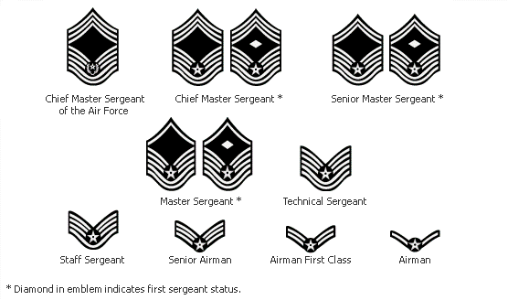

Officer Insignia:

2d Lt 1t Lt 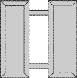 Capt.

Maj Lt. Col Col

Brig Gen Maj Gen.

L. Gen Gen

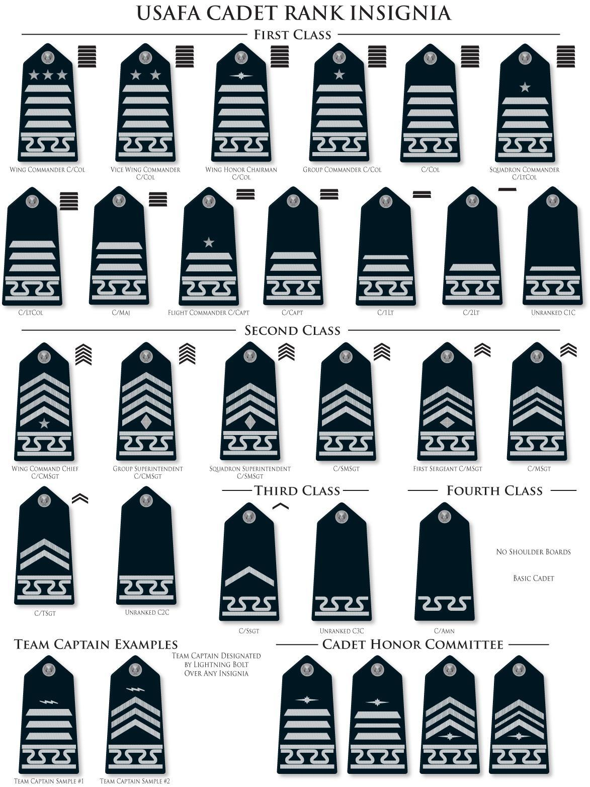
USAF Chain of Command:
Commander in Chief
Secretary of Defense
Secretary of the Air Force
Joint Chiefs of Staff
Chief of Air Force Staff

Scofield’s Address:
Major General John M. Scofield’s address to the graduating class of 1875 at West Point is as follows:

The discipline which makes the soldiers of a free country reliable in battle, is not to be gained by harsh or tyrannical treatment. On the contrary, such treatment is far more likely to destroy than to make an army. It is possible to impart instructions and give commands in such a manner and such a tone of voice as to inspire in the soldier, no feeling but an intense desire to obey, while the opposite manner and tone of voice cannot fail to excite strong resentment and a desire to disobey. The one mode or other of dealing with subordinates springs from a corresponding spirit in the breast of the commander. He who feels the respect which is due to others, cannot fail to inspire in them respect for himself, while he who feels, and hence manifests disrespect towards others, especially his subordinates, cannot fail to inspire hatred against himself

Appendix II

Cadet Milestones

BCT Questionnaire Letter to Send to Cadet

Acceptance Day- Stillman Field Map

Honor’s List Criteria/Honor Code Handbook/
USAFA Endowment Fund Info

Useful Websites

Cadet Milestones

C4C Year (Freshman)

Acceptance Day Early August
Recognition March

C3C Year (Sophomore)

Exemplar Dinner Fall

C2C Year (Junior)

Commitment Dinner Early August
Ring Dance Late May

C1C Year (Senior)

AFSC (Air Force Specialty Code) Fall Hundreds Night Mid-February
Graduation Late May

The USAFA Parents’ BCT Questionnaire. Please complete and return to your parent. You may choose one answer OR circle all that apply!
1) So far, BCT is
a) Fun
b) Not too bad
c) Better than a sharp stick in the eye, but not much
b) I prefer the sharp stick, thank you
d) Don't know, too tired to remember
e) Other
2) The Cadre are
a) Very early risers
b) People with amazing lungs
c) Not too bad
d) The meanest SOBs I have ever met
e) Going to pay for this someday
f) Other
3) Right now, I wish I could have
a) A LONG shower
b) A decent meal
c) A lethal weapon
d) A nap
e) My own bed, TV, VCR, etc.
f) Other
4) The best thing that has happened to me since I came here is
a) My roommate
b) The friends I am making
c) The great shape I am getting into
d) Sleep
e) Mail
f) Other
5) The worst thing that has happened to me since I came here is:
a) My roommate
b) The Cadre
c) The pain of getting into that great shape
d) Blisters
e) That trip to the emergency room
f) Other
6) The thing that hurts the most is
a) My head b) My ears
c) My legs d) My arms
e) My butt f) My feet
g) My stomach h) My collar bones
i) So much hurts I can't tell where it is from
j) Knowing I came here voluntarily

7) I get into the most trouble with the Cadre for
a) Laughing
b) Crying
c) Falling out of formation
d) Whining
e) Knowledge questions
f) Flirting

8) My hair style is
a) Just the same as when I left home
b) Butchered by a maniac who should not be allowed to play with scissors
c) Other
9) My roommate
a) Is from (fill in state) -_________________
b) Is named _______________
c) Is keeping me out of trouble
d) Is getting me into trouble
e) Really cool
f) Not too bad
g) Driving me crazy
h) Other
10) My squadron is
a) Really cool
b) Not too bad
c) Full of geeks
d) Going to win the competition on field day
e) Going to survive the competition at field day
f) Going to be lucky if we show up for the competition on field day
g) Other
11) In regard to physical conditioning, I am
a) Ahead of the curve
b) Keeping up
c) Getting better
d) Panting a lot
e) Praying a lot
f) Vomiting a lot
g) Comatose a lot
h) Other
12) In regard to academic testing, I
A) Aced everything
B) Did pretty good
C) Remembered some subjects better than others
D) Wished there were more questions about cars
E) Will get very good grades my first year because I am taking everything over again
13) If I could give one thing to the Cadre, it would be
a) A sense of humor
b) A sense of kindness
c) A sense of reason
d) A live hand grenade
e) A one way ticket out of here
f) Other
14) The food here is
a) Practically gourmet
b) Not like home, but not bad
c) Better than the bugs and bunny parts I will be eating next summer
d) So disgusting even bugs sound good
e) Who knows? The Cadre doesn't give us time to eat!
f) Other

15) The people who are thinking about me all the time are (CIRCLE ALL!!)
A) My Mom
B) My Dad
C) My boyfriend/girlfriend
D) My best friend
E) All my friends
F) My grandparents
G) A whole host of others who love me and believe in me!
16. My boots are
a) finally broken in.
b) fine but my feet are covered with blisters.
c) black.
d) other ________________
17. My new military haircut looks
a) stunning.
b) bad.
c) sexy.
d) other__________
18. I'm in Basic Squadron________________ and Flight______ which will become Squadron___ after BCT.
19. About all the memorizing...
a) it's a breeze.
b) it's a pain.
c) it's not too bad and I'm actually learning stuff.
d) other_______________________
21. When the Cadre are training me (i.e., yelling at me)
a) they look funny.
b) I don't like it, but know it's part of BCT.
c) it reminds me of __________
d) other ________________
22. We usually run ______miles each day & when we do
a) I'm usually in the middle of the pack.
b) I'm hanging out in the rear, but hey, I make it!
d) I know I'm improving every time.
e) other ______________
23. We usually get up at _________a.m. and the first thing we do is _____________. After that we usually ______________.
24. The weather here has been __________ and about ____°.
25. Eating at attention is
a) the pits.
b) a sure way to shed a few pounds.
c) not a big deal.
d) other ___________
26. I'm getting really good at making a bed.
a) true
b) false
c) working at it
d) other _______________
27. In one day, I typically do _____push-ups. All together since day one, I've probably done ____ push-ups.
28. The last thing I got "trained" for was ________________ and this is what happened: ____________________________________________________
29. BCT I is (better/worse) than BCT II because_____________________________________
30. Jack's Valley is ____________________________________________________
31. The hardest thing at JV is __________________________
and the easiest thing is _______________________________
32. Every day, I love ____________________________________________________
33. The Cadre at BCT I were ___________________________
and the Cadre at BCT II are ____________________________
34. My favorite thing so far has been ______________________________________________
because ________________________________________.
35. The worst thing so far has been _______________________________________________ because________________________________________.
36. I'm going to stick it out because ________________________________.
Basic will be over before you know it. Keep a positive attitude and find a reason to laugh once in a while.
37. My mailbox is:
1. always full
2. usually one or two letters a day
3. long time between mail
4. the post office can't figure out where I'm at

38. Estimated pushups done for all the mail I've received:
1. 20
2. 100
3. 400
4. 600
5. 1,000
6. more! I've lost count you love me so much!
39.Please send mail to this basic who isn't getting enough - we want our other classmates happy at mail call!
Basic Cadet ___________________________
P O Box ___________________
USAF Academy, CO 80841
40. After Acceptance please send me:
Stillman Field
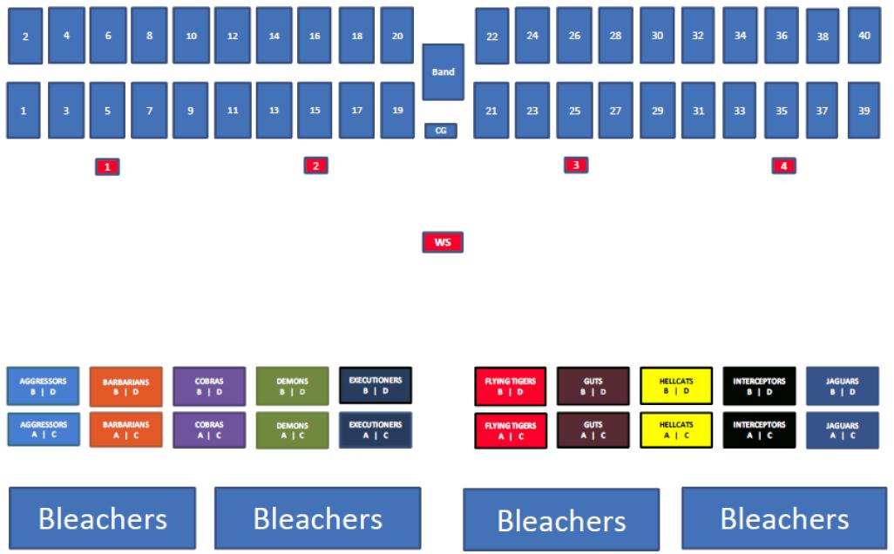

Sample of the line up for USAFA Parades

Honors List Criteria

Dean’s List:
The cadet has to earn a 3.0 or higher Grade Point Average (minus grades from physical education courses). These cadets are authorized to wear the Dean’s pin (silver star) on their uniform for the next semester.

Commandant’s List:
The top 1/3 of each class, based on military ranking, are eligible for this honor. These cadets are authorized to wear the Commandant’s pin (silver wreath) on their uniform for the next semester. Stipulation, if a cadet is on “ANY” probation, he/she is not eligible for the honor.

Athletic Director’s List:
Cadets who earn a semester Physical Education Average (PEA) of at least 3.0 will be on the Athletic Director’s list. These cadets are authorized to wear the Athletic Director’s pin (silver lightning bolt) on their uniform for the next semester. PEA is a weighted 4.00 grading scale
(50% Physical Fitness Test + 35% Phy Ed course grades + 15% Aerobic Fitness Test).

Superintendent’s List:
Cadets must be on the Dean’s/Commandant’s/AD lists combined. These cadets are authorized to wear the Superintendent’s pin (star enclosed in the wreath between two small lightning bolts) on their uniform for the next semester.

Honor Code Handbook

The handbook is available on the USAFA Website/Commandant/Honors Directorate. The current edition is located at the following link:

https://www.usafa.edu/app/uploads/AFCW_HCRH_Jun17.pdf

USAFA Endowment Fund Information

Each fall, parents receive a call from the USAFA Endowment and are asked to become donors to the Air Force Academy Fund. Over the last three years, parents have contributed more than $2.5 million to the Air Force Academy Fund.

The USAFA Endowment’s Air Force Academy Fund is an annual, unrestricted fund that enables the Endowment and the Association of Graduates to fulfill their missions in support of the Academy. The primary purpose of the Air Force Academy Fund is to provide private, unrestricted funds in support of a variety of cadet and graduate programs, capital projects and key Academy priorities as identified by the Superintendent. Throughout the year, a variety of methods are used to raise these funds. If you have questions about these calls or experience any problems, please feel free to contact the USAFA Endowment at (719) 472-0300 or go to http://www.usafa.org/ . Thank you for all you do for the Academy.

Helpful Websites
Academic Calendar website:
https://www.usafa.edu/app/uploads/2020-2021_Calendar.pdf

USAFA Website: https://www.usafa.edu/

USAFA Facebook: https://www.facebook.com/USAFA.Official/

Curriculum Handbook: https://www.usafa.edu/app/uploads/CHB.pdf
(also outlines what summer programs are available for cadets in what year)

Cadet Clubs: https://www.usafa.edu/cadet-life/clubs/
(just a listing of clubs and POCs, not a schedule of where they may be)

Admissions: http://www.academyadmissions.com/
(parents can help us recruit future cadets)

Sports Schedules: http://www.goairforcefalcons.com/calendar/events/

Parent Club Websites and Parent Newsletters: http://www.usafa.edu/parents
(Parent Clubs that are recognized by USAFA and access to the monthly Falcon Family Newsletters)

Parents’ Weekend Website: https://www.usafa.edu/about/traditions/parents-weekend/
(This has information for your planning purposes. Parents’ Weekend is always Labor Day Weekend.)

Eastern MA USAFA Families Club, Inc. Facebook:
https://www.facebook.com/groups/USAFCadetParents/?fref=nf

Eastern MA USAFA Families Club, Inc. Website: www.USAFAEMA.ORG

USAFA Parent Resource Facebook Page: https://www.facebook.com/groups/229767567187985/

Appendix III

Eastern MA USAFA Families Club, Inc. Info

Welcome Letter
Why join the Eastern MA USAFA Families Club?
(Facebook and website addresses on this page)

Dues PaymentForm
Badge ordering Form
Rando Fund Information

Eastern MA USAFA Families Club, Inc.
Dear USAFA Class of 2025 Appointee Parents,

On behalf of the Eastern MA USAFA Families Club, Inc., we first want to congratulate you on your cadet’s appointment to the United States Air Force Academy.
We are an active organization of parents from the area who have a son or daughter attending the Academy, or who has graduated from the Academy. Our purpose is to support each other on this four-year journey that is the Air Force Academy, which is most often described as a roller coaster ride.
Both appointees and family members will be experiencing a whirlwind of preparations and different emotions in the coming months as the appointee prepares to leave for In-processing and Basic Cadet Training (BCT) that will begin on June 25, 2021. Attending a military academy places very different demands and pressures on a cadet and on a cadet’s family. Being a cadet is not at all similar to the experience of being a student at a civilian college. Cadets have unique requirements including curfews, mandatory formations, marching drills, physical training sessions, mandatory intramural sports, daily uniform requirements, and room and personal inspections, all while carrying a 6- or 7-course academic load each semester. Handling all of this can be stressful for both cadets and their families. The USAF Academy is a wonderful and life-changing opportunity, and our members can help you to fully understand these demands, the impact on cadets and families, and provide suggestions to help manage it all.
Over the next few months, our association has organized a number of terrific events to both recognize your cadet’s accomplishment and to help prepare for what lies ahead (see attached schedule of Upcoming Events or our website www.usafaema.org). We hope you will consider joining our group of dedicated parents and friends in supporting our cadets and our Air Force Academy. Dues for a lifetime membership in the Club are $100 and payable by September 1. We have enclosed a dues form with mailing instructions. We have members across the Commonwealth who are ready to assist you in any way we can. If you would like more information, we encourage you to contact any of our officers listed below by telephone or email.
Once again, congratulations, and we wish you and your cadet four incredible years at USAFA!
Go Air Force!

Sincerely,

Eastern MA USAFA Families Club, Inc.

Kim & Dave Margolis, Co-Presidents Vice President ~ TBD
kimmargolis72@gmail.com / david.i.margolis@gmail.com
(781) 346-2757 / (781) 298-1957
Wakefield, MA (Carter ’23)

Chris Matuszczak, Treasurer Carla Stafford, Secretary
chriskevfamily0725@gmail.com carla@sdiver.com
(413) 485-1965 978-429-9696
Westfield, MA (Kealyn ’24) Wayland, MA (Henry ‘23)

Why Join the Eastern MA USAFA Families Club?

Our Club is made up of parents, just like you, who have or had cadets at the United States Air Force Academy. We have been or are going through what you will experience with your cadet. It can be a very emotional ride over the next four years, and our organization is here to help. In addition to information and support, you will enjoy the following benefits:

- Your own Appointee Handbook to help you through your first year (available online at: www.usafaema.org)
- Appointee Send-Off Breakfast at Hanscom Air Force Base
- Summer Picnic where you will get the latest information about Parents’ Weekend and A-Day
- The benefit of upper class mentors who will help you along the way
- Full access to our website (www.usafaema.org)
- Full access to our private Facebook group (Eastern MA USAFA Families Club Inc.)
- Parents’ Weekend informational handout
- Eastern Massachusetts Night at USAFA for your Cadet in April
- Holiday Cookie Wrap and a box of homemade treats sent to your Cadet in December
- Directory of all members so you can locate those that live close to you
- New England All Service Academies Holly Ball for cadets, families, and friends
- The latest updates from the Academy and the Air Force
- Three EMA Club meetings each year to hear guest speakers and to receive and share information about our cadets, graduates, and the happenings at the Academy
- Some great friends you will have for life

Our purpose is simple. We exist to:
- support our cadets at the Academy
- support each other as our cadets attend the Academy
- support the United States Air Force Academy
- support the United States Air Force

A quote from an appointee parent at the beginning of BCT:

Thank you for the well wishes everyone. As you've been through this before, I am sure you all know that we C4C parents will be sitting on pins and needles and glued to WebGuy for the next few weeks. I must say that this club is full of wonderful people who have made the freshmen experience for both cadets and their family members so much smoother than if we had to go it alone. Thank you for that. Susan and Family

You can become as involved as much or as little as you wish, although we hope you will be an ever-present face and take an active role. Certainly as our cadets move along their USAFA experience, the needs from our Club change, but the continuation of this organization, which was founded in 1969, is highly dependent on active participation from its members.

If you have specific career skills that might be helpful, please don’t hesitate to volunteer or offer your expertise. We survive on modest dues income and fundraisers as we go along. Participation is important to make this organization thrive. We look forward to seeing you!

Eastern MA USAFA Families Club, Inc.

Lifetime Dues Payment Form

Dues for the Eastern MA USAFA Families Club, Inc. are for a one-time, lifetime membership. Our dues fee is $100 per family, payable by September 1.

Please provide the following information:

Parent(s) Names:
______________________________________________________

Address: ___________________________________________________________

City: ________________________________State: _______ Zip: ____________

Home Tel: ________________________ Cell: ___________________________

Email: ___________________________@_________________________________

Email: ___________________________@_________________________________

Cadet/Grad Name: __________________________________

Class:______________

Please make your check payable to: Eastern MA USAFA Families Club, Inc.
Please mail your check and this form to:
Lee Dearden, (past) Treasurer
Eastern MA USAFA Families Club, Inc.
108 River Road
Rutland, MA 01543

[Please note that if the payment of dues presents a financial hardship for any family, please contact the Club Presidents, Dave & Kim Margolis (kimmargolis72@gmail.com) to confidentially request a waiver.]

~ The Dennis P. Rando Cadet Humanitarian Fund ~

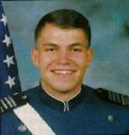

The Rando Fund was the wonderful result of the tragic circumstances surrounding the passing of several AFA cadets and their Instructor Pilots in flight training accidents at the Academy in the mid ‘90s. One of those cadets was C1C Dennis P. Rando of East Bridgewater, Massachusetts. At his funeral, when it was learned that the cadets who traveled to Massachusetts to honor their classmate and friend and to represent all cadets and cadet families, did so at their own personal expense, the USAFA Cadets Parents’ Association of Eastern Massachusetts under the leadership of then president and Rando Fund founder Bob Caggiano, made a request to other cadet families and cadet parents’ associations to donate funds to help reimburse the cadets for their travel.
The response to this request was so tremendous that donations surpassed the amount needed. Bob Caggiano came up with an idea supported by the members of the Cadet Parents Association of Eastern Massachusetts to establish an ongoing fundraising initiative to continue this kind of support for all cadets. They named the Fund in Dennis’ honor as they felt that this would be a most appropriate manner to honor Dennis’ memory and his sacrifice. A proposal was made to Lt. General Paul Stein, the Academy’s Superintendent at the time, who immediately recognized the value of this kind of cadet support and asked that the Rando Fund become a national fund raising effort as the Academy's budget does not have the resources to provide for this type of travel. With his guidance, the fund became a reality in 1997 with Massachusetts Parents Club member, Diane Mackey, serving as the Fund’s first president and principal fundraiser.
The Air Force and the Academy fully support the Rando Fund and have officially recognized it and its mission. In addition to providing free travel for a cadet honor guard in the event of a fellow cadet's passing, the Rando Fund also provides need-based financial support to cadets who may not have the resources to travel home during emergencies such as a death in their family, a serious family illness or injury to a family member. Cadets with a financial need are granted all or part of the travel expenses. The funds are a "gift" made possible by the Fund’s donors. Those donors are cadet families, cadet friends, AFA graduates, and the many cadet parent organizations from across the country. Determinations as to the necessity for a cadet to travel home as well as the assessment of a cadet’s financial need is made by the Cadet Chaplain’s Office in conjunction with the cadet’s AOC and the Commandant’s Office.
In August 2012, the Rando Fund became an affiliate of the USAF Academy Endowment. The Endowment provides all of the administrative support to the Rando Fund managing receipt of donations and management of the Fund’s financial resources. Because the Rando Fund’s Advisory Board volunteers their time to this cause and because the USAF Endowment assumes all the Rando Fund’s administrative costs, the Rando Fund is able to dedicate 100% of every donation to fund its missions in support of the cadets. However, the Rando Fund remains viable and can only continue to support those missions as a result of the donations that people like you and /or your organizations contribute. Every cadet at the Academy is a potential beneficiary of your support. Please consider making a donation to this very worthy cause.
For more information about the Rando Fund, please contact Rando Fund President, Jack Bernazzani at: jackbernazzani@hotmail.com
To make a tax deductible donation, you may choose one of two ways to donate. For a donation using a credit card, go to the Endowment’s Rando Fund link: https://giving.usafa.org/give/rando
You may also send a check made payable to: USAFA Endowment” with “Rando Fund” printed on the check memo line to:
USAFA Endowment
3116 Academy Drive, Suite 200
USAF Academy, CO 80840-4475
Note: Please be sure to include a note indicating the Rando Fund as the intended recipient of your donation, along with your or your organization’s name and address. This will enable the Endowment to send a letter of acknowledgement and ensure that your donation goes to Rando Fund.

