Welcome USAFA Class of 2018!

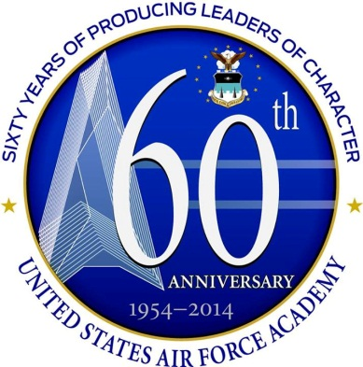

UNITED STATES AIR FORCE ACADEMY

2014 PARENTS’ WEEKEND
28 August – 1 September 2014

THE UNITED STATES AIR FORCE ACADEMY

Vision
USAFA...The Nation’s premier institution for producing leaders of character.
Mission
To educate, train and inspire men and women to become officers of character motivated to lead in the United States Air Force and in service to our Nation.
Core Values
Integrity First
Service Before Self
Excellence In All We Do

The US Air Force Academy Senior Staff
Welcomes You To
Parents’ Weekend 2014!
SUPERINTENDENT
Lieutenant General Michelle Johnson
VICE SUPERINTENDENT
Brigadier General Evan Miller
COMMAND CHIEF MASTER SERGEANT
Chief Master Sergeant Maxwell Grindstaff
COMMANDANT OF CADETS
Brigadier General Stephen Williams
DEAN OF THE FACULTY
Brigadier General Andrew Armacost
DIRECTOR OF ATHLETICS
Dr. Hans Mueh, Brig Gen, USAF, Retired
10th AIR BASE WING COMMANDER
Colonel Stacy Hawkins
PREPARATORY SCHOOL COMMANDER
Colonel Gerald Szybist
306th FLYING TRAINING GROUP COMMANDER
Colonel Steven Burgh

TABLE OF CONTENTS

GENERAL INFORMATION 5
Who Can Attend 5
Registration 6
Security Procedures 6
Parking and Transportation 8
Handicapped Information 8
High Altitude Health Concerns 9
Parents’ Weekend Weather 9
Attire 11
Lodging in the Local Area 12
Emergency Phone Numbers 12
Local Shopping 13
CADET MEETING PROCEDURES 13
How to Contact Cadets 14
HIGHLIGHTS OF PARENTS’ WEEKEND 2014 16
CADET CHAPEL ACTIVITIES 22
USAFA AIRFIELD 24
ATHLETICS PROGRAMS 27
USAFA RECREATIONAL FACILITIES 29
COMMON USAFA DEFINITIONS AND ACRONYMS 32
CADET RANK INSIGNIA 36
USAFA TELEPHONE NUMBERS 37
USAFA MAP 38
CADET AREA MAP 39

NOTE: If events listed in this handout are cancelled or postponed for any reason, local radio and television stations will broadcast the news. On base, you may tune to KAFA, 97.7FM. Message boards at both the North and South Gates of the Academy will notify you of any event changes. You may also call the Parent's Hotline, (719) 333-PNTS (7687), for the latest updates.

PARENTS’ WEEKEND 2014
Welcome to YOUR United States Air Force Academy!
Parents’ Weekend begins on Thursday, 28 August, and ends on Labor Day, 1 September 2014. Parents’ Weekend is an exciting time for cadets, their families and guests. Each year, more than 8,000 parents and guests attend Parents’ Weekend activities. Many have traveled from all over the world to visit their cadet and the Academy. This brochure is a guide to the events and facilities available during your visit. For the latest updated information, call the Parents’ Weekend information line at (719) 333-PNTS (7687) or visit the USAFA web site at http://www.usafa.edu and click on “Parents’ Weekend” at the right side of the page under "Events and Information."
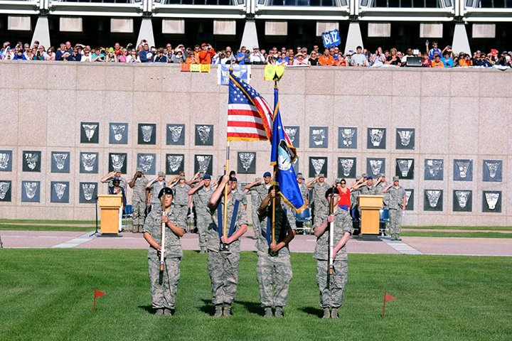
GENERAL INFORMATION
Who Can Attend
All cadet guests, including parents, siblings, aunts, uncles, grandparents or girl/boyfriends, are welcome to visit the Academy during Parents’ Weekend. In fact, cadets of all classes, not just the new Fourth-Class cadets, will host family and guests during this busy weekend.
Parents’ Weekend Information and Visitor Registration
Cadet guests who register via the Parents' Weekend website beginning in July 2014 will be e-mailed Parents' Weekend information. There is no requirement to register nor are there any restrictions as to who can register, however you must have your cadet's name and email address to verify the registration. You will receive an email with links to attachments, including a color brochure, schedule of events, Superintendent welcome letter, parking pass and event flyers. All items may be printed at home. If you are not able to print the items or do not have access to the internet, please ask your cadet to print the documents and send them to you or provide them upon your arrival. The latest information is also posted on the Parents Weekend website at http://www.usafa.edu/superintendent/parentsweekend.
Registration via the website is primarily to provide information to you on Parents’ Weekend activities. It also allows us to collect an estimate of the total numbers of guests, but we do not require updated registrations if your number or information changes. When registering, please make sure to identify any individuals in your group who may be in a distinguished visitor status (such as general officers, active or retired; high-ranking elected officials; international high-ranking individuals; heads of state; celebrities; or others that may be considered of DV stature) and anyone who may need handicapped assistance.
Security Procedures
The USAF Academy is open daily to visitors from 9:00 a.m.–5:00 p.m.; guests will be asked to show a valid driver’s license or a military ID. You may also be asked to show proof of insurance and a valid vehicle registration. If you are driving a rental car, please keep the rental agreement and current proof of insurance in the vehicle at all times. The parking pass identifies your vehicle as belonging to a USAFA visitor – please print the pass and place it in your driver's side dash. Remember that the pass does not get you on base – you must show a valid driver's license or military ID to enter the base. All non-DOD visitors must enter through the North Gate. Guests may ride the shuttles or walk into the Cadet Area but must be escorted by a cadet or military member to enter the Terrazzo or any of the academic buildings or dormitories. No private vehicles may enter the Cadet Area or restricted areas of the base.
All vehicles entering the base are subject to inspection by security personnel. Guests should refrain from bringing large bags, coolers, thermoses, backpacks or other items that will require additional scrutiny or searches from security personnel. Note that seatbelts must be worn by all vehicle occupants at all times when driving on the Academy.
Please make sure to follow all posted speed limits when driving on the base. Drivers may not use hand-held cellular phones while the vehicle is in motion. If you need to make or take a call, please use a hands-free device or pull to the side of the road. Also, be aware that radar detectors are not permitted on base. Finally, keep in mind that wildlife such as deer, elk and wild turkeys can be a hazard while driving on the Academy. Please be alert for them and drive carefully. Remember, they have the right-of-way!
If Force Protection Conditions (FPCONs) change due to world events or events closer to home, some scheduled events may change or require additional security precautions for the safety of all our guests. Any event changes will be advertised in local media and on the message boards at both entry gates.
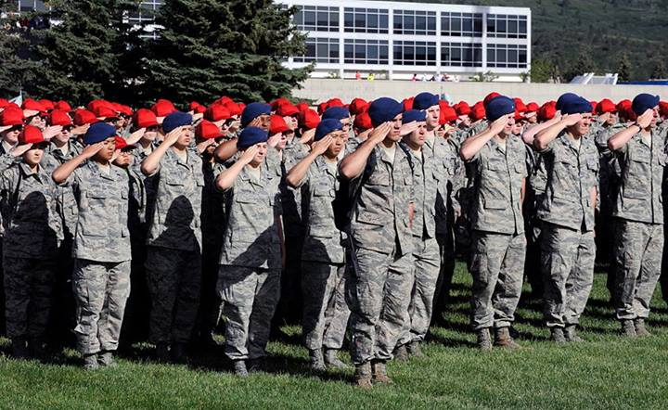
Parking and Transportation
Please plan to arrive early for all Parents’ Weekend events, especially the parade. Traffic, parking and security checks may result in delays getting to your destination. Remember, 8,000+ guests will all be arriving at USAFA on Friday morning at about the same time!
When you arrive on the base (please use the North Gate), follow the signs to visitor parking in the Cadet Field House and Reservoir parking lots (see map in this handout). Vehicles MUST be parked in designated parking spaces only—violators may be ticketed or towed at owner’s expense. There is no guest or cadet parking permitted in the Harmon Hall parking lot on Friday. Private vehicles may not enter the Cadet Area during Parents’ Weekend.
Shuttle buses will operate from visitor parking lots on Friday from 5:30 a.m. to 7:00 p.m., transporting guests to and from the various events within the Cadet Area. Guests are also welcome to walk from the parking areas. Buses will stop at designated bus stops (identified by signs and benches). Shuttle buses will run from the Cadet Field House parking lot to Jacks Valley for the tour on Sunday. No shuttles will run on Saturday or Monday (Labor Day). See map in this handout for bus stops (marked with a small bus-shaped icon).
Throughout your visit, please be prepared with good walking shoes and bottles of water, since bus wait times may sometimes be longer than expected. Although handicapped shuttles will be available throughout the Cadet Area on Friday, there may be extensive walking required from bus stops to your final destination. Please make sure to consider this when bringing elderly or infirm guests to the Academy.
Handicapped Information
The designated handicapped lot for Parents’ Weekend is located immediately north of the parade field (see map). Disabled or handicapped guests should bring their state-issued “disabled/handicapped” placard (USAFA does not issue handicapped parking passes) and any walkers, wheelchairs, breathing support or other special-needs or medical equipment they require. If you are not able to bring a handicapped placard, you may speak with the parking attendant to be allowed to park in the handicapped lot. Handicapped shuttles will operate throughout the Cadet Area on Friday of Parents’ Weekend – we ask that no more than one guest accompany the handicapped individual in order to ensure sufficient space for those who most need it.
Guests with serious medical conditions such as anemia, heart disease or pulmonary disease should consult their doctor about the need for portable oxygen or preventive medication and the advisability of traveling to the Academy. NOTE: The Academy is unable to provide wheelchairs, oxygen tanks and other medical equipment supplies. Please contact a medical supply distributor, your doctor or insurance carrier for your medical needs. Handicapped information is available on the website at http://www.usafa.edu/superintendent/parentsweekend/data/PW%20Handicapped%20services%20info.pdf. If you have any concerns about handicapped support during Parents' Weekend, please email special.events@usafa.edu.
High Altitude Health Concerns
The Air Force Academy Cadet Area is approximately 7,300 feet above sea level. At this altitude, it is possible to contract an illness known as acute mountain or high-altitude sickness. The common symptoms of this disorder include headache, malaise, nausea, vomiting and shortness of breath. Most cases of acute mountain sickness are mild but the altitude may exacerbate other existing medical conditions. High altitude sickness usually resolves within a few days once an individual has had a chance to adapt to the increased elevation. The best way to avoid illness is to allow yourself to acclimatize: try not to over-exert yourself in the first days after your arrival and make sure to drink sufficient fluids to avoid dehydration. Don't go sightseeing at higher elevations (i.e., up in the mountains) until after you have been in Colorado Springs for a few days. Alcohol consumption may worsen these symptoms; if you must drink, make sure to do so in moderation.

Parents’ Weekend Weather
With guests coming from so many diverse areas to the Colorado Springs area, you should be aware of the potential for a wide variety of weather conditions during your visit.
Due to our location on the Front Range of the Rockies and our high elevation, weather at the Academy is highly unpredictable and can change rapidly, even from hour to hour. It can be sunny and warm one day and rainy, foggy and very cold the next day. Normal Colorado weather at this time of year is usually dry and warm with cool evenings and possible afternoon thunderstorms. However, we will occasionally get very cold, wet weather, and that could happen this year. Guests should plan for all types of weather. We recommend you have sunscreen, clear, unopened water bottles and hats for good weather and raincoats, rain hats and umbrellas for bad weather. To help plan your visit, see the USAFA weather site at http://www.usafa.edu/tu/306ftg/oss/weather/sevenday.cfm for more information.

SEVERE WEATHER. Colorado has more thunderstorm days than any other state except Florida. Severe summer weather may bring lightning, hail, torrential rain, flash floods and even the occasional tornado.
HAIL. The state’s mountains and high elevation increase the likelihood that hail will form in a thunderstorm, making Colorado one of the hail capitals of the world. Northeastern Colorado and nearby Great Plains states get more hail each year than any other part of the United States.
FLOODS. In late summer, flash floods may be a major weather hazard. Slow-moving thunderstorms can dump several inches of rain over a small area in a few hours, quickly saturating the ground. In steep mountain terrain, the runoff pours into streams and rivers, causing water levels to rise rapidly. Flash floods are responsible for many deaths, and nearly half of those fatalities are auto related—such as when people unwittingly try to drive through floodwaters. It only takes two feet of water to carry away most automobiles, and six inches of fast-moving water can knock you off your feet. That is why, in a flash flood, it is best to leave your car, get away from the water, and climb to safety.
LIGHTNING. Lightning is one of Colorado’s most dangerous weather hazards. Since the late 1980s, more people have been killed or injured by lightning than by any other weather-related phenomena in Colorado. In an average year, lightning kills three and injures eighteen people.
Hiking during a thunderstorm in Colorado’s mountains can be very dangerous. In the summer, thunderstorms typically begin to form over the mountains in late morning or early afternoon. To minimize your risk of exposure to lightning, it is best to hike early in the morning and watch the weather reports before heading out.
WARNING SYSTEM. Here at the Air Force Academy, the "Giant Voice System" (an outdoor loud-speaker system) will activate when a thunderstorm, lightning or other severe weather threatens the area. When dangerous weather is present, a notification to seek shelter will be broadcast over Giant Voice, warning guests to shelter immediately or limit exposure to the outdoors. Guests should remain in an indoor location until it has been determined that lightning is out of the area or no longer a threat.

Attire
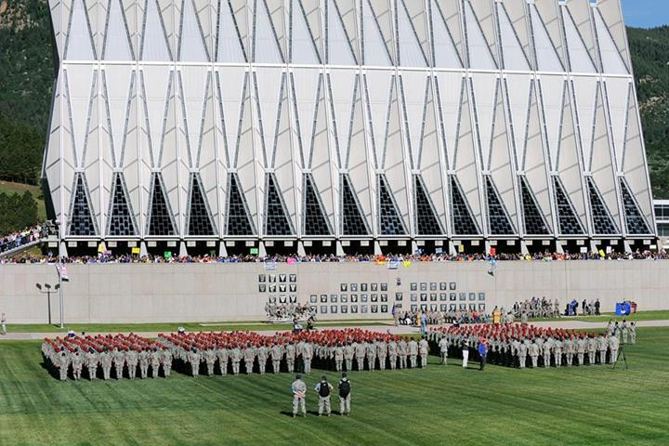
Please ensure children and young adults wear appropriate clothing for a visit to a national military academy. Plan to dress sensibly and comfortably for outdoor activities such as the parade or the tour of Jacks Valley. Wear good walking shoes—any visit to the Academy may require extensive walking. We suggest that guests bring sun block, raincoats and/or umbrellas for scheduled outside events. For Chapel services, please dress appropriately; for example, dress or slacks for women, sport coat for men and service dress uniform or equivalent for military members. Cadets are required to be in the “uniform of the day” as prescribed by the Commandant of Cadets.
Lodging in the Local Area
There are numerous motels and hotels in the Colorado Springs area; however, the Pikes Peak Region is a nationally known resort area, and Labor Day is a busy tourist weekend with many special events taking place in the city and surrounding areas. For lodging information, you may contact any of the below listed organizations:

Colorado Springs Convention & Visitors Bureau
515 South Cascade Avenue
Colorado Springs CO 80903
Phone: (800) 888-4748 or (719) 635-7506

Website: http://www.visitcos.com
Summer hours: 8:00 a.m.-6:00 p.m. seven days a week

Colorado R&R

Academy ITT Ticket and Travel Center
Building 5136
USAF Academy CO 80840-0249
Phone: (877) 517-3381 or (719) 333-7367 DSN: 333-7367
Email: ColoradoRandR@usafa.af.mil

Website: www.coloradorandr.com

Open: Mon-Fri, 9:00 a.m.-5:00 p.m.

Sat, 8:00 a.m.-1200 p.m. Closed Sunday

Rampart Lodge

USAFA’s military lodging facility

3130 Academy Drive

USAF Academy CO 80840

Phone: (719) 333-4910

On-line Reservations: http://www.dodlodging.net
Website: http://www.usafaservices.com/travel-lodging/rampart-lodge

Peregrine Pines FamCamp

For campers, trailers, RVs and tent camping on USAFA.

Phone: (719) 333-4980

Website: http://www.usafasupport.com/the-great-outdoors/famcamp
Summer hours: 9:00 a.m.-8:00 p.m. seven days a week

Emergency Phone Numbers
If you have a medical, fire or police emergency, please call 911 immediately. You may reach Academy Security Forces at (719) 333-2000 or 333-4100. There are several major medical facilities in Colorado Springs to handle medical situations: Memorial Hospital Central, (719) 365-5000, Memorial Hospital North, (719) 364-5000, Penrose-St. Francis, (719) 776-5000 and St. Francis Medical Center, (719) 571-1000.

Local Shopping
With a population of over 400,000, Colorado Springs is the 41st largest city in the US and offers all the amenities visitors could ask for. The Air Force Academy, located on the north end of the city, is close to hotels, shopping, restaurants and tourist attractions. Academy Boulevard, accessed from the South Gate of the Air Force Academy, offers a wide variety of retail stores, services, dining and entertainment establishments, all within minutes of the Cadet Area. For Academy souvenirs, guests are welcome to shop at the USAFA Visitor Center, the Falcon Gift Shop in the Cadet Field House or at the Association of Graduates’ Doolittle Hall. Please be aware that the Base Exchange, Commissary and Auto Service Center, located at the Academy Community Center, are only for authorized personnel (i.e., active duty or retired military personnel and authorized dependents). If you do not have a military ID card, you must be accompanied by your cadet.

CADET MEETING PROCEDURES
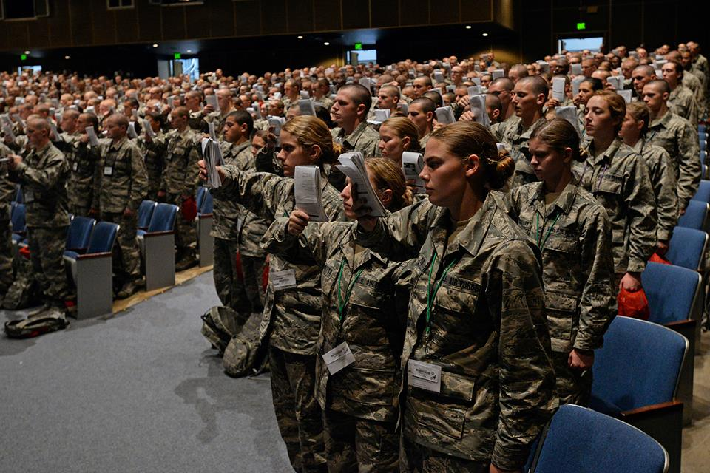
Please make sure to arrange a meeting location with your cadet ahead of time (such as the Cadet Field House, Arnold Hall or the Core Values Ramp). If you have any difficulty navigating the Cadet Area, you may receive assistance from staff positioned at the base of the Core Values Ramp near the east end of Vandenberg Hall or at Arnold Hall throughout the day. All cadets should have their cell phones on Friday morning of Parents’ Weekend, so we recommend you communicate via phone if you lose each other.
NOTE: We appreciate your not interfering with your cadet’s military duties. During the parade, we ask parents to stay off the parade field until the conclusion of the parade. After the parade, you may meet your cadet on the parade field. Following the afternoon activities on Friday or last military duty (LMD), cadets may be allowed an overnight privilege. All Second-, Third- and Fourth-Class cadets must return to the Academy for accountability formations by 9:30 a.m. Saturday morning at Falcon Stadium (10:30 a.m. for First-class cadets). Following the football game, cadets may join their adult parents/guests for the rest of the holiday weekend, signing in on Monday evening at 7:10 p.m. (10:45 p.m. for First-class cadets). Squadron Air Officers Commanding (AOC) authorize all cadet privileges.
How to Contact Cadets
Upon completion of the summer program, all Fourth-Class cadets will change from summer squadrons (letters A–H) to numbered squadrons (1-40). Please be sure to ask your cadet the number of his/her new squadron. Cadets will be permitted to have their personal cellular phones throughout Parents' Weekend, so feel free to contact them directly. However, if you cannot reach your cadet, you can contact their squadron at the phone numbers listed below.
To call your cadet, locate the proper squadron telephone number on the list below. To dial from on- or off-base, all seven digits are required (prefix 333). The area code for the Academy is 719. Please use the Cadet in Charge of Quarters (CCQ) number when calling a cadet. It can be very difficult to contact a cadet during the academic day. In most cases, you will have to leave a message for your cadet to return your call. If you must talk to a cadet (emergencies only), call the Air Officer Commanding (AOC) or the Commandant of Cadets Command Center at 333-2910.
CCQ Duty Hours (times are subject to change): Weekends/Holidays: 6:00 a.m.–2:00 a.m. (11:00 p.m. on last day of weekend/holiday); Academic Days: 6:00 a.m.–11:00 p.m.

Cadet Squadron Locations: Sijan Hall (S); Vandenberg Hall (V).

FIRST GROUP
SQ | CCQ / AOC Phone | Dorm | Floor
01 | 4534 / 8991 | V | 6
02 | 4533 / 4537 | V | 6
03 | 4640 / 4548 | V | 5
04 | 4612 / 4541 | V | 5
05 | 4535 / 4524 | V | 3
06 | 4551 / 4532 | V | 3
07 | 4492 / 4518 | V | 2
08 | 4491 / 4550 | V | 2
09 | 4574 / 4552 | V | 2/3
10 | 4500 / 4569 | V | 2
SECOND GROUP
SQ | CCQ / AOC Phone | Dorm | Floor
11 | 4581 / 4539 | V | 2
12 | 4448 / 4608 | V | 2
13 | 4757 / 4758 | V | 3
14 | 4759 / 4767 | V | 5
15 | 4669 / 4668 | V | 5
16 | 4675 / 4671 | V | 5
17 | 4501 / 4785 | V | 5
18 | 4777 / 4768 | V | 6
19 | 4741 / 4751 | V | 6
20 | 4712 / 6521 | V | 6

THIRD GROUP
SQ | CCQ / AOC Phone | Dorm | Floor
21 | 4666 / 4456 | V | 3
22 | 4659 / 4594 | V | 3
23 | 4529 / 4457 | S | 3
24 | 4447 / 4559 | S | 6
25 | 4695 / 4798 | S | 6
26 | 6842 / 4766 | S | 6
27 | 4660 / 4424 | S | 5
28 | 4748 / 4408 | S | 5
29 | 4717 / 4488 | S | 5
30 | 4711 / 4465 | S | 3
FOURTH GROUP
SQ | CCQ / AOC Phone | Dorm | Floor
31 | 3050 / 4474 | S | 3
32 | 3052 / 4451 | S | 2
33 | 4300 / 4604 | S | 2
34 | 4304 / 4444 | S | 6
35 | 4311 / 4606 | S | 5
36 | 4306 / 4476 | S | 3
37 | 0667 / 0337 | S | 6
38 | 0668 / 0338 | S | 5
39 | 0669 / 0339 | S | 3
40 | 0670 / 0340 | S | 2

HIGHLIGHTS OF PARENTS’ WEEKEND 2014

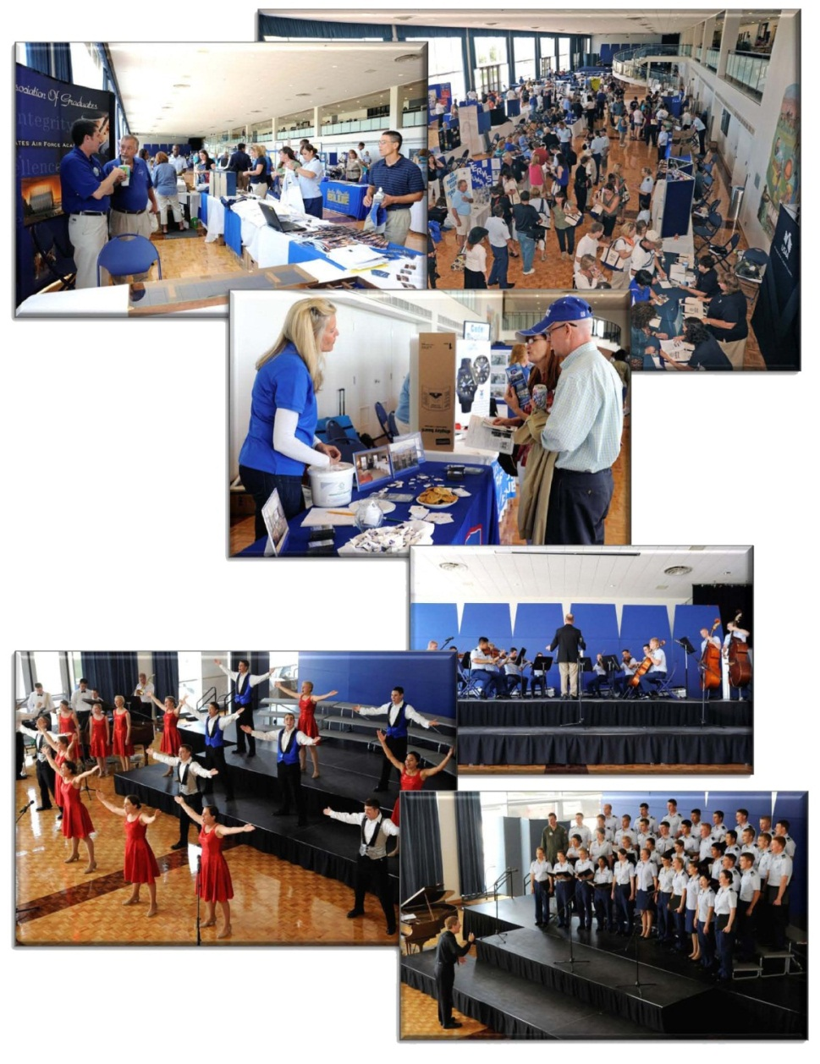
When you arrive at the Academy on Friday, follow the signs to guest parking on the west side of the Cadet Area. Shuttle buses will run throughout the day on Friday to bring you to various locations in the Cadet Area, including Arnold Hall, the Cadet Chapel and Fairchild Hall. Note that the buses do not go to the Visitor Center and guests should not plan to park in either the Harmon Hall or Visitor Center parking lots. See the Parents’ Weekend schedule of events for all activities scheduled over the weekend. Highlights are listed below.
FRIDAY, 29 August 2014
Parents' Weekend Information Fair: The USAFA Student Center, Arnold Hall, welcomes parents, guests and cadets throughout the day on Friday, beginning with breakfast options at 8:00 a.m. At 10:00 a.m., you may attend the Parents' Weekend Information Fair held in Arnold Hall. Academy organizations and Parents Clubs will provide a wide variety of information on the Academy, including free parent handbooks, an opportunity to talk with the Association of Graduates staff, and on-site purchases of BCT videos (preorders will be mailed). In addition, food vendors such as Subway and Godfather’s Pizza will be available to satisfy your luncheon needs. After lunch, stick around to watch performances from the Cadet Show Choir, Cadet Orchestra and the Cadet Chorale on the east ballroom stage from 1:30-2:15 p.m.!
Cadet Wing Media will offer family portraits during the Information Fair in the Arnold Hall ballroom from 10:00 a.m. to 4:00 p.m., no appointment necessary. Portrait sittings are free; you can decide whether or not to purchase later. Interested families should stop in early with their cadet and allow up to 15 minutes for the photo session. Advance purchase of BCT yearbooks is available (with delivery in Nov/Dec 2014). Call (719) 333-4644 for more information.
VECTOR Program Informational Session (Arnold Hall Banquet Room, 10:30-11:15 a.m. and 1:30-2:15 p.m.): Vital Effective Character Through Observation and Reflection (VECTOR) is the foundational character development seminar 4-degrees attend during their freshman year at USAFA. This VECTOR informational session will provide an overview of the topics cadets discuss and include videos, experiential exercises and discussions on topics such as personal/institutional values, personal purpose, and the power of vision to facilitate the discussion of character and leadership concepts involving the cadets' lives here at USAFA and in the Air Force. For more information, contact the USAFA Center for Character Development at (719) 333-6437.
Cadet Wing Parade: MANDATORY FOR ALL CADETS. The Cadet Wing Parade begins at 9:00 a.m. at Stillman Parade Field. Arrive early (by 8:20) to see a Cadet Capabilities Exercise (CAPEX) with gliders landing on the field and a demonstration by the Wings of Blue parachute team. View demonstrations by the Cadet Falconers, Model Aircraft Club and Saber Drill Team (Note: Please ensure individuals in your party that may be sensitive to loud noise are warned the cannon fire at the start of the parade). If the parade is cancelled for severe weather, guests may visit the Information Fair at Arnold Hall or check with their cadet to see whether their Squadron has moved up their Open House to 10:00 a.m.–12:00 p.m.
Lunch at Mitchell Hall: MANDATORY FOR FOURTH-CLASS CADETS. (12:15 a.m. – 1:15 p.m.) Fourth-Class cadets may purchase tickets for their guests to join them for lunch (initial guest tickets will be limited to 3 per cadet, with the possibility of more tickets becoming available depending on sales). Your cadet must purchase your tickets and provide them to you upon your arrival at USAFA – please make sure to coordinate with your cadet to ensure he/she knows how many tickets to request! Guests must be escorted by their cadets to Mitchell Hall. Visitors will also find lunch available at the Cadet Field House, Visitor Center, Falcon Club, Arnold Hall and various Squadron picnics (prices/times vary). NOTE: Tailgate picnic lunches will be available to First-, Second- and Third-class Cadets in the cadet squadrons.
Academic Advising and First-Year Programs (Arnold Hall Banquet Room, 2:30-3:00 p.m.). This informational meeting will discuss academic advising and other first-year support programs for new cadets. As parents are important referral agents for their cadets, we hope you will join us to learn about the variety of programs designed to support our 4-degree cadets as they transition to the rigorous academic environment of USAFA.

Athletics Open House: Come visit the Cadet Field House, Hall of Excellence at the Falcon Athletic Center and the Cadet Gymnasium from 1:00-3:00 p.m. to meet the Athletics staff and learn all about the many athletics programs available at USAFA!
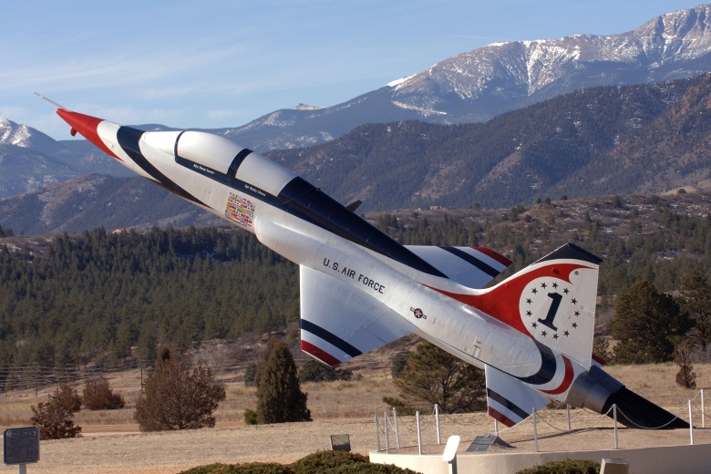
Airfield Open House (94th FTS Bldg., 9211 Talon Dr. and 98th FTS Bldg., 9201 Talon Dr., 1:00-6:00 p.m.). The USAFA airfield hosts an open house to provide orientations and answer parent questions. Come view static displays of USAFA aircraft and parachute equipment and visit with the staff of the 306th Flying Training Group. Cadets must escort their guests to the airfield. Guests are not permitted access to midfield for safety reasons. A van shuttle will be available for the Airfield Open House, departing from the base of the Core Values Ramp at 12:30, 1:30, 2:30, 3:30, 4:30 and 5:30 p.m., and returning from the Airfield to the Core Values Ramp at 1:00, 2:00, 3:00, 4:00, 5:00, 6:00, and 7:00 p.m. Look for the vans with the “Airfield Open House” sign in the window.
Squadron Open Houses: Each Cadet Squadron will host an open house in the cadet dormitories, Sijan and Vandenberg Halls, on Friday. Guests and 1st and 2nd class cadets may attend between 10:15 a.m.-12:15 p.m. Guests and 3rd and 4th class cadets may attend between 1:00-3:00 p.m. Guests must be escorted at all times while in the Cadet Area buildings. Following the afternoon open houses (or last military duty), cadets may join their families for the evening. Squadron Air Officers Commanding (AOCs) authorize all cadet privileges. All Second-, Third- and Fourth-Class cadets must return to the Academy for accountability formations by 9:30 a.m. Saturday morning (10:30 a.m. for First-class cadets).
Dinner BUFFET: A buffet dinner is available Friday evening at Mitchell Hall from 5:00 to 7:30 p.m. Open to cadets and their guests. You must be escorted by your cadet and may pay the cashier.
USAFA Observatory Open House (Observatory, East of Fairchild Hall, 8:00 – 10:00 p.m.). The USAFA Physics and Astronomy Club invites you to come view the night sky through our 24” telescope! You will have the opportunity to tour the facility, see images taken on our own 24 inch telescope, use the telescope to explore your universe first hand (weather permitting) and hear some of the incredible history and lore behind the constellations that can be seen from our vantage point, 7,258 feet above sea level! Transportation will be provided to the Field House parking lots.
SATURDAY, 30 August 2014
Breakfast buffet: Available at Mitchell Hall from 7:00 to 9:00 a.m. Open to cadets and their guests. You must be escorted by your cadet and may pay the cashier.
Falcons Home Football Game: Purchase your tickets early for the season-opening USAFA home football game on Saturday, 30 August 2014. Cheer on the Air Force Falcons as they play Nicholls State University at Falcon Stadium beginning at 12:00 p.m. For tickets, call the USAFA Athletic Ticket Office at (800) 666-8723 or go on-line at http://goairforcefalcons.cstv.com/tickets/afa-tickets.html.
Guests must purchase their own tickets. Cadets are required to attend the game but do not require tickets and must sit with the Cadet Wing throughout the football game. Following the football game, cadets may join their adult parents/guests for the rest of the holiday weekend in the Colorado Springs local area (150 mile radius), returning to the Academy by Monday evening at 7:50p.m. (11:00 p.m. for First-Class cadets). Each Squadron Air Officer Commanding (AOC) authorizes cadet privileges. See the USAFA website or schedule of events for various other sporting events available during Parents’ Weekend.

SUNDAY, 31 August 2014
Luncheon meals will be available at:
Mitchell Hall—Brunch buffet from 9:00 a.m.–1:00 p.m. Open to cadets and their guests. You must be escorted by your cadet and may pay the cashier.
Academy Falcon Club—Join us for a delightful Sunday brunch from 10:00 a.m. to 1:30 p.m. Call for reservations: (719) 333-4253.
Jacks Valley Tour: The Jacks Valley orientation tour, from 10:00 a.m. to 2:00 p.m., offers you the opportunity to visit the site of the Basic Cadet Training (BCT) field training exercises. Your cadet must escort you during this tour. Please wear comfortable walking shoes and bring clear, unopened water bottles. No privately owned vehicles are allowed in Jacks Valley. Buses will depart for Jacks Valley from the Cadet Field House parking lot every 15 minutes, beginning at 10:00 a.m. The last bus will depart for Jacks Valley at 1:30 p.m., and the last bus will depart Jacks Valley at 2:30 p.m.
MONDAY, 1 September 2014
BRUNCH AT Mitchell Hall:
Brunch buffet is available from 7:00 a.m. to 1:00 p.m. Open to cadets and their guests. You must be escorted by your cadet and may pay the cashier.
Academic Call to Quarters (End of Parents’ Weekend): All Second-, Third-, and Fourth-Class cadets must sign in by 7:50 p.m. First-class cadets must sign in by 11:00 p.m.

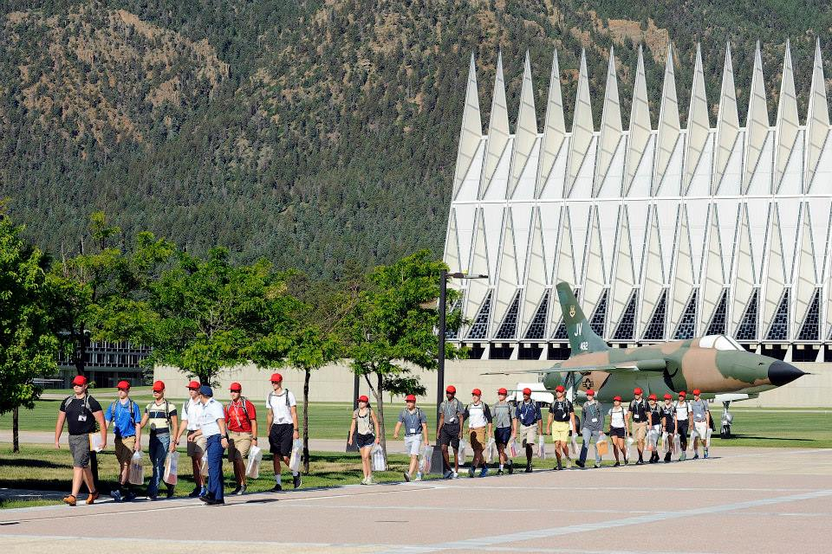
CADET CHAPEL ACTIVITIES
The chaplains at the Air Force Academy are privileged to minister to the spiritual and moral needs of your cadet. Their mission is to provide for and support spiritual and character development through the free exercise of religion and pastoral care. To fulfill this critical mission, we offer worship opportunities, religious education, fellowship activities, choirs, retreats and pastoral counseling.
The Cadet Chapel is open to visitors from 9:00 a.m. to 5:00 p.m. on weekdays. It is closed to visitors on Sunday when services are held (from 9:00 a.m. until 1:00 p.m.) and will open for visitors from 1:00 p.m. until 5:00 p.m. Parking for Sunday services is in the Harmon Hall parking lot. The Chapel will be closed on the Monday Labor Day holiday.
Parents' Weekend Worship Services: Cadets and their families are welcome to attend services at the Cadet Chapel, Community Center Chapel or any place of worship in the local area.

Services at the Cadet Chapel are:
Friday:
12:30-2:00 p.m. Islamic Worship Service
7:00-9:30 p.m. Jewish Shabbat Service
Sunday:
9:00–10:00 a.m. Protestant Traditional Service
10:00–11:00 a.m. Catholic Mass
10:00–11:00 a.m. Buddhist Service
11:00 a.m.–12:00 p.m. Protestant Contemporary Service
12:00–1:00 p.m. Catholic Mass
Community Center Chapel Services are:
Sunday
9:00–10:00 a.m. Catholic Mass
10:15–11:15 a.m. Protestant Evangelical Service
11:30 a.m.–12:30 p.m. Protestant Gospel Service
Please contact the Cadet Chaplain Corps’ Office if you have any questions about Chaplain Services at the Academy or about any of the religious services or activities during Parents’ Weekend.
Cadet Chapel Phone Number: (719) 333-2636
Mailing Address: HQ USAFA/HC, 2348 Sijan Drive, Suite 100, USAF Academy CO 80840-8280

Community Center Chapel Phone Number: (719) 333-3300
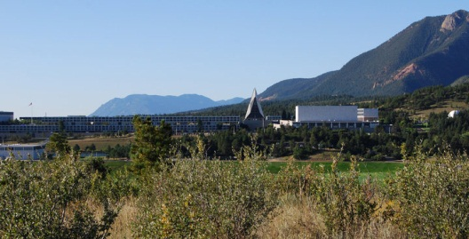
USAFA AIRFIELD
306 FTG: The 306th Flying Training Group is located east of Stadium Boulevard and welcomes guests escorted by their cadet on Friday of Parents’ Weekend. The airfield is closed on Saturday and Sunday and for the Monday holiday.
The 306 FTG has a long and distinguished history, beginning with an integral role in WWII and continuing to its current mission of “developing the character, education and leadership of tomorrow's Airmen through airmanship programs in powered flight, soaring and parachuting.” Originally established as the 306th Bombardment Group (Heavy) at Gowen Field, ID, on 28 Jan 1942, the 306th now belongs to the Air Education and Training Command and provides support to the US Air Force Academy.
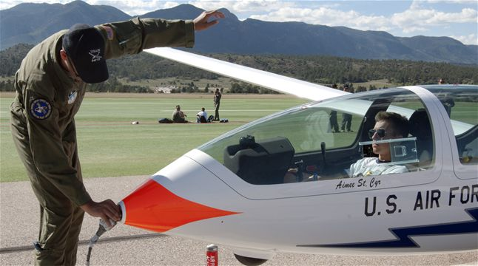
94 FTS, 98 FTS and 557 FTS: The 94th, 98th and 557th Flying Training Squadrons (FTS) are the flying squadrons at the Academy Airfield that provide instruction to the cadets in a variety of airmanship programs at USAFA’s busy day, VFR-only airfield. They provide the maximum opportunity for cadet participation in a USAF operational environment, motivating them toward careers as Air Force officers. The 94 FTS conducts over 17,000 training and competition glider sorties annually, focused on developing airmanship and leadership for USAFA and ROTC cadets through soaring. The 98 FTS is the Air Force Academy’s parachute training squadron, which offers free fall parachute training in which students are solo and unassisted on their very first jump. The 557 FTS is home to the Air Force Academy's Powered Flight Program and Cadet Flying Team, and teaches fundamentals of powered flight while exposing cadets to a USAF operational environment.
Soaring (Glider) Program: During their third-class year, cadets have the opportunity to fly and solo in a glider in the soaring program. Although Air Force pilots supervise the operations, it is a cadet run program with cadet instructor pilots accomplishing the majority of the flight and ground instruction. Students completing the basic soaring course may apply for enrollment in a semester-long upgrade course to become one of the “Youngest Instructor Pilots in the Air Force” in a glider. In this and other advanced courses, cadets experience many aspects of leadership while instructing soaring. Soaring instructors can also compete to become members of the Aerobatic Glider Team or the Sailplane Racing Team.
Parachute Training: Cadets may elect to enter free fall parachute training after their Fourth-Class year. Those who successfully complete training (five jumps) earn Military Parachute Wings. Cadets who excel in the basic free fall program may be selected to continue in more advanced courses, becoming jumpmasters and members of the Academy parachute team, “Wings of Blue," the top collegiate parachuting team in the country. The Wings of Blue team carries the Air Force flag in front of two million spectators annually and is recognized as the official parachute team of the U.S. Air Force.
USAF Academy Flying Team: Cadets with an FAA private pilot license are encouraged to apply for the USAF Academy Flying Team. Participation on the flying team is an extracurricular activity. The team competes in flying events such as navigation, message drop, and power-on and power-off spot landings, as well as ground events such as simulator, aircraft identification and computer accuracy. Cadets selected for the team undergo rigorous training in the specialties in which they will compete. The team has a long history of winning first-place at the regional level and has developed into one of the top flying competition teams in the country.
USAF Academy Aero Club: The USAF Academy Aero Club, through the Academy Flight Training Center, enables cadets to fly general aviation aircraft during their free time. They may obtain private, commercial and instrument certificates. Aircraft may also be used for recreational and cross-country flights. Discounts are available for Prep School candidates and USAFA cadets.
Powered Flight Program: The Powered Flight Program provides cadets an introduction into an operational USAF flying squadron environment through powered flight and solo opportunities in the T-53. Cadets progress through a syllabus where they are introduced to aircraft systems, emergency procedures, basic flying maneuvers and landings. The core learning outcomes of leadership, discipline and courage are developed as they progress to an opportunity to solo the T-53 after approximately nine sorties.

ATHLETICS PROGRAMS
The Air Force Academy athletics program is designed to improve overall physical fitness, teach athletic skills and develop leadership qualities such as self-confidence, initiative, teamwork and the ability to handle pressure. To achieve its goals, the Academy offers one of the most extensive physical education, intramural sports and intercollegiate athletic programs in the nation.
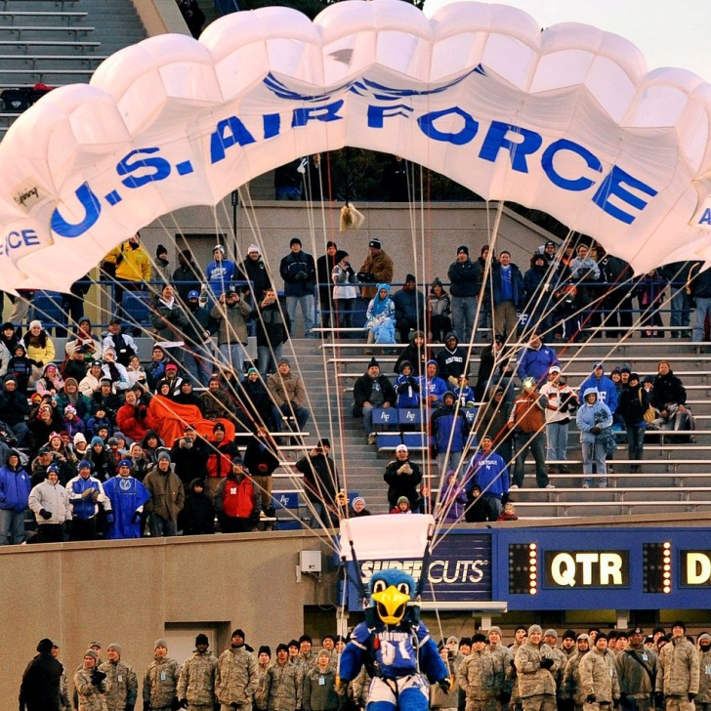
Because of the emphasis on athletics, the Academy provides its cadets some of the finest athletic facilities in the country. The Cadet Field House contains Clune Arena, a 6,000-seat basketball arena, a 2,500-seat ice hockey arena and a multi-purpose area consisting of an Astroturf infield surrounded by a 1/6-mile track. The Cadet Gymnasium houses three full-sized gymnasiums, an Olympic-size swimming pool and water polo pool, 30 courts for racquet sports, an indoor tennis complex and areas for weightlifting, gymnastics, wrestling, boxing and judo.

The Falcon Athletic Center is the home to the United States Air Force Academy’s Director of Athletics, administrative staff, sports medicine, the Fighting Falcons football team and the Hall of Excellence.
The Falcon Athletic Center, a four-level structure, provides over 161,000 square feet of space. This state-of-the-art facility contains a two-story, 23,000 square foot weight room with a 40-yard running track for weight training and exercising, a complete sports medicine area that contains a hydrotherapy area with a Swim-Ex and lap pool, a rehabilitation area and medical treatment/taping area.
The Hall of Excellence facility highlights the history of Academy sports, including intercollegiate, intramural and physical education. This exhibit showcases the accomplishments of our graduates and substantiates the significance of athletics on Air Force officers past and present. Exhibits include general officers, political/industry leaders, astronauts, Olympians/professional athletes, women leaders, intramural/physical education, 29 intercollegiate sports, visiting academy displays, wall of champions, national team’s wall/bow games, and ultimately, interactive kiosks and a Walk of Honor. Outside are 33 tennis courts, five team handball courts, five volleyball courts, an outdoor track and an additional 143 acres of athletic fields. Falcon Stadium, which can seat 46,500 people, is the site of home football games.
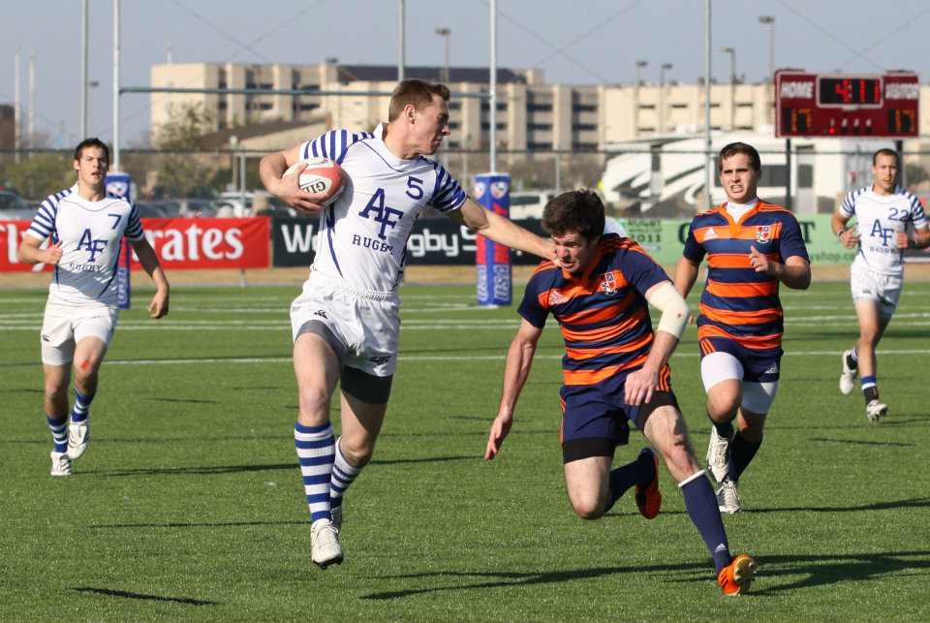

USAFA RECREATIONAL FACILITIES
We are pleased to offer you and your family the opportunity to use the following USAFA facilities:
Academy Falcon Club: Located on Academy Drive. Join us for a Sunday Brunch from 10:00 a.m.–1:30 p.m. We recommend calling (719) 333-4253 for reservations. Coat and tie are not required; however, civilian attire must be in good taste (no blue jeans or shorts). The club will be closed on Labor Day.
Peregrine Pines FamCamp: A secluded recreational vehicle park in the pines with 105 campsites, each with a table, grill, electrical, water and sewer hookups. Other amenities include shower, laundry, restroom facilities and a small community facility. Located just east of Stadium Blvd, one-half mile north of Falcon Stadium. Open year round. A dump station with water is available next to the camp. Call (719) 333-4980 for reservations and information. Parents of cadets may make reservations up to ninety days in advance.
Equestrian Center: Located in Pine Valley adjacent to Pike National Forest. Trail riding at the Equestrian Center is a real bargain. Not only are the rates unbeatable, you get access to many acres at the Academy as well as 44,000 acres of pristine wilderness in the adjoining Pike National Forest. You can ride our beautiful trails on an hourly basis or pay one price for all day. Evening guided family rides are available by reservation and limited to immediate family members of authorized military personnel. The Equestrian Center will be open on Labor Day and closed Tuesday. For further information, call (719) 333-4607.
Eisenhower Golf Course: Voted best golf course in the Department of Defense and best golf course in the Air Force. The Eisenhower Golf Course is the finest 36 holes of golf available in Colorado! The golf course entrance is located off Parade Loop. During Parents’ Weekend, cadets can reserve tee times for parents and family members by calling (719) 333-4735. Rental golf clubs and carts are available on a first-come, first-served basis. Due to the high altitude in Colorado, we recommend visitors consider using golf carts. Also, you are welcome to visit our golf pro shop and snack bar.
Academy Flight Training Center: Interested in aviation for your cadet? We invite you to stop by the USAF Academy Flight Training Center for information on the immediate and long-range advantages of flight. Also available, on a prescheduled basis, is an orientation flight that is designed to demonstrate some of the aspects of flight training your cadet will be eligible to receive. Discounts are available for Prep School candidates and USAFA cadets. For more information, please call (719) 333-4542.
Farish Recreation Area: How would you like to see Mother Nature at her best? We have alpine fishing, lodging, camping, mountain biking, paddle boating and miles of beautiful hiking trails. Advanced reservations for lodging are required. For additional information, call (719) 687-9098.
Indoor Pool: The indoor pool at the Base Fitness Sports Center will be open Sat–Sun–Mon 7:00 a.m.–5:00 p.m. Guests must be escorted by authorized military members. For more information, call (719) 333-4522.
Academy Bowling Center: Looking for some indoor exercise? Try our base bowling lanes, located at 5128 Cathedral Drive in the Community Center area. Hours are subject to change. Also, try our famous burgers along with our snack bar specials. For further information, call (719) 333-4709.
Barry Goldwater Visitor Center: The Visitor Center features electronic and photo displays on Academy history and cadet life, a 250-seat theater in which a 14-minute film on the Academy experience is shown every half hour, a gift shop and a snack bar with indoor and outdoor seating. A one-third mile paved nature trail leads from the Visitor Center to the Cadet Chapel. During Parents’ Weekend, the Visitor Center and Cadet Gift Shop at the Cadet Field House offer cadets and military members a 10% discount on all regularly priced items.
Cadet Activities (Arnold Hall): Arnold Hall (Cadet Social Center) offers facilities for your use during Parents’ Weekend. Visit our various displays, exhibits and artwork honoring Air Force leaders, heroes and Air Force history.
Arnold Hall Cadet Treats: Balloons, mugs, Beast (Basic Cadet Training) and club T-shirts, party decorations, stuffed animals, treats and special gifts (south end of Arnold Hall).
Falcon Gift Shop (Cadet Field House): A wonderful selection of Air Force Academy gifts and clothing. During Parents’ Weekend, the Visitor Center and Cadet Gift Shop at the Cadet Field House offer cadets and military members a 10% discount on all regularly priced items.

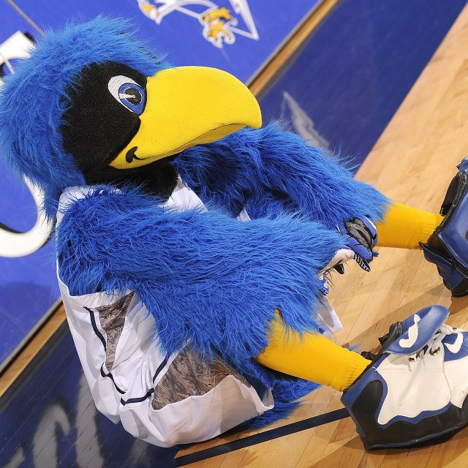
COMMON USAFA DEFINITIONS AND ACRONYMS

A Hall | Arnold Hall, cadet social center or student union
ACQ | Academic Call to Quarters, the time when the lower three classes are required to be in their rooms or in the library, completing homework assignments or studying
AFCW | Air Force Cadet Wing, the USAFA corps of cadets, approximately 4,600 strong, which consists of four groups and 40 squadrons
AMI | Morning Inspection, routine morning inspection of the cadet dormitories
AMT | Academy Military Trainer. An NCO who works with the AOC to provide military training to cadets in each squadron.
AOC | Air Officer Commanding. The AF Officer in charge of the Squadron.
AOG | USAFA Association of Graduates, the alumni association for USAFA
Arnie’s | Arnold Hall, student social center. Arnie’s usually refers to the food court area, now called the Richter Lounge
Basic | A new cadet who has entered Basic Cadet Training, but has not been accepted into the Cadet Wing
BCT | Basic Cadet Training, the initial training program that all cadets go through prior to entering their freshman year at USAFA
Beast | Another name for the six weeks of Basic Cadet Training each cadet completes upon entering the Academy
Blues | Basic cadet uniform, consisting of blue trousers, light blue short sleeved or long-sleeved shirt, and tie, if appropriate
BOR | Stands for “base of the ramp” located at the bottom of the Core Values Ramp
C1C | Cadet First-class, a senior
C2C | Cadet Second-class, or a junior; also called “2 Degree”
C3C | Cadet Third-class, or a sophomore; also called “3 Degree”
C4C | Cadet Fourth-Class, or a freshman, also called Doolies or Smacks; also called “4 Degree”
CCQ | Cadet in Charge of Quarters is a duty for Third-class cadets. It primarily involves sitting at the CQ desk and answering the phone (“sitting CQ”)
Check-points | Fourth-Class cadets traditionally have to memorize “Checkpoints” each day, and must be able to recite them if asked. Checkpoints include: Name/rank of the Officer in Charge; Name/rank of the Senior Officer of the Day, Number of days until each class graduates, Number of days until Air Force next beats Army, Number of days until Air Force next beats Navy, Number of days until the next Air Force Day, Meals for the day (main course, drink and dessert)
CIC | Cadet In Charge, usually the cadet in charge of a particular detail or duty
Comm | The Commandant of Cadets, a one star general who oversees military training at the Academy
Contrails | A pocket-size book that contains the knowledge Fourth-Class cadets are expected to learn during their first year, including quotations, aircraft, Air Force history and information about the operational Air Force and the Academy. The cover of Contrails is typically the class color of the class it was issued to.
CS | Cadet Squadron, there are 40 Cadet Squadrons with approximately 100 cadets in each.
CSP | Cadet Sight Picture, the Bible of the military aspect of cadet life. It contains everything from standards regarding cadet conduct to uniform standards, room standards and information about privileges, passes, and some forms.
CST | Combat Survival Training, held in Jacks Valley
CVR | Core Values Ramp. Ramp that provides the cadet wing access to the Terrazzo. Used to be called the “Bring Me Men” Ramp until the USAFA/Air Force core values were placed above the ramp.
D&B | The cadet Drum and Bugle Corps, a marching band consisting of musically inclined cadets
DG | Distinguished Graduate, a top graduate of a program
Doolie | Cadet Fourth-Class, or a freshman
ESET | Expeditionary Skills and Evasion Training
Firstie | A First-class cadet is a senior, or C1C (cadet first class)
GR | Graded Review, or academic exam
Hamster | Cadet slang for the chicken cordon bleu served at Mitchell Hall (may sometimes resemble a battered and fried hamster)
LMD | Last Military Duty is used to denote the time at which a cadet’s military responsibilities for the day (or week) are completed, and he is free to take a day or night pass (if eligible) or sign out on leave
M-Days / T-Days | Refers to the cadet academic schedule, where a cadet has two different daily class schedules, an “M-Day schedule” and a “T-Day schedule” on alternating days.
Mitch’s | Mitchell Hall, the cadet dining facility.
NCO | Non-commissioned Officer (enlisted personnel)
NCQ | Night Call to Quarters is the time between and Release from Night Call to Quarters (usually an hour prior to Reveille), during which cadets are required to be in their rooms, sleeping
ODS | The Officer Development System was a training methodology to make academy training more like the “real life” active duty Air Force
OIC | Officer in Charge, refers to a commissioned officer who is serving as the duty officer in the Cadet Area on a given day, also called “Officer of the Day” or “Duty Officer”
OPORD | Operations Order which prescribes duties and requirements for the cadet wing
PC | Physical Conditioning is organized physical training done by cadets, normally outside of physical education or organized sports (often used as “PC gear” meaning exercise clothing)
PFT | The Physical Fitness Test is a fitness test which all cadets are required to take each semester
PQ | Pilot Qualification, refers to physical qualifications necessary to enter pilot training
Proxy Card | Access card that cadets and military members carry that provides access to cadet area buildings and gates
SAMI | Saturday Morning Inspection is a stringent room and personal appearance inspection conducted on Saturday mornings
SAR | Squadron Assembly Room (one in each Squadron), used for official and unofficial meetings, briefings, training, recreation
SCA | Scheduling Committee Action, required for any organized cadet activity that falls outside of the normal schedule of calls; must be approved by the Academy’s interdisciplinary Scheduling Committee and is most often used for athletic activities or trips.
SERE | Survival Evasion Resistance and Escape training, held in Saylor Park and required during one three week summer session before the third class year. This program was replaced with Combat Survival Training (CST) in 1995 and done away with entirely in 2005. In 2007, the program returned for the Class of 2014.
Supt | Superintendent (pronounced “soup”) of the Air Force Academy, the three-star general who oversees all facets of operations and commands the Academy
The Bird | Refers to the costumed Falcon who represented Air Force Academy Athletics
Training Session | Refers to a high-intensity exercise where fourth class cadets are expected to recite knowledge and/or to perform physical training, usually within a squadron
Transition Week | Week between Summer Programs and the academic year, when cadets move into their academic year squadrons. The week is spent moving, book buying, and trading stories from the summer.
T’zo | Terrazzo, quadrangle in the center of the cadet area where cadets march in noon meal formation
UOD | Uniform of the Day, the term for whatever uniform cadets are required to wear on a given day. The UOD is announced every morning over the loudspeaker by Command Post and Fourth-Class cadets must remember it as part of Checkpoints.
WOB | Wings of Blue, Cadet parachute (“sky-diving”) team

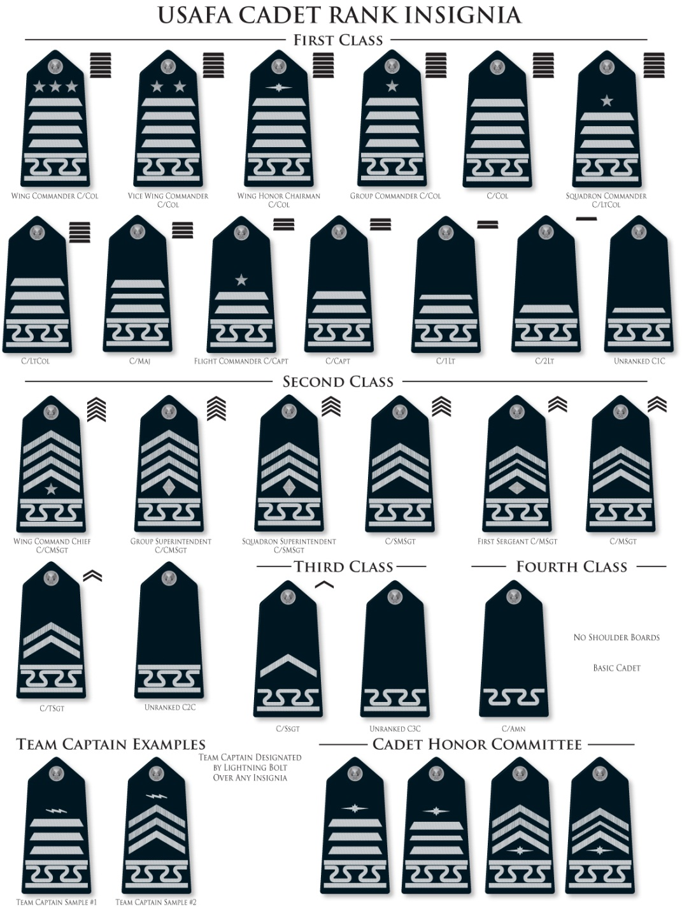

USAFA TELEPHONE NUMBERS

USAFA BASE OPERATOR & INFORMATION
(719) 333-1110
CADET CHAPEL
(719) 333-2636
COMMUNITY CENTER CHAPEL
(719) 333-3300
CADET WING MEDIA (BCT Videos/Yearbooks/Photographs)
(719) 333-4644
ASSOCIATION OF GRADUATES
Doolittle Hall
(719) 472-0300
Weekdays 7:30 A.M.–4:30 P.M.
ARNOLD HALL
(719) 333-2710
Fri 7:00 a.m.–11:00 p.m.
Sat–Sun–Tue 8:45 a.m.–11:00 p.m.
Labor Day Closed
ARNOLD HALL FOOD COURT
Godfather’s Pizza, Subway
(719) 333-0664
Mon–Sat 11:00 a.m.–10:00 p.m.
Sun 12:00 p.m.–6:00 p.m.
Labor Day Closed
HAP’S PLACE LOUNGE
Arnold Hall
(719) 333-4690
Mon–Thu. 6:00 p.m.–10:00 p.m.
Labor Day Closed
CADET TREATS
Arnold Hall
(719) 333-4610/4622
Mon–Fri 8:00 a.m.–2:00 p.m.
CADET TICKET OFFICE
Arnold Hall
(719) 333-4497
Mon–Fri 8:30 a.m.–3:30 p.m.
EISENHOWER GOLF COURSE
(719) 333-4735
IKE'S GRILL GOLF COURSE SNACK BAR
(719) 333-2606
Daily 6:30 a.m.–5:00 p.m.
ACADEMY FALCON CLUB
(719) 333-4253*
Lunch: Tue–Fri 11:00 a.m.–1:30 p.m.
Sat & Labor Day Closed
Brunch: Sun 10:00 a.m.–1:30 p.m.
*Reservations Suggested
FIELD HOUSE SNACK BAR
(719) 333-3321
Mon–Fri 9:00 a.m.–3:30 p.m.
Sat–Sun Closed
ACADEMY BOWLING LANES SNACK BAR
(719) 333-4709
Mon–Thur 9:00 a.m.–8:00 p.m.
Fri–Sat 9:00 a.m.–11:00 p.m.
Sun 11:00 a.m.–5:00 p.m.
FALCON GIFT SHOP
Cadet Field House
(719) 333-2484
Thur, Sep 2 12:00–5:00 p.m.
Fri, Sep 3 8:00 a.m.–6:00 p.m.
BARRY GOLDWATER VISITOR CENTER & GIFT SHOP
(719) 472-0102
Fri, 2 Sep–Mon, 3 Sep 8:00 a.m.–6:00 p.m.

VISITOR CENTER SNACK BAR
(719) 472-0689
Daily 11:00 a.m.–6:00 p.m.
PEREGRINE PINES FAMILY CAMPGROUND
(719) 333-4980
Mon–Fri 10:00 a.m.–5:00 p.m.
FARISH RECREATION AREA
(719) 687-9098
EQUESTRIAN CENTER
(719) 333-4607
Mon–Sat 9:00 a.m.–5:00 p.m.
Sun 12:00 pm–5:00 p.m.
CHILDCARE CENTER (authorized military only)
(719) 333-6779
Mon–Fri 6:30 a.m.–6:00 p.m.
HOME CHILDCARE (civilians and military)
(719) 333-7957

USAFA Map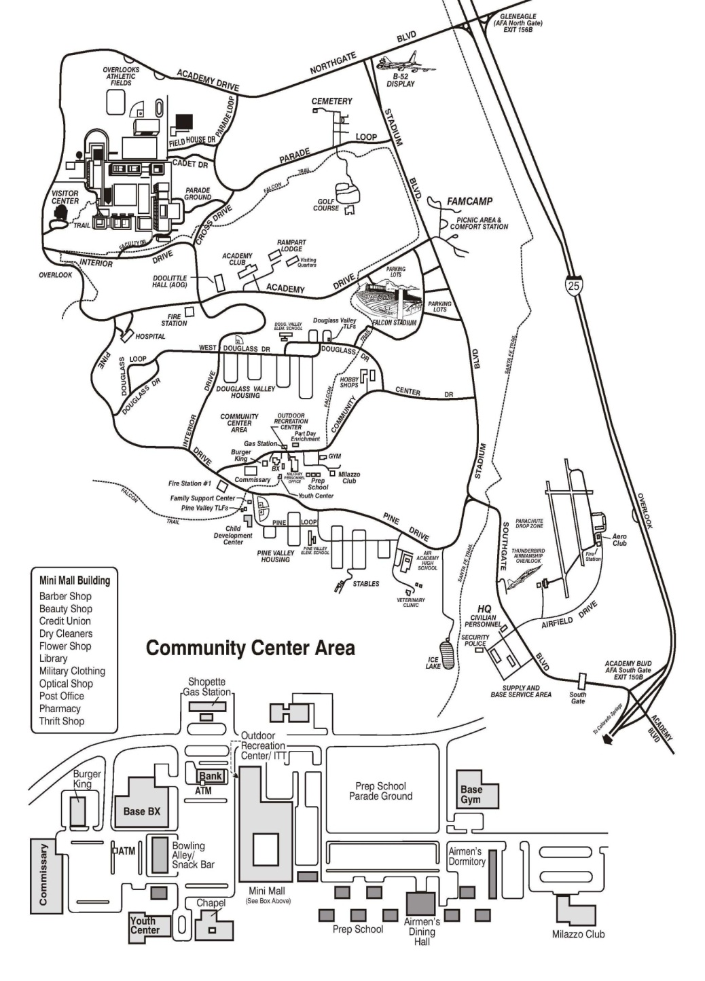
USAFA Cadet Area Map